

Department of Mechanical Engineering

Program: Mechanical Engineering

|  |  |
| --- | --- |
| Course Number | **MEC 723** |
| Course Title | **Mechanical Systems Design** |
| Semester/Year | **Winter 2015** |
| Instructor | **Dr. Fil Salustri** |

|  |  |
| --- | --- |
| **Report NO.** | **3** |

|  |  |
| --- | --- |
| Report Title | **Final Report** |

|  |  |
| --- | --- |
| Section No. | **01** |
| Group No. | **4** |
| Submission Date | **December 3, 2015** |
| Due Date | **December 3, 2015** |

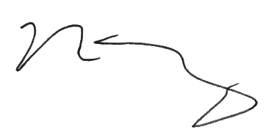

|  |  |  |
| --- | --- | --- |
| Name | Student ID | Signature* |
| Brendan Kong | *xxxx50821* | gib |
| Gibrail Laskhekham | *xxxx61056* | jalt |
| Jonathan Alt | *xxxx02102* | vasily |
| Vasily Gorbounov | *xxxx59345* |  |

(Note: remove the first 4 digits from your student ID)

*\*By signing above you attest that you have contributed to this submission and confirm that all work you have contributed to this submission is your own work. Any suspicion of copying or plagiarism in this work will result in an investigation of Academic Misconduct and may result in a “0” on the work, an “F” in the course, or possibly more severe penalties, as well as a Disciplinary Notice on your academic record under the Student Code of Academic Conduct, which can be found online at:* [*www.ryerson.ca/senate/current/pol60.pdf*](http://www.ryerson.ca/senate/current/pol60.pdf)*.*

# Executive Summary

The following report presents the design of a human-powered concrete mixer for use in underdeveloped communities. This concrete mixer will help alleviate the issue that plagues these communities; getting the technology to automate tedious, dangerous work for lack of infrastructure and trained workers, and that they cannot further develop infrastructure without the technology and trained workers. Without the reliance on advanced technology by utilizing readily available materials, the final design will be simple to manufacture and is considerably cost-effective, providing these underdeveloped locales with an efficient alternative to current methods of mixing concrete.

This report is intended to provide the executive board and technical staff with background information on the conceptualization of the concrete mixer. Throughout the research phase, it was imperative that the final concept be treated as a black box. Doing so prevented any bias that may have affected the design process during latter stages. With respect to the reference design, which was found to be the current method of mixing concrete in these communities, certain characteristics and requirements that the final concept must include were determined. Also, by personifying potential users that may come in contact with the mixer, the team was able to eventually design a product that fulfills the needs of these users, rather than just designing a product that will yield the most concrete in the shortest time but includes intricate and expensive components. During the design concept phase, many initial concepts werecompared against one another based on criteria the design team set that once again best reflected the needs of the users. This “survival of the fittest” method ensured that the best possible concept will be selected as the final design.

After several iterations, the final design had been selected. This design satisfies all requirements that had been set during the early stages of research. This final design is highly innovative yet only consists of everyday readily available materials that are fashioned together. It encompasses the best set of embodiments that provide an efficient and ergonomic design while being a commercially viable solution to the design problem.

# Table of Contents

Executive Summary i

Table of Contents ii

List of Figures vi

List of Tables viii

1.0 Product Strategy Specifications 1

1.1 Design Brief 1

1.2 Literature Review 2

1.2.1 Existing Designs 2

1.2.2 Common Characteristics of Existing Solutions 2

1.2.3 Breadth of Technology 3

1.2.4 Expected Market 3

1.2.5 Concrete Composition 4

1.2.6 Mixing Concrete 4

1.2.7 Concrete Yield 5

1.2.8 Maintenance 5

1.3 User Groups 6

1.4 Reference Design 7

1.4.1 Justification for Selection of Reference 8

1.5 Product Strategy 10

1.5.1 Strategic Issues 10

1.5.1.1 Usability and User Breadth 10

1.5.1.2 Market Segment 10

1.5.1.3 Degree of Innovation 11

1.5.1.4 Functional Complexity 11

1.5.1.5 Time to Market 11

1.5.1.6 Production 12

1.5.1.7 Environmental Concerns and Maintainability 12

1.5.1.8 Profitability 12

1.5.1.9 Risk 13

1.5.1.10 Cost 13

1.5.1.11 Customization 14

2.0 Product Requirement Specifications 15

2.1 Usage Scenario Chart 15

2.1.1 Scenario Diagram for ‘Concrete Production’ (Most Users) 16

2.1.2 Scenario Diagram for ‘Concrete Production’ (Stan Only) 17

2.1.3 Scenario Diagram for ‘Assembly and Disassembly’ (Most Users) 18

2.1.4 Scenario Diagram for ‘Assembly and Disassembly’ (Stan Only) 19

2.1.5 Scenario Diagram for ‘Bystander Interaction(s)’ (Most Users) 20

2.1.6 Scenario Diagram for ‘Cleaning and Maintenance’ (Most Users) 21

2.1.7 Scenario Diagram for ‘Cleaning and Maintenance’ (Gagandeep Only) 22

2.1.8 Scenario Diagram for ‘Relocation’ (Most Users) 23

2.1.9 Scenario Diagram for ‘Relocation’ (Stan Only) 24

2.1.10 Scenario Diagram for ‘Repair’ (Most Users) 25

2.1.11 Scenario Diagram for ‘Repair’ (Stan Only) 26

2.2 Requirements Diagram 27

2.3 Requirements Diagram Justifications 28

3.0 Product Architecture Specifications 31

3.1 System Identification Matrix (SIM) 31

3.2 Subsystem Descriptions 32

3.2.1 Mobility Subsystem 32

3.2.2 Structural Subsystem 32

3.2.3 Containment Subsystem 32

3.2.4 Delivery Subsystem 33

3.2.5 Mixing Subsystem 33

3.2.6 User Interface Subsystem 33

3.2.7 Control Subsystem 34

3.3 Systems Diagram* 35

3.3.1 Interpretation of Systems Diagram 36

3.4 Quantitative Justifications 37

4.0 Product Concept Specification 38

4.1 Initial Ideation 38

4.1.1 Mobility 38

4.1.2 Structural 39

4.1.3 Mixing 40

4.1.4 Control 41

4.1.5 User Interface 42

4.1.6 Containment 43

4.1.7 Delivery 44

4.2 Morphological Charts 45

4.2.1 Uncorrected 46

4.2.2 Corrected 47

4.2 Embodiments 48

4.2.1 Mobility 48

4.2.2 Structural 49

4.2.3 Mixing 50

4.2.4 Control 51

4.2.5 User Interface 52

4.2.6 Containment 53

4.2.7 Delivery 54

4.4 Initial Concept Methods and Results 55

4.4.1 Concept A 55

4.4.2 Concept B 55

4.4.3 Concept C 55

4.4.4 Concept D 56

4.4.5 Concept E 56

4.4.6 Concept F 56

4.4.7 Concept G 57

4.4.8 Concept H 57

4.4.9 Concept I 58

4.4.10 Concept J 58

4.5 Pairwise Comparison 59

4.5.1 Weights of Product Characteristics 60

4.5.2 Justification of Criteria Rankings 61

4.6 Weighted Decision Matrix* (No Recursion) 62

4.6.1 Concept Refinement 64

4.6.1.1 Concept EAD 64

4.6.1.2 Concept G1 65

4.6.1.3 Concept I1 65

4.7 Weighted Decision Matrix* (First Recursion) 67

4.7.1 Concept Refinement (First Recursion) 68

4.7.1.1 Concept EAD1 68

4.7.1.2 Concept I2 69

4.8 Weighted Decision Matrix (Second Recursion) 70

4.8.1 Final Concept Refinement and Justification 71

4.8.1.1 Containment 71

4.8.1.2 Mixing 71

4.8.1.3 Mobility 71

4.8.1.4 Delivery 72

4.8.1.5 Structural 72

4.8.1.6 User Interface 72

4.8.1.7 Control 73

4.8.1.8 Fulfilling Requirements 73

5.0 Final Concept Detailed Design Information 74

5.1 Part Selection 75

5.2 Part Design 75

5.3 Material Selection 75

5.4 Optimization 76

5.5 Operational Considerations 76

5.6 Human Factors Considerations 77

5.7 Environmental Considerations 78

5.8 Maintenance Considerations 78

5.9 Manufacturing and Assembly Considerations 79

5.10 CAD Model Renderings of Final Concept 80

6.0 Conclusion and Recommendations 96

REFERENCES 98

APPENDIX A: Working Drawings 100

Assembly Drawings 101

Bill of Materials (BOM) 103

Part Drawings 106

APPENDIX B: Mathematical Analysis 121

Determining Mechanical Advantage 121

Determining Necessary Force to Spin Drum 124

APPENDIX C: Scheduling (Gantt Chart) 127

APPENDIX D: Data Sheets 128

# List of Figures

Figure 1: Aggregate for Concrete Being Combined in a Depression in the Ground [9] 7

Figure 2: Concrete Ingredients Being Combined in Depression in the Ground [10] 7

Figure 3: Prepared Concrete Being Placed in Buckets for Transport to Application Point [11] 8

Figure 4: Scenario Diagram for ‘Concrete Production’ Case. 16

Figure 5: Scenario Diagram for ‘Concrete Production’ Case (Stan). 17

Figure 6: Scenario Diagram for ‘Assembly and Disassembly’ Case. 18

Figure 7: Scenario Diagram for ‘Assembly and Disassembly’ Case (Stan). 19

Figure 8: Scenario Diagram for ‘Bystander Interaction(s)’ Case. 20

Figure 9: Scenario Diagram for ‘Cleaning and Maintenance’ Case. 21

Figure 10: Scenario Diagram for ‘Cleaning and Maintenance’ Case (Gagandeep). 22

Figure 11: Scenario Diagram for ‘Relocation’ Case. 23

Figure 12: Scenario Diagram for ‘Relocation’ Case (Stan). 24

Figure 13: Scenario Diagram for ‘Repair’ Case. 25

Figure 14: Scenario Diagram for ‘Repair’ Case (Stan). 26

Figure 15: Requirements Diagram. 27

Figure 16: Systems Diagram 35

Figure 17: Uncorrected Morphological Chart. 46

Figure 18: Corrected Morphological Chart. 47

Figure 19: Final Concept Design. 74

Figure 20: Concrete Mixer in Loading Position Side View. 80

Figure 21: Concrete Mixer in Loading Position Dimetric View. 81

Figure 22: Concrete Mixer in Loading Position Front View. 82

Figure 23: Concrete Mixer in Loading Position Top View. 83

Figure 24: Concrete Mixer in Unloading Position Side View. 84

Figure 25: Concrete Mixer in Unloading Position Dimetric View. 85

Figure 26: Concrete Mixer in Unloading Position Front View. 86

Figure 27: Concrete Mixer in Unloading Position Top View. 87

Figure 28: Concrete Mixing Drum Detail. 88

Figure 29: Friction Powertrain Detail. 89

Figure 30: Concrete Mixer Rear Trimetric View. 90

Figure 31: Friction Drive Revealed. 91

Figure 32: Drum Roller Bearing. 92

Figure 33: Drum Roller Support. 92

Figure 34: Revamped Axle Mounting Locations. 93

Figure 35:Axle Close-up. 94

Figure 36: Common Scissor Jack. 95

Figure 37: Concrete Mixer Assembly View 1. 101

Figure 38: Concrete Mixer Assembly View 2. 102

Figure 39: Axle Shaft Part Drawing. 106

Figure 40: Chock Part Drawing. 107

Figure 41: Bicycle Crank Support Part Drawing. 108

Figure 42: Friction Drive Upright Support Part Drawing. 109

Figure 43: Drum Agitator Part Drawing. 110

Figure 44: Drum Bearing Support Part Drawing. 111

Figure 45: Drum Concrete Corral Part Drawing. 112

Figure 46: Drum Roller Bracket Part Drawing. 113

Figure 47: Drum Support System Part Drawing. 114

Figure 48: Friction Drive Half-shaft Part Drawing. 115

Figure 49: Front Fork Support Part Drawing. 116

Figure 50: Front Fork Support Bracket Part Drawing. 117

Figure 51: Handle Part Drawing. 118

Figure 52: Plywood Platform Mount Part Drawing. 119

Figure 53: Plywood Platform Part Drawing. 120

Figure 54: Gantt Chart. 127

Figure 55: Michelin Ad for the S83 Scooter Tire [19]. 128

Figure 56: Michelin Ad for the XZL Tire [19] 129

Figure 57: Michelin Tire Marking Definitions [19]. 129

Figure 58: Michelin XZY Tire Specifications [19]. 129

Figure 59: Toyota Land Cruiser 70-Series Repair Manual Frame Dimension Page [20]. 129

Figure 60: Myers ISO Export Drum [21]. 129

# List of Tables

Table 1: Breadth of User Personas. 6

Table 2: Usage Scenario Chart. 15

Table 3: System Identification Matrix (SIM). 31

Table 4: Justifications of Inputs and Descriptions of Flows. 36

Table 5: Mobility Embodiments. 48

Table 6: Structural Embodiments. 49

Table 7: Mixing Embodiments. 50

Table 8: Control Embodiments. 51

Table 9: User Interface Embodiments. 52

Table 10: Containment Embodiments. 53

Table 11: Mobility Embodiments. 54

Table 12: Pairwise Comparison. 59

Table 13: Product Characteristics Weights. 60

Table 14: Weighted Decision Matrix Part 1 (No Recursion) 62

Table 15: Weighted Decision Matrix Part 2 (No Recursion). 63

Table 16: Weighted Decision Matrix (First Recursion). 67

Table 17: Weighted Decision Matrix (Second Recursion). 70

Table 18: Bill of Materials. 103

Table 19: Gear Diameters. 122

Table 20: Excel Calculations (Sprocket Ratio). 122

# 1.0 Product Strategy Specifications

## 1.1 Design Brief

Many parts of the developing world suffer a “bootstrapping” problem: they cannot get the technology to automate tedious, dangerous work for lack of infrastructure and trained workers, and they cannot develop the infrastructure without the technology and trained workers. To help bootstrap these situations, design a way to mix concrete built entirely from readily available materials. Key to this project is to identify and define in some detail the situations in which your intervention will be used.

## 1.2 Literature Review

### 1.2.1 Existing Designs

Human powered concrete mixing is done either with some sort of contraption or manually where all materials are put in some sort of container and agitated with some sort of tool like a hoe or shovel [2].

All concrete mixing done via a mechanical device is done in one of two ways, either the container it is in rotates, which mixes the concrete, or the container is still while some sort of agitator moves through it to mix the concrete.

### 1.2.2 Common Characteristics of Existing Solutions

Modern Concrete Mixers Features:

* Able to accept and contain ingredients and concrete, such as an open drum
* Transportation method, such as wheels
* Mixes water and ingredients to produce concrete
* Used for civil engineering purposes [3]

Human Powered Concrete Mixers will have similar features as modern concrete mixers. Current solutions include a central hammock-style cloth that agitates the ingredients [12]. Another solution involves turning a central drum with handles placed in a way that resembles a ‘captain’s wheel’ and is spun to mix the concrete [4].

### 1.2.3 Breadth of Technology

Materials assumed to be available:

* Wheelbarrow
* Concrete mix (including Portland Cement)
* Wood
* Nails/Hammers
* Shovels/Hoes
* Steel/Plastic Drums
* Scrap metal
* Blades of some kind (chisels, knives, machetes etc)
* Rope (twine, natural etc)
* Rubber tires (car, truck, bicycle)
* Buckets

### 1.2.4 Expected Market

* Low income, developing countries
* Rural location (off-grid)
* Low accessibility environments where a truck might not be able to access
  + Maybe there are very little trucks to go around
  + Could be cost-prohibitive to rent or buy concrete
  + No access to utilities
* Places with minimal skilled labour
* Average homeowner that likes to tinker with things and build

### 1.2.5 Concrete Composition

Concrete is typically made from a mixture of [1]:

* Water (impurities absent)
* Portland Cement
  + Helps the mixture bind
  + silica, alumina, lime, gypsum, iron
* Aggregates (bulk of materials)
  + Sand, gravel, crushed stones
  + Possible to use recycled concrete, glass, ground up old concrete

### 1.2.6 Mixing Concrete

Concrete can be mixed by hand, brings up some safety issues [2]:

* Requires barrier-based safeguards to prevent the cement from entering eyes and lungs, and irritating the skin (gloves, respirator, goggles, and long-sleeved clothing)
* Solids are added to an system that holds the solids (Portland cement, aggregates) and the water is gradually added to it, which is agitated by way of something that “folds” the mixture to the point where the mix is not too watery and not too dry (implying that a viewing system is required to allow for this)
* Requires a great deal of effort to mix concrete with only using hand tools
  + This usually involves mixing in a wheelbarrow with the use of a shovel
  + Best in small batches (1 wheelbarrow-full)

### 1.2.7 Concrete Yield

The amount of concrete per batch produced by the human-powered one that will be designed will be based upon an estimation, taking into consideration the volume of concrete that is typically produced and delivered to a construction site by a concrete mixing truck as well as the volume that can be held by a wheelbarrow. The justification of this is that a cement truck represents the high-end volume amount of concrete mixing and a wheelbarrow represents that of the low end. Additionally, it will be assumed that the wheelbarrow will be used to transport the mixed concrete from the human-powered mixer to the location where the mix is to be poured [4]. As such, it will be beneficial if the mixer that is to be designed will produce one or more wheelbarrow loads worth of concrete from a single batch. The amount of concrete that can be held in a wheelbarrow is 0.142m3 [5]. The amount of concrete that can be held in a cement truck is 7.65 m3 [6]. Density of concrete is 2400 kg/m3 [7].

### 1.2.8 Maintenance

It is necessary to promptly clean all surfaces of tools, mixers, and transportation devices that will need to be re-used by the workers as the mix that is left over will harden and become difficult to remove [2]. This means that a cleaning system of sorts is required.

## 1.3 User Groups

Below is a collection of various personas created that encompass a wide range of user groups, providing a broad range of the groups of people who will most likely interact or come in contact with the cement mixer.

Table 1: Breadth of User Personas.

|  |  |
| --- | --- |
| **Name** | **Personas** |
| Gagandeep | 10 year old frail and malnourished elementary school student, is curious, plays with puzzles and LEGO® bricks. Likes to play soccer at a field near the house where he lives with his mother, father, grandmother and 2 younger siblings. |
| Jesus | 37 year old maintenance worker. Jesus likes bowling and wearing velour suits. He is lazy and hates his job, however his membership in a drug cartel sponsored workers union ensures that he keeps his job despite his abysmal performance. |
| Kanye | 18 years old. He could not attend post-secondary education as he must support his mother and 5 siblings. He picked up a construction job, responsible for creating infrastructure for his developing town. He works 10-12 hour days under the scorching sun. Is overworked. |
| Dan | Dan is an abled bodied male that is employed as a dock worker (manual labourer)– that is, he is responsible for the unloading of cargo and transferring the load from the container on the dock after it has been offloaded by a crane operator to a another form of transportation. As labour rules are lax in developing countries, Dan ends up working before dawn and well into dusk. He has not been issued any PPE as organizations such as OSHA does not exist and he just does what his supervisors tell him to do – otherwise he risks his job and wages for the day. |
| Stan | Stan is man living in an indeterminate region in Eastern Europe. He was born during the cold war and is now 66 years old. Stan has a missing hand and eye, however economic hardships compel him to work manual labor jobs to support his family. |
| Grady | 29 year old construction worker. He has frequent anger management problems and claims to hear conflicting voices in his head. His biggest fear is that his wife will cheat on him. He works out 6 times per week and is very strong. His size, strength, ego, and frequent angry outbursts cause him to frequently start fights with coworkers, making keeping a job a challenge. |
| Kim | 25 year old technician with a degree at local community college. Grew up tinkering with small mechanical devices and reverse engineering them. Very adept at using industrial tools. |

## 1.4 Reference Design

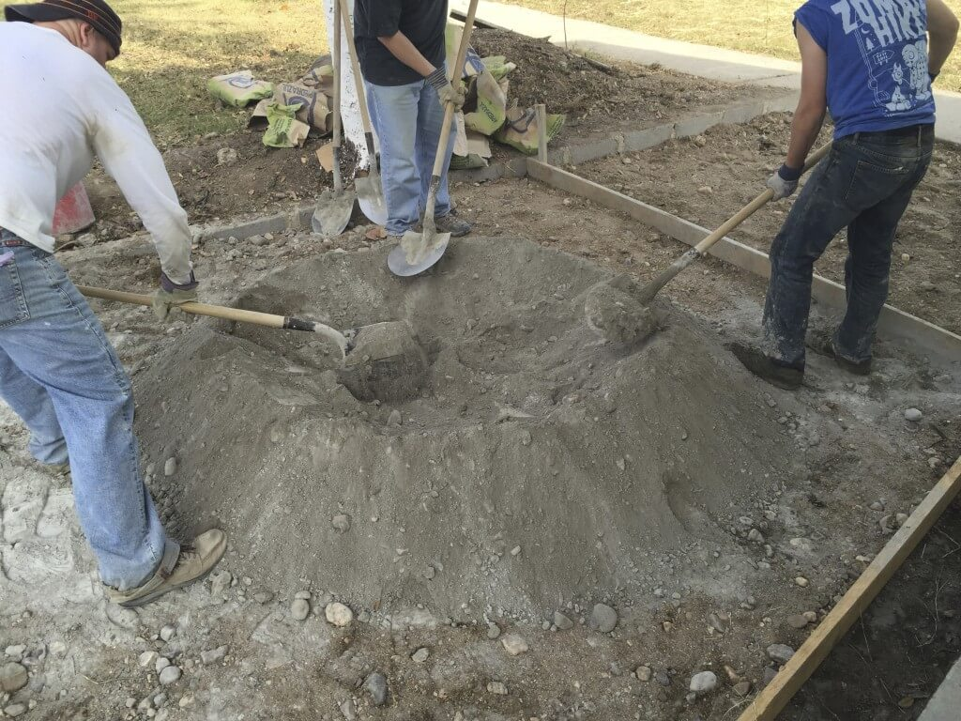

Figure 1: Aggregate for Concrete Being Combined in a Depression in the Ground [9]

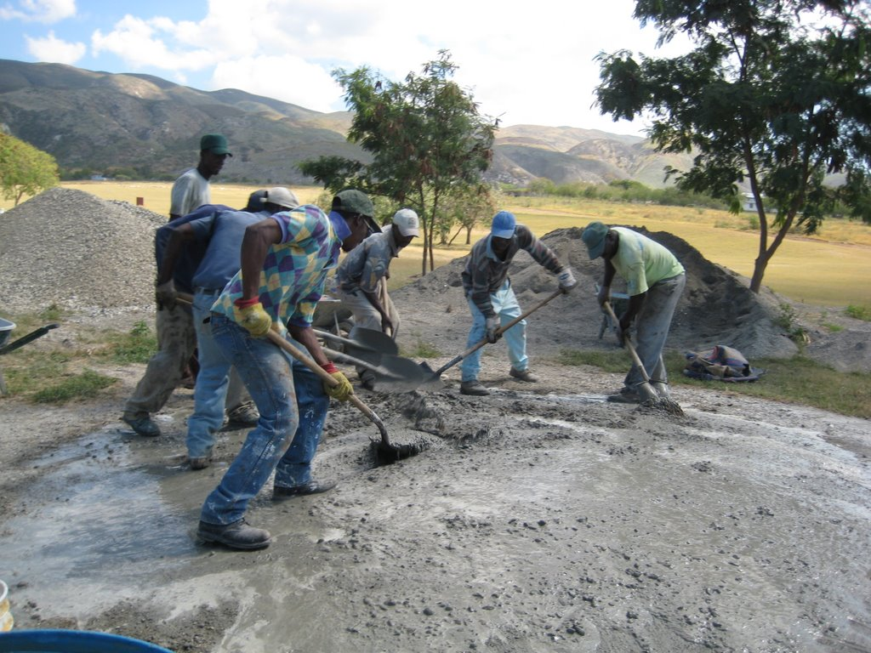

Figure 2: Concrete Ingredients Being Combined in Depression in the Ground [10]

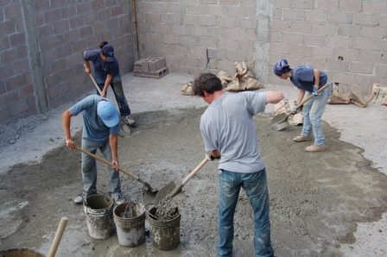

Figure 3: Prepared Concrete Being Placed in Buckets for Transport to Application Point [11]

### 1.4.1 Justification for Selection of Reference

The reference design to which the human powered mixer will be compared is mixing the concrete in a depression in the ground [8] see Figure 1. The aggregates, cement, and water are combined using shovels while standing in the depression that has been created, see Figure 2. This mixture is then transported to the application point using a wheelbarrow.

The reference design requires sufficient space and appropriate ground conditions in which a depression can be made. This means that there is a need for a large area of ground that can be readily transformed into a concrete mixing basin. The tools necessary are shovels for the purpose of both creating the depression and mixing the concrete, a water supply of sorts to be used as an ingredient in the mixture, as well as buckets to transport the mixed concrete to the point of application.

The flaws of the reference design are many and will need to be mitigated or eliminated by the human powered mixer. The first flaw is that to create a depression in the ground to mix the concrete, lots of time and effort are expended; digging a depression of sufficient volume to mix a large quantity of concrete requires a very large surface area as the pit needs to be shallow enough such that a worker can reach their shovel to the bottom of it and still mix the concrete and not sink too deep to the point where they will be stuck in the mix. The extension of this problem is that in environments that are very rocky, creating a depression can be very difficult or even impossible using hand shovels. The next flaw in this reference design is that to create a large amount of concrete, many workers are required to mix this concrete quickly. This is because the larger the depression, the greater the volume of concrete that can be produced, and the greater amount of work required to mix said volume of concrete. Additionally, as there is a great deal of manual labour involved, the demographic of people that are able to effectively use the reference design must be physically fit.

There are 2 other ways to mix concrete that are not considered: concrete mixer trucks and powered portable concrete mixers. These two are ineligible as a reference design since the concrete mixer design is to be used in a developing nation where it is assumed that there will not be access to either portable power nor are the resources to attain a cement truck available. The concrete mixer truck requires existing infrastructure specifically roads, while the powered portable concrete mixer requires a power supply.

## 1.5 Product Strategy

The design team works for an NGO in an advisory capacity to provide engineering solutions to underdeveloped locales to help develop their infrastructure.

A great deal of infrastructure involves mixing concrete, and so to facilitate this our product is a human powered concrete mixer. It competes directly with mixing concrete by hand. The goal is for our design to be a simple and cost effective replacement that is substantially more efficient than the current method of mixing by hand to justify the cost of its purchase.

The customer (whoever is wishing to mix concrete) wants a human powered concrete mixer for which the team provides the design. The customer then either manufactures the concrete mixer themselves at a cost, or subcontracts it out to a local machine shop to be made. They then take full ownership of the mixer and the team is out of the picture except for providing instructions regarding maintenance and repair.

### 1.5.1 Strategic Issues

#### 1.5.1.1 Usability and User Breadth

The users are construction workers. They are able bodied since working construction requires them to withstand the physical rigors of the job. They may however have some physical disadvantages such as visual impairment, hearing loss, or even a missing hand or eye. Their education can be non-existent at a minimum, including even illiteracy. Their job training may also be non-existent at the minimum.

#### 1.5.1.2 Market Segment

The concrete mixer is marketed towards under equipped organizations involved in construction. This ranges from a local construction company to a group of people who just want to improve where they live. They are not a high-tech enterprise so no fancy engineering is required from the concrete mixer only practical performance, it must work, be robust, and be a worthy investment in the short term, since the construction project may be as simple as a concrete shed.

#### 1.5.1.3 Degree of Innovation

Looking to design a product that is effectively simple and economical. As an NGO working for likely financially under-equipped clients, the major concern is accessibility rather than innovation. However, the design will significantly alter current performance, function and efficiency of the reference design. Innovation for the sake of innovation has no purpose here, since it will incur costs that the client will be unwilling to bear.

#### 1.5.1.4 Functional Complexity

The concrete mixer does three tasks - 1) Offer a vessel to store the unmixed concrete, 2) Agitate and mix the concrete and 3) Deposit concrete into desired location. It will also offer a way to easily reposition the mixer at a different location (near or far). As a whole, it is a very bare bones machine in which its sole goal is to mix concrete - nothing more.

#### 1.5.1.5 Time to Market

Our product is low-tech, meaning that technological advances will be very unlikely to have any effect on it. We’re dealing with customers who are essentially stuck in time, so their demand for a human powered concrete mixer isn’t going anywhere. This establishes that there is no real limit for time spent on design and development, however there is no reason to spend excess time on it, since as mentioned before it is a barebones product.

#### 1.5.1.6 Production

The concrete mixer is manufactured by the customer, either themselves or by subcontracting it out. Assuming it is a small construction operation, the production run of the concrete mixer will be just the one. Different customers will manufacture it at different machine shops, so it is in no way mass produced.

#### 1.5.1.7 Environmental Concerns and Maintainability

Our design will make beneficial use of readily available materials that would otherwise be considered waste. However, the target audience can decide on whether they want to procure virgin raw materials versus reusing. Furthermore in light of the ‘human-powered’ vector of the design, the environmental concerns are minimal.

Due to the simplicity of the machine, parts are minimal in quantity thusly more reliable. As work site equipment are often abused, maintainability is preferred over replacement. Parts will be minimally complex and attached using removable fasteners versus something more permanently attached thus easily replaced in field. The low parts count assists this aspect.

#### 1.5.1.8 Profitability

Profitability is of no concern as the design is given away for free. There is no revenue in this nor any costs apart from our own labour, which is independent of the manufacturing cost of the concrete mixer. The concrete mixer will be used for construction projects, where it only a cost borne by the client. The term efficiency is then more applicable than profitability, since the goal is to mix the most concrete while spending the least amount of money.

#### 1.5.1.9 Risk

As an NGO, there are minimal financial risk in designing the human powered concrete mixer, as long as it fulfills the cost criteria. In a worst case scenario, clients will decide to not use the concrete mixer for their construction projects. This will only happen if they have no money to buy it in the first place or if they pay their workers so little that it’ll be cheaper to hire some more workers than to purchase the concrete mixer. Minimizing the cost of our concrete mixer while also making it as efficient as possible will prevent this from happening.

Operational risk involves personal injury and machine breakdown. Our job will be to minimize the chance of either of them happening where the concrete mixer itself is at fault. Operating conditions are decided upon by the customer and the team only has an advisory influence on them.

#### 1.5.1.10 Cost

The cost of the machine is determined by the manufacturing cost. The clients pay for the concrete mixer themselves, so it must be a worthy investment, as given by the equation:

|  |  |  |
| --- | --- | --- |
|  | $MC_{1}$ > ${ MC}_{2}$ + *I* | Eq. 1.0 |

Where *M* is a mass of concrete. $C_{1}$ is the cost to mix that mass of concrete by hand, while $C_{2}$ is the cost to mix it using our concrete mixer, and *I* is the initial cost of the mixer itself.

Therefore the initial cost of the machine must be minimized.

Targeting a minimal assemblage cost, as the target user must be considered which (developing country). Our design will utilize cheap readily available materials.

#### 1.5.1.11 Customization

Should be flexible in design, can use alternate material in place if design material insufficient

Raw materials can be substituted with local specimens if not available. Materials will vary depending on developing country (for example, scrap steel may be more plentiful in Asian countries due to their steel production, vs. reliance on natural fibers such as bamboo in the Himalayas) and as such the team will take this into account via the alternate construction methods. In addition, there are no mandated dimensions - users can choose to scale the design up or down depending on their requirements.

# 2.0 Product Requirement Specifications

## 2.1 Usage Scenario Chart

Table 2: Usage Scenario Chart.

|  |  |  |  |  |  |  |  |
| --- | --- | --- | --- | --- | --- | --- | --- |
|  | **Gag** | **Jesus** | **Kanye** | **Kim** | **Dan** | **Stan** | **Grady** |
| **Concrete Production** |  |  | X |  |  | X | X |
| **Relocation** |  |  | X |  | X | X | X |
| **Bystander** | X |  |  |  |  |  | X |
| **Repair** |  | X | X | X |  | X | X |
| **Cleaning and Maintenance** | X | X | X |  |  |  | X |
| **Assembly and Disassembly** |  |  | X | X | X | X | X |

### 2.1.1 Scenario Diagram for ‘Concrete Production’ (Most Users)



Figure 4: Scenario Diagram for ‘Concrete Production’ Case.

### 2.1.2 Scenario Diagram for ‘Concrete Production’ (Stan Only)

Figure 5: Scenario Diagram for ‘Concrete Production’ Case (Stan).

### 2.1.3 Scenario Diagram for ‘Assembly and Disassembly’ (Most Users)



Figure 6: Scenario Diagram for ‘Assembly and Disassembly’ Case.

### 2.1.4 Scenario Diagram for ‘Assembly and Disassembly’ (Stan Only)



Figure 7: Scenario Diagram for ‘Assembly and Disassembly’ Case (Stan).

### 2.1.5 Scenario Diagram for ‘Bystander Interaction(s)’ (Most Users)



Figure 8: Scenario Diagram for ‘Bystander Interaction(s)’ Case.

### 2.1.6 Scenario Diagram for ‘Cleaning and Maintenance’ (Most Users)

Figure 9: Scenario Diagram for ‘Cleaning and Maintenance’ Case.

### 2.1.7 Scenario Diagram for ‘Cleaning and Maintenance’ (Gagandeep Only)



Figure 10: Scenario Diagram for ‘Cleaning and Maintenance’ Case (Gagandeep).

### 2.1.8 Scenario Diagram for ‘Relocation’ (Most Users)



Figure 11: Scenario Diagram for ‘Relocation’ Case.

### 2.1.9 Scenario Diagram for ‘Relocation’ (Stan Only)



Figure 12: Scenario Diagram for ‘Relocation’ Case (Stan).

### 2.1.10 Scenario Diagram for ‘Repair’ (Most Users)



Figure 13: Scenario Diagram for ‘Repair’ Case.

### 2.1.11 Scenario Diagram for ‘Repair’ (Stan Only)



Figure 14: Scenario Diagram for ‘Repair’ Case (Stan).

## 2.2 Requirements Diagram



Figure 15: Requirements Diagram.

## 2.3 Requirements Diagram Justifications

**Legend:**

Product Characteristic

* Functional Requirement
  + Constraint
    - Justification

Stable

* Will remain stationary on the ground
  + - Mixer should be able to remain stationary as the reference design
* Design should not easily become off-balanced
  + - Must be designed in a way that balance is always kept during transportation

Safety

* Will remain stationary on the ground
* Exposed pinch points are covered
  + - Purpose such that users will not be injured by a pinch point hazard

Durability

* Must resist deformation
  + The mixer must be able to accept a minimum of 340.8 kg of concrete at any given instance
    - Volume of wheelbarrow is 0.142 m3 [5]
    - Density of concrete is 2400 kg/m3 [7]
    - Based on reference design’s concrete delivery method of wheelbarrow
* Must resist rough handling
  + Must be able to functionally survive and not yield after a 1 ft drop
    - The reason behind this is that the reference design’s delivery method, a wheelbarrow, could feasibly experience and survive a drop from a foot-high ramp
    - Must resist an impact from a moderate strength baseball bat swing

Efficiency

* Use a mechanical advantage to amplify human power to mix concrete
  + Must be able to mix the concrete under the power of one person
    - Based off of the assumption that a wheelbarrow’s worth of concrete can be prepared by one person
    - Recommended upper force limits for a single person in standing, kneeling, and seated are 225 N (with whole body) 110 N (primary arm and shoulder muscles with arms fully extended), 188 N, and 130 N respectively [14]

Affordability

* + $0.055/kg of concrete is the maximum concrete production cost
    - Justification that this is at most as expensive as the reference design’s cost
    - based on the time cost of labour to mix the concrete with the assumption of the minimum wage rate of $11.25/hour [13] and a mixing rate of 206 kg of concrete/hour
    - This number is scaled based on the hourly wage in the operating locale
  + Must cost less than $400
    - Justification is that 5 wheelbarrows cost $80 [4] and the mixer will provide an increase in efficiency that is well worth the cost increase to this point
    - This number is scaled based on the hourly wage in the operating locale. If wages are high, then decreasing required work hours yields large cost savings, so the concrete mixer can cost more. If wages are low, then decreasing required work hours gives a smaller effect, so the concrete mixer must cost less.

Easily assembled and reassembled

* Can disassemble into components
  + - to simplify transport, where it can be broken down into parts and moved, and to simplify repair, so that broken parts can be detached and replaced or repaired

Maintainability

* Must provide access to key components
  + - Can disassembled into components

Portability

* Must be movable from place to place
  + The mixer must be able to be moved from one location to another through the use of two fit individuals. One person should be able to move it alone, although this will be difficult. An analogy would be a couch.
    - Based off of the assumption that those mixing the concrete will be fit and working in groups of at least two people
    - Recommended upper force limits for a single person in standing, kneeling, and seated are 225 N (with whole body) 110 N (primary arm and shoulder muscles with arms fully extended), 188 N, and 130 N respectively [14]

Reliability

* Lifespan
  + Will be able to last at least 2 years of use
    - Should be in use long enough to justify initial cost in comparison to alternative methods (wheelbarrow)
    - The warranty period on the reference design’s delivery method, the wheelbarrow, is 2 years [16]

Usability

* Minimal steps to create concrete
* must be operated by intuitive methods
  + - Should not involve unnecessary steps to achieve goal
    - Workers shouldn’t have to overthink on the next step, should be a straightforward process

Functionality

* Accept water, cement, and aggregates
  + - The ingredients necessary to produce concrete are obviously required to be accepted into any device designed to mix concrete
* Deposit concrete into a container
  + - Reference design has the concrete moved to the container, the wheelbarrow, therefore the new design should perform this function
* Combine water, cement, and aggregates using human power to form concrete
  + The mixer must produce at least 206 kg of concrete/hour
    - Anecdote that it takes 10 minutes to mix a wheelbarrow of concrete
    - Volume of wheelbarrow is 0.142m3 [5]
    - Density of concrete is 2400 kg/m3 [7]
    - Based on reference design’s concrete delivery method

# 3.0 Product Architecture Specifications

## 3.1 System Identification Matrix (SIM)

The functional requirements were identified in the PRS (see Appendix A) and then used to determine the necessary subsystems to facilitate these requirements:

Table 3: System Identification Matrix (SIM).

|  |  |  |  |  |  |  |  |
| --- | --- | --- | --- | --- | --- | --- | --- |
|  | **Subsystems** | | | | | | |
| **Functional Requirements** | **Mobility** | **Structural** | **Containment** | **Delivery** | **Mixing** | **UI** | **Control** |
| Remain stable on the ground | **x** | **x** |  |  |  |  |  |
| Remain stationary on the ground | **x** |  |  |  |  |  |  |
| Resist deformation |  | **x** |  |  |  |  |  |
| Resist rough handling |  | **x** |  |  |  |  |  |
| Use a mechanical advantage to amplify human power to mix concrete |  |  |  |  | **x** |  |  |
| Combine water, cement, and aggregates to mix concrete |  |  | **x** |  |  |  |  |
| Can move from place to place | **x** |  |  |  |  |  |  |
| Require few steps to mix concrete |  |  |  |  | **x** | **x** | **x** |
| Intuitive operation |  |  |  |  |  | **x** | **x** |
| Accept water, cement, and aggregates |  |  | **x** |  |  |  |  |
| Deliver concrete into a wheelbarrow |  |  |  | **x** |  |  |  |

The functional requirements were identified in the PRS and then used to determine the necessary subsystems to facilitate these requirements.

## 3.2 Subsystem Descriptions

### 3.2.1 Mobility Subsystem

This subsystem facilitates the functional requirements to move from place, remain stable on the ground, and remain stationary on the ground. This is in correspondence to the design characteristics of the mixer to be stable, safe, and portable. This sub-system receives energy in the form of human power and information from the control system. It outputs energy in the form of stress to the structural system and heat, noise, and friction outside of the mixer system.

### 3.2.2 Structural Subsystem

This is responsible for the requirements to resist both deformation and rough handling as set out by durability product characteristic. This system receives energy in the form of stress from two subsystems; the containment and mobility systems. The structural system outputs energy in the form of strain outside of the mixer system.

### 3.2.3 Containment Subsystem

This subsystem handles the functional requirement of accepting water, cement, and aggregates as determined by the functionality product characteristic. The containment subsystem accepts mass from outside the mixing system in the forms of sand, aggregates, water, and cement. These are then output from the containment subsystem to that of mixing. The containment system also outputs stress to the structural sub-system.

### 3.2.4 Delivery Subsystem

This subsystem is responsible for the functional requirement of depositing the cement to a container, which is set out by the functionality product characteristic. The delivery sub-system receives and outputs mass in the form of concrete from the mixing subsystem and outside of the concrete mixer system.

### 3.2.5 Mixing Subsystem

This subsystem handles the functional requirements of amplifying human power to mix concrete as well as mixing cement, aggregates, and water to form concrete. These functional requirements were set by the efficiency and functional product characteristics. The mixing subsystem accepts energy in the form of human power from outside of the overall system. Other inputs to the mixing system are different forms of mass, consisting of sand, aggregates, water, and cement. The last input to this sub-system is information in the form of commands from the control system. There are three outputs of this system, the first being energy outputted outside of the concrete mixing system in the form of heat, noise, and friction. The second output is mass in the form of concrete and is output to the delivery sub-system. Finally, there is information in the form of feedback being sent from the mixing to the control sub-systems.

### 3.2.6 User Interface Subsystem

This subsystem is in place to facilitate the functional requirement of intuitive operation set out by the product characteristic of usability. The user interface subsystem accepts information in the form of user command from outside of the concrete mixing system. It also receives information in the form of feedback from the control sub-system. The outputs of this sub-system are both information, the first being commands sent from the user interface to the control sub-system and the second being feedback sent out of the user interface to the outside of the concrete mixing system.

### 3.2.7 Control Subsystem

This subsystem is responsible for facilitating the functional requirement of needing few steps to mix concrete, which was specified by the product characteristic of usability. The control sub-system accepts data in the form of commands from the user interface sub-system. It also sends data in the form of commands to the mobility and mixing sub-systems. There is also information input from the mobility and mixing subsystems in the form of feedback. Finally, the control sub-system sends information based feedback to the user interface.

## 3.3 Systems Diagram*



Figure 16: Systems Diagram

*Note: Bolded Lines = Mass Transfer, Thin Lines = Energy Transfer, Dashed Lines = Info Transfer

### 3.3.1 Interpretation of Systems Diagram

Table 4: Justifications of Inputs and Descriptions of Flows.

|  |  |  |
| --- | --- | --- |
| **Arrow** | **Flow** | **Good/Bad?** |
| 1 | Human Power energy flow into Mobility system to move mixer, can also ‘over move’ and end up in wrong location or worse | Both |
| 2 | Human Power energy flow into Mixing system to operate, can over or under mix concrete as well as correctly mixing | Both |
| 3 | Sand mass flow into Containment system, quantity could be incorrect | Both |
| 4 | Aggregates mass flow into Containment system, quantity could be incorrect | Both |
| 5 | Water mass flow into Containment system, quantity could be incorrect | Both |
| 6 | Portland Cement mass flow into Containment system, quantity could be incorrect | Both |
| 7 | User Commands information flow into User Interface | Both |
| 8 | Stress energy flow when mixer is being moved, transmit forces to Structural system | Both |
| 9 | Stress energy flow when mixer is being loaded/unloaded, transmit forces to Structural system | Both |
| 10 | Portland Cement mass flow from Containment to Mixing system | Good |
| 11 | Water mass flow from Containment to Mixing system | Good |
| 12 | Aggregates mass flow from Containment to Mixing system | Good |
| 13 | Sand mass flow from Containment to Mixing system | Good |
| 14 | Concrete mass flow from Mixing system to Delivery system, mixing time may be inadequate, see Arrows 7 and 15 | Both |
| 15 | User commands machine (information flow) to operate, may instruct machine to operate defectively | Both |
| 16 | Machine may give faulty feedback (information flow) dependant on user input | Both |
| 17 | Control system (information flow) may instruct machine to operate defectively | Both |
| 18 | Machine may give faulty feedback (information flow) dependant on Mixing and Control systems | Both |
| 19 | Energy flow of Strain from loads sustained by Structural system | Bad |
| 20 | Heat, friction, noise, damage signifies inefficiencies and issues | Bad |
| 21 | Concrete mass flow from Delivery system | Good |
| 22 | Feedback (information flow) from User Interface, displays operational status of machine | Good |

## 3.4 Quantitative Justifications

The amount of concrete needed to be held was determined from milestone 1 by the specification that the mixer must hold a minimum of the same amount of concrete that a wheelbarrow can, which is 0.142 m3 [5]. The product of this and the density of concrete, 2400kg/m3 [7] yields the mass of concrete interfacing between the systems, 340.8 kg.

The amount of water was determined through finding the ratio of the concrete ingredients, where water makes up approximately half of the mix, therefore has a mass of 170.4 kg. The amount of sand and aggregates were similarly determined, with cement making up 1 part, or 20.05 kg; 2.5 parts sand, or 50.117 kg; and the aggregates making up 5 parts, or 100.24 kg. This was used by seeking the ratio of the ingredients for foundation walls [19].

The amount of force that is recommended to be applied was drawn from milestone 1, where the recommended amount of force that can be applied by the whole body in a standing position is 225 N, while that when kneeling and using primary arm and shoulder muscles while fully extended is 110 N [14].

# 4.0 Product Concept Specification

## 4.1 Initial Ideation

With the following initial ideas, the embodiments that were deemed the most appropriate with respect to the PSS and PRS were drawn up and described in section 2.2.

### 4.1.1 Mobility

* Wheelbarrow style 1 wheel, 2 stilts
* 2 wheels, rickshaw style, 2 stilts
* 3 wheels, tricycle style, hybrid of wheelbarrow and rickshaw
* 3 wheels, front swivel
* 3 wheels, rear swivel
* 4 wheels, all swivel (these are called casters)
* 4 wheels, with no swivel
* 4 wheels, rear swivel
* 4 wheels front swivel
* 4/3/1 skid(s), just drag it along
* Tank treads for flotation
* Rollers
* Steerable bogey

Brainstorming was used to come up with the mobility embodiments. Mobility embodiments have 2 parameters: contact surfaces and quantity. Therefore, an exhaustive search was done by brainstorming through all possible combinations of stilts, wheels, skids, and swivel wheels, with up to 4 elements. Some extras were thought up later.

### 4.1.2 Structural

* Tubular frame, panels and all components attached
* Frame made of welded or bolted plates. Monocoque design.
* Metal frame (screws, bolts/nut, welded joints)
* ABS/PVC tubing frame (plastic cement/welding/adhesive joints)
* Wood/timber frame (wood joints, or lashings)

Design by analogy was used in the tubular frame versus plate based frame embodiments. The analogy was based on nature, where all organisms with solid bodies either have an exoskeleton consisting of plates, or an endoskeleton consisting of bones.

### 4.1.3 Mixing

* Holding system spins like washing machine, tumbling of materials mixes them
* Holding system spins like washing machine around stationary agitator
* Holding system stationary, moving agitator
* Both holding system and agitator move
* Paddle style agitator
* Screw-type agitator
* No agitator (relies on gravity and rotation to mix)

Brainstorming was used to come up with mixing methods. In a mixing system, there is a containment system holding the material being mixed, and an optional agitator. They then move around each other in some sort of configuration. They are all listed above.

### 4.1.4 Control

* Human (he/she/it visually checks progress)
* Mechanical (such as physical detents to prevent overreaction, or locks that engage after ‘x’ number of rotations)
* Mechanical (timer, specific time intervals)
* Physical properties (inertia prevents excessive acceleration of mixer)
* Biological fatigue (if you’re tired, it’s time to stop)

It is a human powered concrete mixer, so no electricity can be provided, necessitating the use of alternative control systems. Opposed convention by making mechanical or biological control systems rather than electronic ones.

### 4.1.5 User Interface

* Levers
* Cranks
* Pedals
* Rowing style
* Sliders
* Dials
* Button(s)
* Knob(s)

Brainstorming was used to come up with all types of physical interfaces that the user could interact with to use with the concrete mixer.

### 4.1.6 Containment

* Drum
* Tube
* Bowl
* Sack
* Trough
* Drain pipe (metal or plastic)

Brainstorming was done to figure out different ways to contain the concrete mixture. Anything that could hold material was included.

### 4.1.7 Delivery

* Chute
* Inversion/tipping of holding vessel
* Scoop that scoops the concrete from the holding system
* Funnel
* Extrusion

A number of delivery embodiments were thought up by using design by inversion, where instead of the delivery system helping the containment system deliver the concrete, the containment system would help the delivery system deliver the concrete.

## 4.2 Morphological Charts

Some of the inconsistent embodiments that were encountered were the bathtub and spinning vessel; spinning vessel and extrusion; sled and trapdoor, hammock and auger; and finally, the bucket and paddle embodiments. These were found by an exhaustive search to determine a pair of embodiments that would contradict each other. Some more inconsistent embodiments that were found were: hammock and spindle, hammock and extrusion, as well as bathtub and extrusion. These were found during the creation and initial evaluation of the 5 concepts in section 2.4.

Based on the contradictions, the initial *uncorrected* Morphological Chart has been replaced with the updated *corrected* version in 2.2.2. Concept generation will utilize the latter instead of the former.

### Morphological Chart.png4.2.1 Uncorrected

Figure 17: Uncorrected Morphological Chart.

### Morphological Chart1 (Corrected).png4.2.2 Corrected

Figure 18: Corrected Morphological Chart.

## 4.2 Embodiments

### 4.2.1 Mobility

Table 5: Mobility Embodiments.

|  |  |
| --- | --- |
| **Idea** | **Description** |
|  | This was inspired by the conventional cart, such as a shopping cart, where there are two fixed and two swivel casters. The swivel casters would be mounted on the side of the mixer where the user applies force to move the mixer. This is because, when fully loaded, the cart will be quite heavy and it is easier to turn it with the swivel points at the back rather than the front due to a relatively lower amount of inertia. |
|  | An alternative to having two swiveling casters is to have four swiveling casters. This presents more degrees of freedom than the previous embodiment, and is great for environments where greater maneuverability is required. A downside to this design is that it becomes difficult to roll in a straight line, and should be used only for short distances. |
|  | This mobility embodiment uses the basis of a wheelbarrow and a rickshaw and combines them for best suiting a heavy load. This is advantageous as there are only two wheels, making it more reliable and less complex. The disadvantage is that the user has to lift the mixer up and |
|  | A single sled is a vehicle with a smooth underside that is used to slide across a surface. The implementation of a sled will present tremendous amounts of frictional forces created due to the large surface area acting on the ground. |
|  | An alternative to a single sled is to have a 3 sled system. This reduces the force of friction with the reduction of the surface area. Satisfactory on grassy surfaces as well as snowy climates. |
|  | A four wheeled cart that can be steered using the same rotational lever that the user pulls the bogey with. |

### 4.2.2 Structural

Table 6: Structural Embodiments.

|  |  |
| --- | --- |
| **Idea** | **Description** |
|  | **EXOSKELETON:** A metal structure with no covering panels (ie, frame is exposed). Will require protective coatings to protect it from environmental damage. Can be constructed out of ferrous and/or non-ferrous materials and joined using a large variety of fastening options such as welding or fasteners. |
| **ENDOSKELETON:** A metal internal structure that is covered with exterior panels to protect it from environmental damage. Can be constructed out of ferrous and/or non-ferrous materials and joined using a large variety of fastening options such as welding or fasteners. Ingress of contaminants may be an issue, requires cleaning out regularly. |
|  | **EXOSKELETON:** Intended to utilize scrap PVC and/or ABS tubing/piping. Will require special fittings and cement or fasten together with fasteners. Will not corrode even if left exposed - no further action is required. |
| **ENDOSKELETON:** Intended to utilize scrap PVC and/or ABS tubing/piping. Will require special fittings and cement or fasten together with fasteners. Covered with exterior panels to protect it from environmental damage. Ingress of contaminants may be an issue, requires cleaning out regularly. |
|  | **EXOSKELETON:** Constructed from either engineered wood products such as plywood or raw timber. Will utilize adhesives, fasteners, joints or lashings to assemble. Exposed to elements, May require protective sealant. |
| **ENDOSKELETON:** Constructed from either engineered wood products such as plywood or raw timber. Will utilize adhesives, fasteners, joints or lashings to assemble. Covered with exterior panels to protect it from environmental damage. Ingress of contaminants may be an issue, requires cleaning out regularly. |

### 4.2.3 Mixing

Table 7: Mixing Embodiments.

|  |  |
| --- | --- |
| **Idea** | **Description** |
|  | The spindle embodiment was inspired by the way that washing machines move around the clothing during operation. This would be made from metal for durability and strength and will use rotational movement to mix the concrete. The disadvantage of this is that it requires a rotational movement input, which means that the human interface systems will be limited in compatibility. |
|  | This method of mixing was also inspired by a video where the concrete is mixed by rocking a canvas containment and having it tumble. This is modified by securing baffles to the inside edge to provide a greater degree of mixing. This will allow the concrete to be moved in a way similar to a rocking chair, back and forth, and will require little effort once it is set in motion. |
|  | The mixing screw is in the form of internal fins which is a reversal of the spindle, with the mixing occurring due to a component on the inside of a cylinder rather than the outside of it. This is compatible with a containment system that is round and requires it to be able to spin. |
|  | This option completely removes the need of the agitator from the vessel, and relies on an external shaking or rotational force to allow the concrete contents to mix. This is a cost-effective solution from the previous two, and allows for easier maintenance. |
|  | The agitators would mix the concrete by way of using the ends of the arms to churn the mixture until it reaches the proper consistency. This will require a greater degree of human power amplification than some other designs as the concrete is very dense and viscous. Inspired by the tabletop blender. |
|  | Opposed to the rotating agitators, the vessel itself is in rotation. The agitators are stationary and fixed in position. Once again this embodiment requires a greater degree of human power amplification than other designs, |

### 4.2.4 Control

Table 8: Control Embodiments.

|  |  |
| --- | --- |
| **Idea** | **Description** |
|  | The user is fully in charge of device, he/she/it determines when to activate functions, in other words nothing is automated. Requires operator with prior experience or training. |
|  | A device, for example, counts the number of revolutions of the drum and stops the rotation at a predetermined number to better control mixing. |
|  | Similar to the counter, the timer starts/stops a function using a predetermined interval. Useful as a reminder for operator as it is often an audible device (similar to mechanical timers on a bomb). |
|  | Utilizes the rotational or residual energy to dictate mixing period, similar to how a pendulum swings less and less as friction and other forces slows it down over time until it is stationary. |
|  | The strength and stamina of the energy source dictates length of mixing period. User may give up on machine due to tiredness. |

### 4.2.5 User Interface

Table 9: User Interface Embodiments.

|  |  |
| --- | --- |
| **Idea** | **Description** |
|  | A very effective method of converting human power into rotational motion. 4 handles will allow the user to rotate the machine from their most comfortable position. Its symmetrical design will not imbalance the machine. |
|  | This handle can be utilized to create rotational motion within the selected containment and mixing subsystems. It would be attached to the containment system which must be on an axis to allow for this rotation. |
|  | A hand crank is a simple and effective solution to mix concrete using human power. One can look to a human powered ice-cream maker as a reference to this embodiment. |
|  | A ball or spherical shapes implement attached to the end of a rod, allows for wide range of motion (many degrees of freedom) and positive hand placement, easy to grip or utilize with disabled users. |
|  | Similar to the knob/joystick except with the addition of a longer handle and restricted range of motion (only one degree of freedom) makes it less likely to activate wrong function. However functionality is also reduced. Meant to be pulled or pushed on. |
|  | Primarily intended for foot activation, restricted range of motion increases accuracy. May have issue if users have no feet. |

### 4.2.6 Containment

Table 10: Containment Embodiments.

|  |  |
| --- | --- |
| **Idea** | **Description** |
|  | This was selected as a candidate as it is a component that may be readily available in the environment that the concrete mixer is designed to be used. This allows for a containment system that will be waterproof, strong, and hard-wearing. |
|  | This was determined to be a possible embodiment for the containment system as it is readily available and water-tight. In addition, it lends itself to being compatible with rotational mixing methods. |
|  | The hammock containment embodiment was inspired by a video where a fabric sling being used to hold the mixture and tumble the ingredients to be used as a makeshift concrete mixer. The disadvantage of this embodiment is that the fabric will have to regularly be replaced or repaired. |
|  | The trough would be made from sheets of metal cut to size and then welded to become one component. This has the advantage of being water-tight as well as strong due to the all-metal construction, with it potentially being relatively heavy and more difficult to construct. |
|  | The drain pipe was selected as a possible candidate for the containment system as it was considered to be a readily available material in developing countries. This provides a simple and cost effective solution, and can be easily cut to form. |

### 4.2.7 Delivery

Table 11: Mobility Embodiments.

|  |  |
| --- | --- |
| **Idea** | **Description** |
|  | This embodiment is the simplest to implement as the concrete falls out the bottom of the delivery system by way of a single flap. This is advantageous as there is no user force required to deliver the concrete. The disadvantage of this is that the flap and support for the hinge has to be very robust and possibly heavy. This was inspired by the back of a dump truck and the way that the fill is held in the back of it. |
|  | The chute is a simple concept, a downward sloped shape which utilizes gravity to force the mixed concrete out of the containment system. Chutes are used in the industry to transfer material from a higher elevation to a lower one. |
|  | Inversion is simply rotating the containment system to empty the contents. For example, if the bucket was chosen as the containment system, the user would simply flip it over to dump out the contents. |
|  | Mechanism to extrude the concrete through a die, using a pivot axis that can be operated with the use of a lever. Similar to how the garbage compactor in the back of a garbage truck functions as it is disgorging its load. |
|  | Typically used in combination with a trapdoor, a funnel enables precise placement of concrete and increases the flow rate which allows the wet concrete mix to discharge quicker. |

## 4.4 Initial Concept Methods and Results

The individual subsystems are mostly compatible with one another. This subsystem independence means that the concepts can be generated by a mix and match process. Only 10 concepts are generated, however many more can be made by simply swapping out embodiments. For example a rotary handle can very easily be swapped for a windmill style handle. The key feature of each concept was how it mixed the concrete. Therefore the 10 concepts cover all possible ways to mix concrete, since all other subsystem’s embodiments are interchangeable.

### 4.4.1 Concept A

Bathtub, paddles, carriage, chute, plastic exoskeleton, windmill handle, human control.

This concept works by paddles the concrete ingredients in a bathtub having the user tilt the ingredients by way of a rotary handle. A chute is used to deliver the concrete, and the mixer is moved from place to place using the carriage mobility system. Finally, the structure of this concept is made of plastic and is an exoskeleton.

### 4.4.2 Concept B

Trough, mixing screw, all swiveling, funnel, ~~plastic endoskeleton~~ metal exoskeleton, rotary handle, fatigue.

The concrete is mixed by a mixing screw that is spun through the use of a rotary handle. The concrete mix is held in a trough and is delivered by a funnel. The metal exoskeleton is used as a support system and the mixer is moved using four swivel casters.

### 4.4.3 Concept C

Bucket, spindle, steerable buggy, flap/ trapdoor, wood exoskeleton, windmill handle, human control

The concrete is held in a bucket and mixed using a spindle. The wood exoskeleton acts as the structural system and a windmill handle is operated by the user to rotate the spindle. The trapdoor at the bottom of the bucket is the means that the concrete is delivered. Finally, the mobility system is embodied by a four wheel steerable bogey.

### 4.4.4 Concept D

Hammock, ~~spindle~~ paddles, 2 swiveling, ~~extrusion~~ inversion, plastic exoskeleton, lever, mechanical timer

The concrete is mixed by way of paddles and is held in a hammock-style sling. The concrete is delivered by inverting the mixer and four casters, two of which swivel, allow for mobility. The paddles is done by the user operating a lever and the structural system is provided by a plastic exoskeleton.

### 4.4.5 Concept E

Drain pipe, paddles, carriage, inversion, wood exoskeleton, lever, physical property (inertia etc.)

A drain pipe is used to hold the concrete and paddles, provided by the user operating a lever, allows the concrete to mix. The wood exoskeleton acts as the structural system and the concrete is delivered by inverting the mixer. Mobility is provided by the carriage-style movement system.

### 4.4.6 Concept F

Trough, spinning agitator, sled, funnel, wood endoskeleton, pedal actuated, mechanical counter control system.

A pedal driven agitator mixes the concrete inside of a trough. The trough dumps into a funnel to discharge the concrete. It is made out of a wooden frame made out of wooden beams that rests on a sled for transport. A mechanical counter counts agitator spins.

### 4.4.7 Concept G

Drain pipe, agitator, 2 swiveling casters, flap/trapdoor, metal exoskeleton, crank operated, controlled via fatigue.

In this concept, the drain pipe holds the concrete mix and is mixed via and agitator, with operator fatigue being the metric by which mixing duration is measured. A pair of swiveling casters at the front provide mobility in addition to fixed casters in the rear. It is structurally made out of bolted or welded metal panels, one of which is either on sliders or hinged to the bottom of the drain pipe to form a flap or trapdoor from which concrete can be discharged. The agitator is actuated with a crank.

### 4.4.8 Concept H

Hammock, spindle, 3 skids, extrusion, plastic exoskeleton, lever, human control.

Instead of having the containment system stationary while the mixing system rotates inside, this concept will have a stationary spindle which the cloth hammock containing concrete mix will wrap around the spindle to mix the concrete. The hammock will be pulled around the spindle by a reciprocating lever and is mounted on 3 skids for transportation. The concerete is pushed out of the cloth hammock using extrusion to eject it, and to facilitate this the whole thing is made out of plastic plates bolted together. The user controls everything, there are no external control systems or aids.

### 4.4.9 Concept I

Bucket, spinning vessel, mounted on 4 swiveling casters, inversion for dumping, metal endoskeleton construction, rotary handle, controlled with mechanical counter.

A spinning bucket will, like a dryer, allow the concrete to tumble within to mix. It is mounted on swiveling casters to allow for omnidirectional mobility, to simplify dumping, the bucket tips over to eject the concrete mix. A rotary handle allows the bucket to be spun and doubles for a handle to grasp when tilting the bucket. The rotary motion allows for easy implementation of a mechanical counter, where each rotation increments one.

### 4.4.10 Concept J

Bathtub, no agitator, carriage, chute, wood exoskeleton, joystick actuator, inertial control.

This concept works by meaning of a shaking bathtub style container. The shaking motion mixes the concrete and is actuated by a large joystick. The whole thing is mounted on a carriage with a frame of wooden panels. Inertial control is the only form of control in this concept.

## 4.5 Pairwise Comparison

Table 12: Pairwise Comparison.

|  |  |  |  |  |  |  |  |  |  |  |  |  |
| --- | --- | --- | --- | --- | --- | --- | --- | --- | --- | --- | --- | --- |
|  |  | **A** | **B** | **C** | **D** | **E** | **F** | **G** | **H** | **I** | **J** | **K** |
| **Stability** | **A** | - | B | C | D | E | A | G | A | I | J | K |
| **Safety** | **B** | - | - | C | BD | B | B | B | B | I | BJ | BK |
| **Durability** | **C** | - | - | - | D | C | C | C | C | I | J | K |
| **Efficiency** | **D** | - | - | - | - | D | D | D | D | D | D | K |
| **Affordability** | **E** | - | - | - | - | - | E | G | H | I | J | K |
| **Ease of Assembly** | **F** | - | - | - | - | - | - | G | GF | I | J | K |
| **Maintainability** | **G** | - | - | - | - | - | - | - | H | I | G | K |
| **Portability** | **H** | - | - | - | - | - | - | - | - | I | H | K |
| **Reliability** | **I** | - | - | - | - | - | - | - | - | - | I | IK |
| **Usability** | **J** | - | - | - | - | - | - | - | - | - | - | JK |
| **Functionality** | **K** | **-** | **-** | **-** | **-** | **-** | **-** | **-** | **-** | **-** | **-** | **-** |
| **Totals** | **-** | **2** | **8** | **6** | **9** | **2** | **1** | **4** | **3** | **9** | **5** | **10** |

100 = 2x + 8x + 6x + 9x + 2x + 1x + 4x + 3x + 9x + 5x + 10x

100 = 59x

**x = 1.69**

### 4.5.1 Weights of Product Characteristics

Table 13: Product Characteristics Weights.

|  |  |
| --- | --- |
| **Product Characteristic** | **Weight (%)** |
| **Stability** | 3.38 |
| **Safety** | 13.52 |
| **Durability** | 10.14 |
| **Efficiency** | 15.21 |
| **Affordability** | 3.38 |
| **Ease of Assembly** | 1.69 |
| **Maintainability** | 6.76 |
| **Portability** | 5.07 |
| **Reliability** | 15.21 |
| **Usability** | 8.45 |
| **Functionality** | 16.90 |

### 4.5.2 Justification of Criteria Rankings

Using the pairwise comparison chart, certain design criteria were kept in mind when deciding which Product Characteristics were more important than others. It had been decided that there must be a focus on the Functionality and Efficiency of the Concrete Mixer. When calculating the relative weights of each Product Characteristic, this emphasis on Functionality and Efficiency is revealed as they are ranked first and second respectively relative to the other PC’s. Safety was also found to be a high priority for the Concrete Mixer. As a design company looking to provide an efficient and cost-effective solution for the developing world, we must also heavily consider the safety of this solution. On the opposite end of the spectrum, it was observed that Ease of Assembly was ranked last relative to the other PC’s. As the assemblage of the Concrete Mixer must be considered when designing the product, the other PC’s were valued with a higher importance. Also low in ranking is Affordability. This may seem counterintuitive as the mixer must be affordable for developing countries, however it was decided that other PC’s could not be compromised.

## 4.6 Weighted Decision Matrix* (No Recursion)

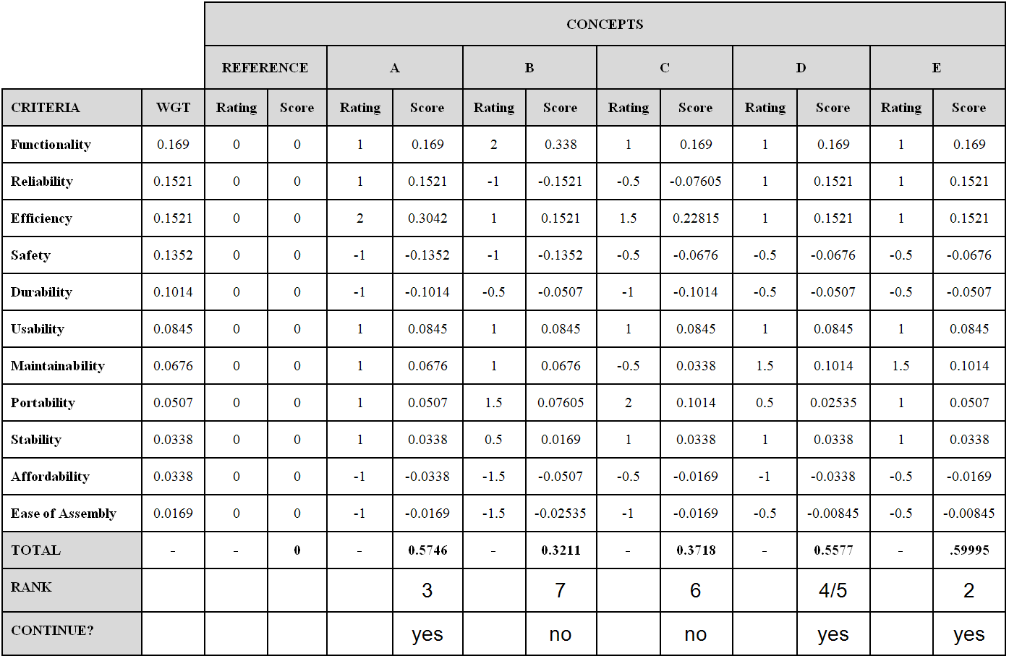

Table 14: Weighted Decision Matrix Part 1 (No Recursion)

*Note: Rating on a -2 to +2 Scale

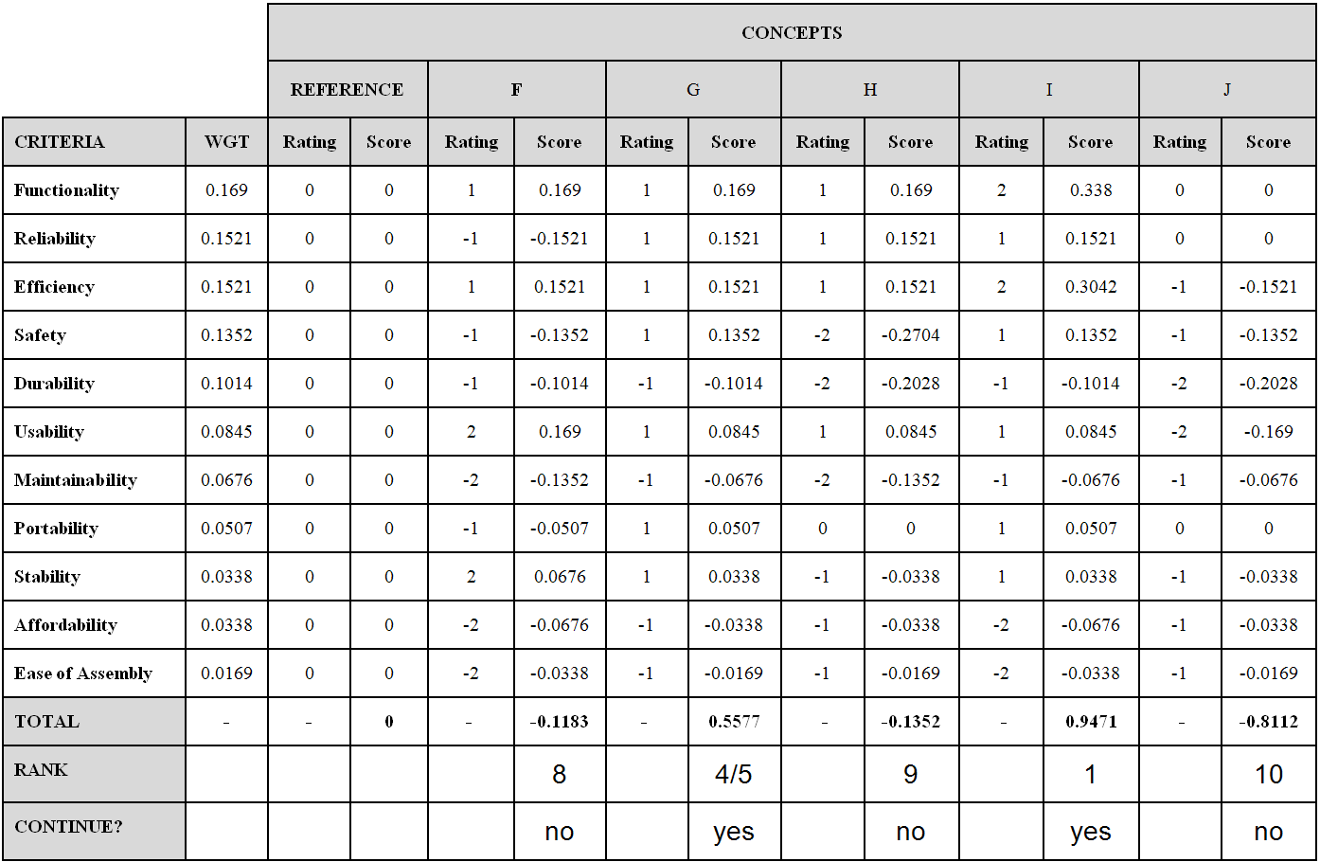

Table 15: Weighted Decision Matrix Part 2 (No Recursion).

*Note: Rating on a -2 to +2 Scale

### 4.6.1 Concept Refinement

The concepts that were decided to be carried out with were concepts I, E, A, D, and G (in descending order). This was done as there was a distinct cluster of high scoring concepts evaluated on the first WDM, thus is was decided that the concepts included in this group be carried forward to refinement. The next stage was to refine the concepts.

How the concrete is actually mixed is the most important differentiating factor between the different concepts, since this is what it is supposed to do and the mechanism behind it is of prime importance. Concepts E, A, and D all rocked the concrete to mix it, so they were combined into a single concept that had the best features of the 3. On I and G, known as I1 and G1, improvements were done by addressing the worst features and improving them.

#### 4.6.1.1 Concept EAD

Concepts E, A, and D all scored similarly in the WDM, so rather than addressing the individual scores, the best way to refine it would be to select the best subsystems of the 3. The resulting combination of embodiments is shown below:

Drain pipe, paddles, carriage, chute, wood exoskeleton, windmill handle, human control

* Containment: a drain pipe is the cheapest and serves the function well. A custom formed bathtub style containment system offers no real benefits, while a cloth hammock is very difficult to get concrete out of. Try to empty pudding out of a Ziploc bag.
* Mobility: the carriage system was continued since it was better than casters. Casters cannot be made larger without raising the height of the overall product, and are useless on rough terrain that would be encountered on a construction site.
* Delivery: a chute gives the opportunity to direct the concrete as it is poured. Inversion is worse since the whole containment system must be upended to get the concrete out.
* Structural: wood is cheap and easily worked, while plastic is more expensive. A wooden exoskeleton consisting of wooden panels bolted together forms the structural system.
* User interface: a windmill handle is all that is required, since all other embodiments are more complicated and are not necessary for a simple paddles motion. Unlike a lever, the windmill handle gives extra handles to grasp when rotating, rather than having to reposition one’s whole body to continue using it as it moves towards or away.
* Control: human control is best for a human powered system. A person can judge how the machine is working and make adjustments on their own, without any mechanical counters of any sort.

#### 4.6.1.2 Concept G1

Drain pipe, agitator, carriage, chute, metal endoskeleton, crank, fatigue control

Concept G scored poorly on maintainability, durability, affordability, and ease of assembly. Maintainability and durability are connected, since poor durability will require frequent maintenance. Poor maintainability partially stems from the flap/trap door dumping mechanism. Since the concrete is mixed in a drain pipe, this embodiment is redundant, since the drain pipe can act as a chute to dump the concrete. This results in one less component to break or maintain, improving both. The poor durability is caused not only by that, but also the casters, which perform poorly in rough terrain. The best way to address this is to mount the mixer onto a carriage, which has only 2 wheels mounted on an axle, rather than the swiveling casters which are smaller, have space for dirt to accumulate, and are overly complex for the task at hand. Both of these changes result in better affordability and ease of assembly, since there are less components to buy and assemble. The resulting concept is shown below:

#### 4.6.1.3 Concept I1

Bucket, spinning vessel, carriage, inversion, metal endoskeleton, rotary handle, human control.

Concept I was the best concept so far, since it had the most efficient mixing mechanism. Despite being simple to use and efficient, it was costly and difficult to assemble, requiring many moving parts. As previously, the casters are replaced with a carriage to make it more durable, easier to assemble, and cheaper, since only 2 wheels are required. The mechanical counter is complex and would be difficult to install since it would have to interface with the rotating bucket. It serves no real purpose and is therefore removed. The resulting concept I1 is shown below:

## 4.7 Weighted Decision Matrix* (First Recursion)

Table 16: Weighted Decision Matrix (First Recursion).

|  |  |  |  |  |  |  |  |  |  |
| --- | --- | --- | --- | --- | --- | --- | --- | --- | --- |
|  |  | **CONCEPTS** | | | | | | | |
|  |  | **REFERENCE** | | **EAD** | | **G1** | | **I1** | |
| **CRITERIA** | **WGT** | **Rating** | **Score** | **Rating** | **Score** | **Rating** | **Score** | **Rating** | **Score** |
| **Functionality** | 0.169 | 0 | 0 | 1 | 0.169 | 1 | 0.169 | 2 | 0.338 |
| **Reliability** | 0.1521 | 0 | 0 | 1 | 0.1521 | 1 | 0.1521 | 1 | 0.1521 |
| **Efficiency** | 0.1521 | 0 | 0 | 2 | 0.3042 | 1 | 0.1521 | 2 | 0.3042 |
| **Safety** | 0.1352 | 0 | 0 | 1 | 0.1352 | 1 | 0.1352 | 1 | 0.1352 |
| **Durability** | 0.1014 | 0 | 0 | 1 | 0.1014 | 0 | 0 | 0 | 0 |
| **Usability** | 0.0845 | 0 | 0 | 1 | 0.0845 | 1 | 0.0845 | 1 | 0.0845 |
| **Maintainability** | 0.0676 | 0 | 0 | 1 | 0.0676 | 0 | 0 | 0 | 0 |
| **Portability** | 0.0507 | 0 | 0 | 2 | 0.1014 | 2 | 0.1014 | 2 | 0.1014 |
| **Stability** | 0.0338 | 0 | 0 | 1 | 0.0338 | 1 | 0.0338 | 1 | 0.0338 |
| **Affordability** | 0.0338 | 0 | 0 | -1 | -0.0338 | 0 | 0 | -1 | -0.0338 |
| **Ease of Assembly** | 0.0169 | 0 | 0 | -1 | -0.0169 | 0 | 0 | -1 | -0.0169 |
| **TOTAL** | **-** | **-** | **0** | **-** | **1.0985** | **-** | **0.8281** | **-** | **1.0985** |
| **RANK** |  |  |  |  | **1/2** |  | **3** |  | **1/2** |
| **CONTINUE?** |  |  |  |  | **Yes** |  | **No** |  | **Yes** |

*Note: Rating on a -2 to +2 Scale

### 4.7.1 Concept Refinement (First Recursion)

Concept G1 scored the worst and was dropped. This is because mixing the concrete in a container with an agitator is less efficient than the others and also less functional. There are two reasons for this: the linear relationship between mixing rate and effort, and the localized mixing.

Mixing something with an agitator can be expressed with a simple equation of C = SR, where C is the mixing rate, S is the size of the agitator, and R is the rotary speed of the agitator. A large agitator can mix a larger volume, and a high speed will do it quickly. However due to the viscous nature of the concrete, more force will be required to mix more concrete as the mixing rate goes up. Therefore there’s no significant mechanical advantage gained from using an agitator compared to a shovel. The work needed is still the same. On the other hand, the spinning bucket is aided by the inertia of the bucket, while the paddles in a drain pipe are assisted by gravity.

The localized mixing is also a problem in concept G1. Unlike the other 2 concepts where the entire batch of concrete is mixed, the agitator can only mix the volume it is currently interacting with. It will then have to be moved around to mix other parts of the mass of concrete.

The remaining concepts EAD and I1 were compared against one another. Concept refinement was done by blending together concepts, essentially taking the best of the two. If that was impossible, concept refinement was done by fixing the worst aspects. A preliminary consideration was the ease of assembly and affordability could not be improved any more, since any sort of machine is more costly and harder to assemble then a simple shovel.

#### 4.7.1.1 Concept EAD1

Drain pipe, paddles, carriage, chute, metal endoskeleton, windmill handle, human control

The only way that this concept could be refined would be by changing the wooden frame to a metal one: a metal endoskeleton. No other subsystem embodiments could be improved in a way that raised a score. The metal endoskeleton is better than the wooden one for the simple reason that wood is softer than concrete and would quickly erode in the harsh condition of a construction site.

#### 4.7.1.2 Concept I2

Bucket, mixing screw, carriage, inversion, metal endoskeleton, rotary handle, human control.

Similarly, concept I2 also lacked subsystem embodiments that could be changed to yield a net positive result. Looking at the concept in detail, a rotating containment system for mixing could result in the problem where a lump of unmixed concrete is stuck in the middle and cannot be broken apart. The addition of a mixing screw around the inside of the bucket would help this and improve reliability. The improved concept is shown below.

## 4.8 Weighted Decision Matrix (Second Recursion)

Table 17: Weighted Decision Matrix (Second Recursion).

|  |  |  |  |  |  |  |  |
| --- | --- | --- | --- | --- | --- | --- | --- |
|  |  | **CONCEPTS** | | | | | |
|  |  | **REFERENCE** | | **EAD1** | | **I2** | |
| **CRITERIA** | **WGT** | **Rating** | **Score** | **Rating** | **Score** | **Rating** | **Score** |
| **Functionality** | 0.169 | 0 | 0 | 1 | 0.169 | 2 | 0.338 |
| **Reliability** | 0.1521 | 0 | 0 | 1 | 0.1521 | 2 | 0.3042 |
| **Efficiency** | 0.1521 | 0 | 0 | 2 | 0.3042 | 2 | 0.3042 |
| **Safety** | 0.1352 | 0 | 0 | 1 | 0.1352 | 1 | 0.1352 |
| ***Durability*** | 0.1014 | 0 | 0 | 2 | 0.2028 | 0 | 0 |
| **Usability** | 0.0845 | 0 | 0 | 1 | 0.0845 | 1 | 0.0845 |
| ***Maintainability*** | 0.0676 | 0 | 0 | 1 | 0.0676 | 0 | 0 |
| **Portability** | 0.0507 | 0 | 0 | 2 | 0.1014 | 2 | 0.1014 |
| **Stability** | 0.0338 | 0 | 0 | 1 | 0.0338 | 1 | 0.0338 |
| **Affordability** | 0.0338 | 0 | 0 | -1 | -0.0338 | -1 | -0.0338 |
| ***Ease of Assembly*** | 0.0169 | 0 | 0 | -1 | -0.0169 | -1 | -0.0169 |
| **TOTAL** | **-** | **-** | **0** | **-** | **1.1999** | **-** | **1.2506** |
| **RANK** |  |  |  |  | **2** |  | **1** |
| **CONTINUE?** |  |  |  |  | **No** |  | **Yes** |

*Note: Rating on a -2 to +2 Scale

### 4.8.1 Final Concept Refinement and Justification

I2 won out as the final concept. The reason for this was that mixing the concrete my rotating it inside a bucket with a mixing screw is far superior to rocking it back and forth in a drain pipe. In a drain pipe, the concrete tumbles twice per cycle, while a rotating bucket lets it tumble and therefore mix constantly.

A final level of refinement was done to ensure that the system embodiments could all be justified. The only improvement noted was the replacement of the handle with pedals and the addition of a lever to tip the bucket when dumping. The resulting concept is referred to as the final concept. The final concept uses the best embodiments of each subsystem.

#### 4.8.1.1 Containment

The bucket containment system is the best embodiment because it uses a relatively common item: any bucket, and is round, allowing it to spin to mix the concrete. This makes it compatible with all rotary mixing systems.

#### 4.8.1.2 Mixing

The bucket with mixing screw mixing system results in far superior mixing since the action involves motion and agitation along the central axis of the rotating bucket while being inexpensive, since any structural element attached to the inside of the bucket will work.

#### 4.8.1.3 Mobility

The carriage mobility system is the simplest, requiring only 2 wheels. It allows the concrete mixer to traverse uneven terrain, and can be hitched to a motor vehicle, animal, or person for long distance transport. It offers an unparalleled combination of versatility and simplicity.

#### 4.8.1.4 Delivery

The delivery system is embodied with inversion. The bucket acts as a chute since it can direct where the concrete is dumped to an extent. This effectively combines the containment and delivery system into one, simplifying the design.

#### 4.8.1.5 Structural

Of all materials, metal is the best, since it is common, relatively inexpensive, and durable. Plastic parts require molding for complex parts and can only be cheaply fastened using bolts. They are less durable than metal. Wood is inexpensive and easy to work with, yet is far less durable, especially for construction purposes, where the metal and masonry involved are harder and stronger than wood, and will easily damage it. An endoskeleton of tubular steel is the best system for structural support, since an exoskeleton of plates will require complex parts and tight tolerances to stay together, while tubular steel is common and easy to weld or bolt together to form a solid frame.

#### 4.8.1.6 User Interface

The user interface only consists of two components that totally replaced that which was in Concept I2. A lever is now used to tilt the bucket from the vertical to the horizontal position for pouring. It is the simplest way to do this. Pedals are used for power, since they are the most efficient form of harnessing human power, much better than a rotary handle. Human legs are powerful and capable of working for a long duration while being resistant to repetitive strain injuries, unlike arms which are much weaker.

#### 4.8.1.7 Control

The machine is human powered, so no electronic control system can be used. The task of mixing concrete is conceptually simple, so no mechanical control system is also required. Controlling the machine can be done using simple human judgement, where the speed and duration of mixing is determined by the operator, with both being limited by the operator’s physical capabilities and resistance to fatigue. Physical properties like inertia assist in maintaining speed during mixing, since a heavy drum will continue to spin from its own inertia assuming minimal friction.

#### 4.8.1.8 Fulfilling Requirements

The product requirement specifications were prepared in milestone 1. These requirements will be fulfilled by the final concept, I2. This is done by the embodiments that provide a physical representation of the systems prepared in the product architecture specifications. These specifications were created in a way that address the requirements and the product characteristics; the final concept must therefore fulfill all of the requirements that were set along the way in the design process as each subsequent step relies on the information and definition of the one prior.

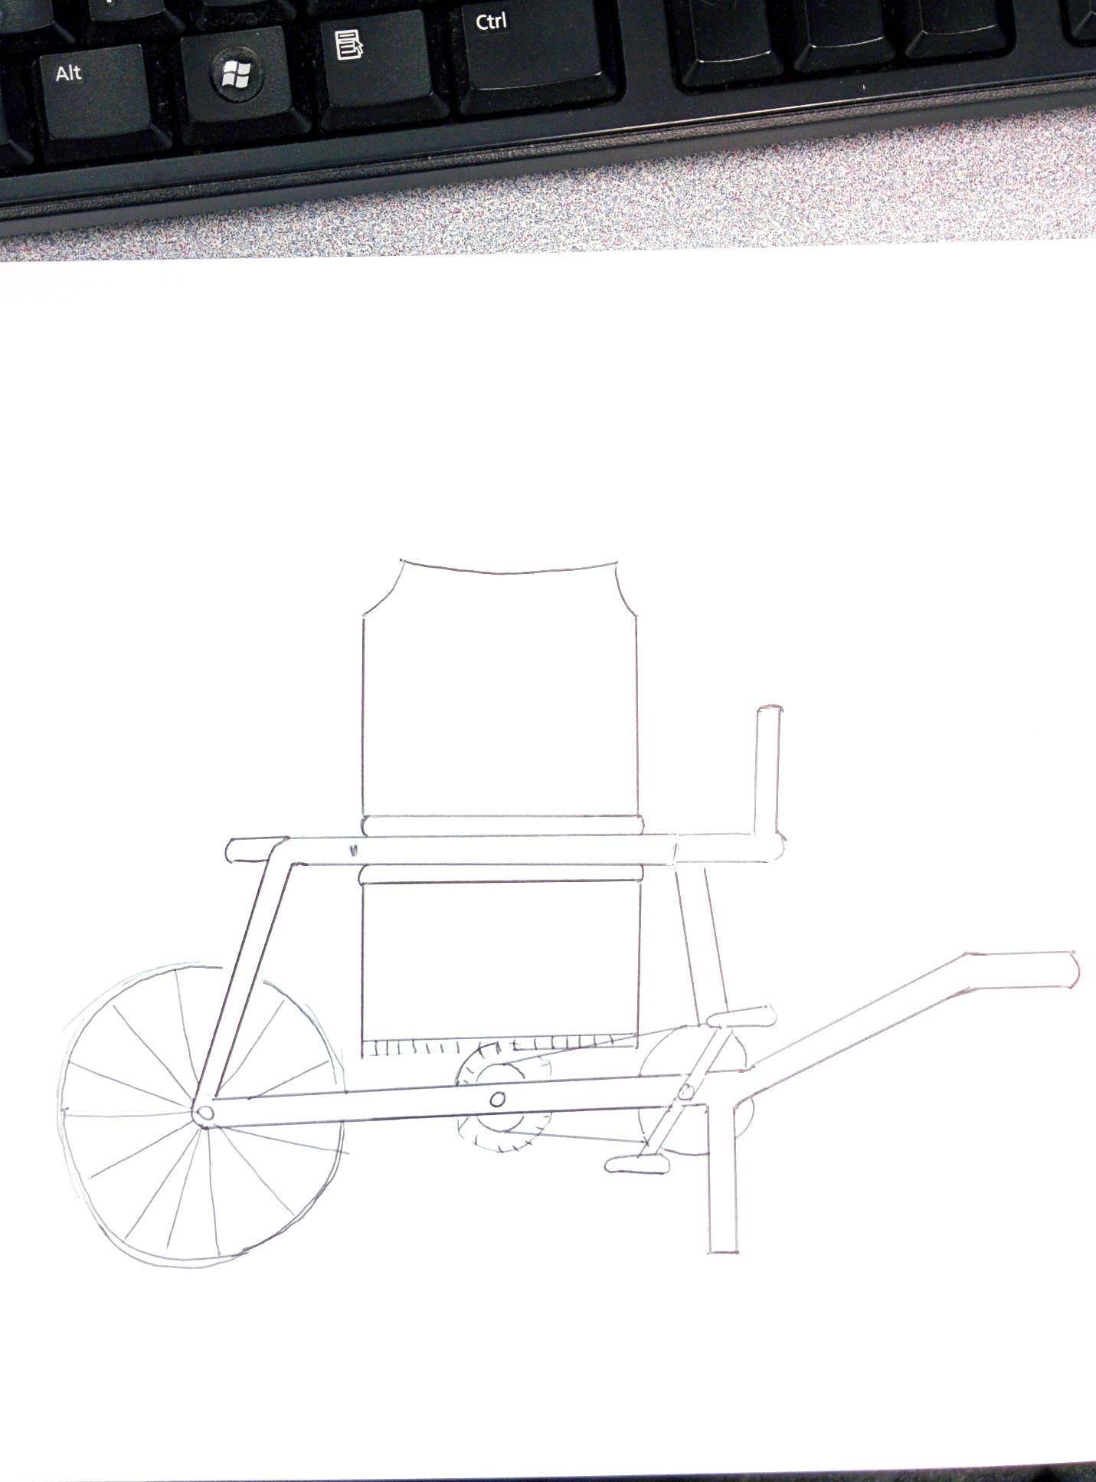

Figure 19: Final Concept Design.

# 5.0 Final Concept Detailed Design Information

## 5.1 Part Selection

The part that will be used for the mixing drum is a chemical drum. This is because it can be repurposed for use in the mixer as well as being a water-tight container, which was dictated by the functionality product characteristic.

The parts that will provide for delivery of human power to the mixing system were required to be efficient and ergonomic. This can be accommodated through using a bicycle frame along with its pedals and chain drive system attached. This allows for both an effective power delivery method as well as simplifying the amount of labour required to assemble the mixer. This is because there is no need to assemble and manufacture an additional structural system for the power delivery.

In addition, the frame of the mixer will consist of a carbon steel chassis from a car, specifically a Toyota Land Cruiser 70 Series in addition to using car tires as a part of the mobility system.

## 5.2 Part Design

The structure of the mixer will be made from tubular carbon steel as is has the benefit of strength with a lower weight than a solid steel bar would have. This material will also be used for the handles and front support of the mixer.

## 5.3 Material Selection

The material selection in any design are critical as they dictate what the physical response of the product will be to any applied load, motion, or change in temperature. Failure to adequately select materials can lead to failure of the system and possibly the entire system.

The material selected for the structural system will be carbon steel taking the form of a used car chassis. This is because of the affordability, ease of machining, and availability that is inherent to this particular steel. In addition, carbon steel is among the stronger materials that are available, the main alternative being wood. This is in accordance to the affordability and durability product characteristics that were specified in the initial design of the mixer.

## 5.4 Optimization

The optimization of this design involved the refinement of the mechanisms that were used to mix and deliver the concrete as well as the ones that allowed for the mixer to move from place to place. This was done by optimizing gear ratios and determining the amount of torque necessary to deliver the concrete to the wheelbarrow and lift the mixer enough to move it.

## 5.5 Operational Considerations

The operational considerations taken into account are numerous. These are critical as they impact the performance and the degree to which the product characteristics are fulfilled. One operational consideration was to tilt the mixing drum to provide for a better mixing system. The initial concept had the mixing drum positioned vertically, which would cause difficulties as the heavy concrete would be difficult to mix in that orientation. An angle of 45 degrees was specified as the concrete would mix easier.

Another consideration that was taken into account was to have a long handle to tilt to deliver the concrete to the wheel barrow. This was to amplify the human power that would be used to tilt the drum as the moment is larger when the distance vector is increased. In addition, the mixing drum is tilted about its center, therefore the amount of torque required to tilt the drum will be minimized.

One more operational consideration taken was to use a ring and bevel gear to spin the drum and, using the internal fins, mix the concrete. This is another way that the mixer fulfils the product characteristic of amplifying human power to mix concrete. The rotational motion is brought about by using pedals and spinning an axle connected to the chain drive of the bike.

Another operational consideration that was made was to design the handle length in a way that maximizes the applied moment about the pivot point. This was done because the less force required in lifting to move the mixer from place to place, the better.

One final operational consideration taken was to aid the concrete in being poured out. The concrete will be poured from the mixing drum directly into the wheelbarrow as the beaded lip of the chemical drum will provide sufficient means for the pouring to occur.

## 5.6 Human Factors Considerations

An important factor to consider in the design of any product are ergonomics, or human factors. These are important as it is advantageous to have the user able to operate the concrete mixer in a way that does not produce excess strain on them. This is done in several ways, such as designing user interfaces, such as hand holds, to be used at the appropriate heights.

One such factor that was taken into account was the sitting knee height of the user. This was used to design the height that the hand holds sit off of the ground to be used for moving the mixer. The height that was taken was the upper end of the male sitting height, the 95th percentile. This came to be 567 mm [18]**.** The 95th percentile male was used because the way that the mixer would be lifted requires the user to first squat down and lift using their leg muscles. The more height above the ground that the knee is, the more that the user would have to bend down to lift it. The 95th percentile male, the greatest knee height that can be reasonably designed for, was taken into account as the shorter users would not have to bend down as much. This was a constraint as it is better to lift with the knees bent at or less than 90 degrees. The sitting knee height perfectly captures this as the knees in this dimension are at 90 degrees.

The frame of the mixer is to be painted with a visible and bright colour. This is to provide easy visibility and improve the safety of the mixer.

Another consideration that was taken was to how the user will deliver power to the mixing system. The concept that was used to deliver power consists of pedals. The ergonomic consideration that was taken was to use a bike frame and seat. This employs the use of human factors as a bike frame is designed in a way that the power is delivered efficiently and ergonomically. The solution was to mount the bike frame to the frame of the mixer.

One more ergonomic consideration was the usage of hand grips on the end of the handles such that the user will be able to lift and move the mixer. This is because the grips prevent hand slippage as well as allow for the hand to grip the handle in a more ergonomically pleasing way.

## 5.7 Environmental Considerations

One other consideration that was made in the design of the mixer was to take environmental impacts into account. Some design criterion that improve the impacts of the mixer on the environment include the re-use of parts, such as the bicycle frame, car chassis, wheels, and mixing drum. This improves the impact that the mixer has on the environment as the re-use of parts allows them to be used, rather than discarded.

## 5.8 Maintenance Considerations

Maintenance considerations were made to allow for better maintainability as well as cleaning of the mixer. This is critical as the nature of this product was to ‘bootstrap’ the problem of not having existing infrastructure. The maintenance of this part is critical as this mixer should serve the needs of creating infrastructure until other, more conventional, alternatives are available. In addition, the product characteristics state that it would be preferable to have a maintained and repairable mixer rather than one that will require replacement.

The cleaning of the mixer will be done through removing all waste concrete from the mixing drum using water and hand tools, such as trowels and shovels. The consideration taken to accommodate this was to allow for the drum to tilt to allow for the removal of all waste material. This was also done to allow the concrete to be delivered to the wheelbarrow.

Another maintenance consideration taken was to have the structure of the mixer painted. The protective layer of paint will prevent water, which the mixer will frequently be exposed to, from corroding the structure of the mixer.

## 5.9 Manufacturing and Assembly Considerations

The manufacturing of this mixer is another critical process. The mixer must be able to be made within the means that were specified in the outset of the mixer’s design. The assumption made was that the manufacture and parts of the mixer provided by the client and the client would have access to a machine shop. This means that considerations have to be made such that the mixer can be manufactured within the aforementioned environment.

The structure of the mixer is to be made from carbon steel, specifically tubular 2 inch stock. This is because of the machinability, availability, and relatively low expense of carbon steel. The machining of carbon steel requires less specialized tools than a harder material, for example titanium, which are not as readily available in the environment that the mixer is going to be manufactured.

The assembly of this mixer will necessarily be simple and straightforward. This is because the product characteristics of this product specify that the mixer shall be easy to assemble. This will also fulfil the requirement of allowing for easy disassembly.

This was taken into consideration when the number and type of interfaces that were between the parts, as well as what types of joining, such as fastening or bonding, were used to achieve said interfaces. In addition, the total number of discrete parts were minimized where easy assembly and manufacturing would benefit from this.

## 5.10 CAD Model Renderings of Final Concept

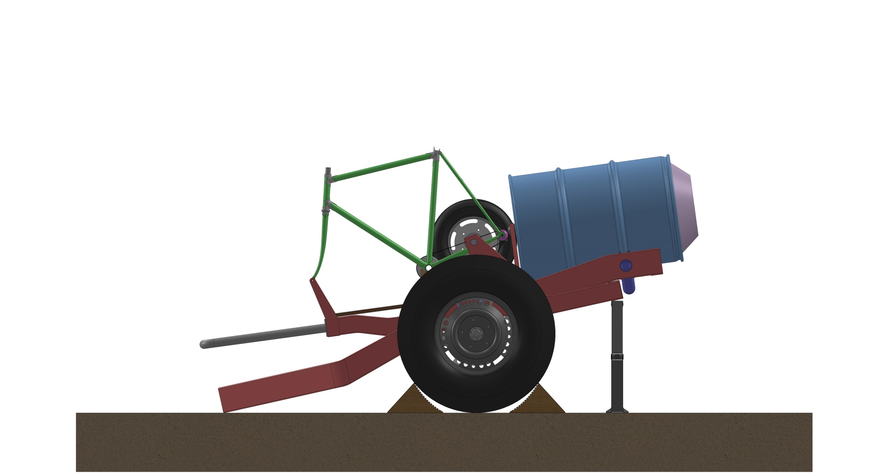

Figure 20: Concrete Mixer in Loading Position Side View.

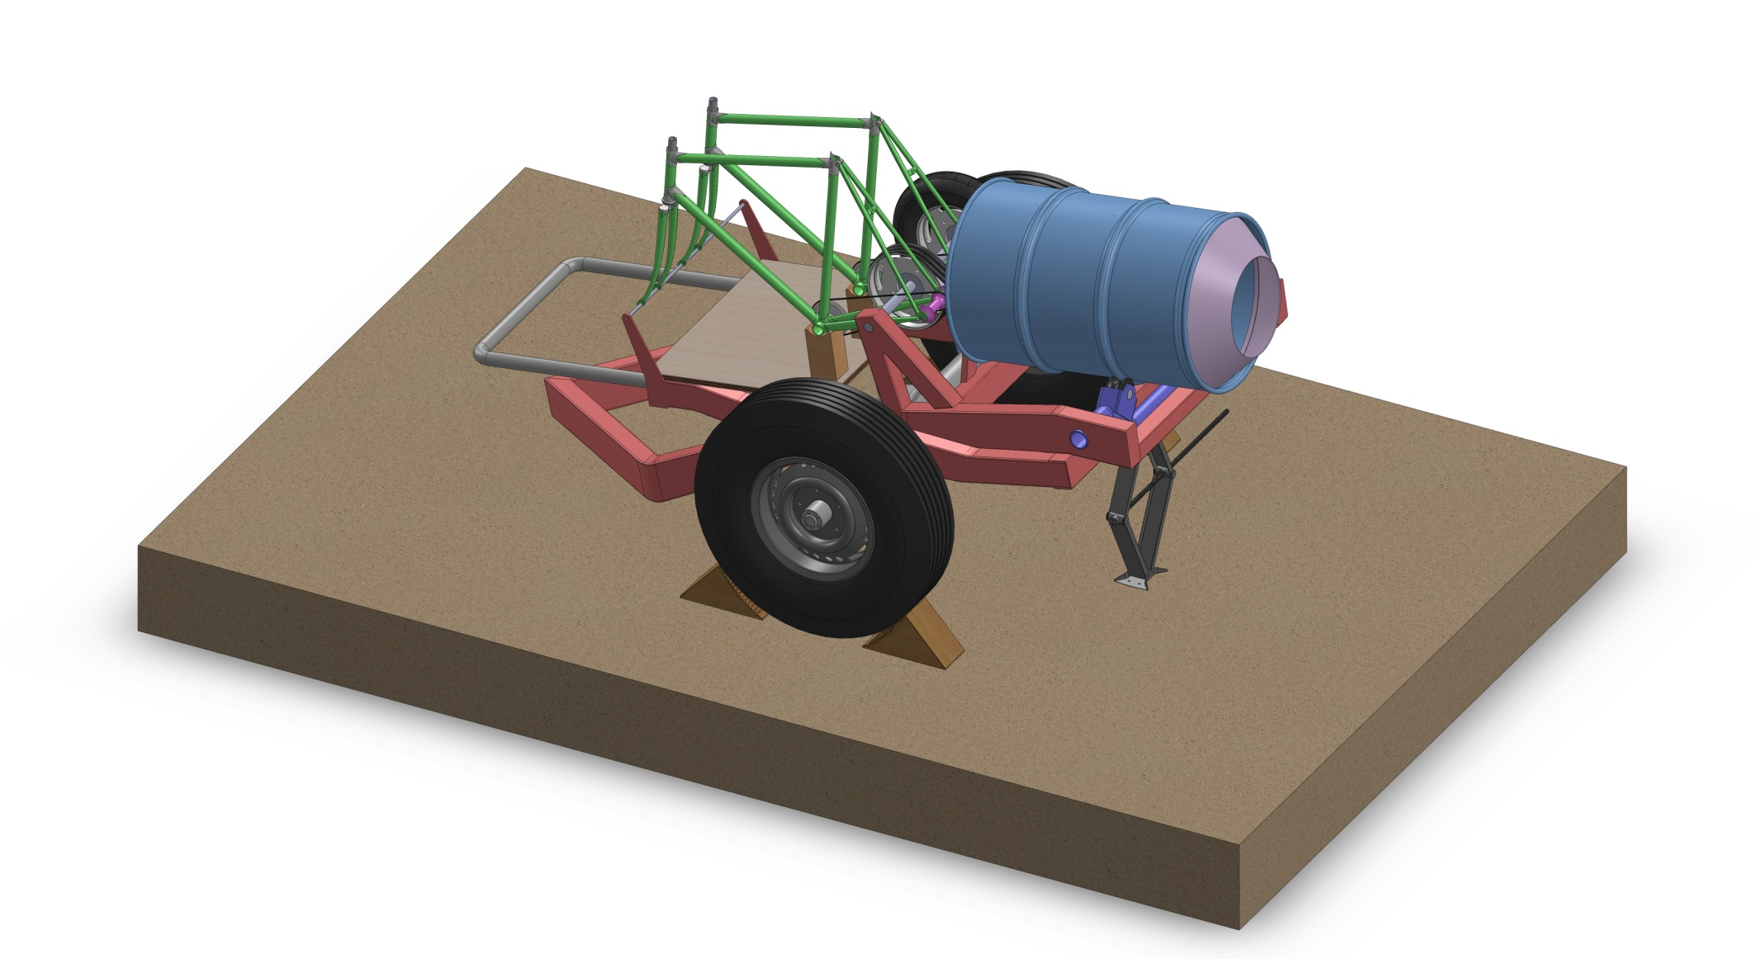

Figure 21: Concrete Mixer in Loading Position Dimetric View.

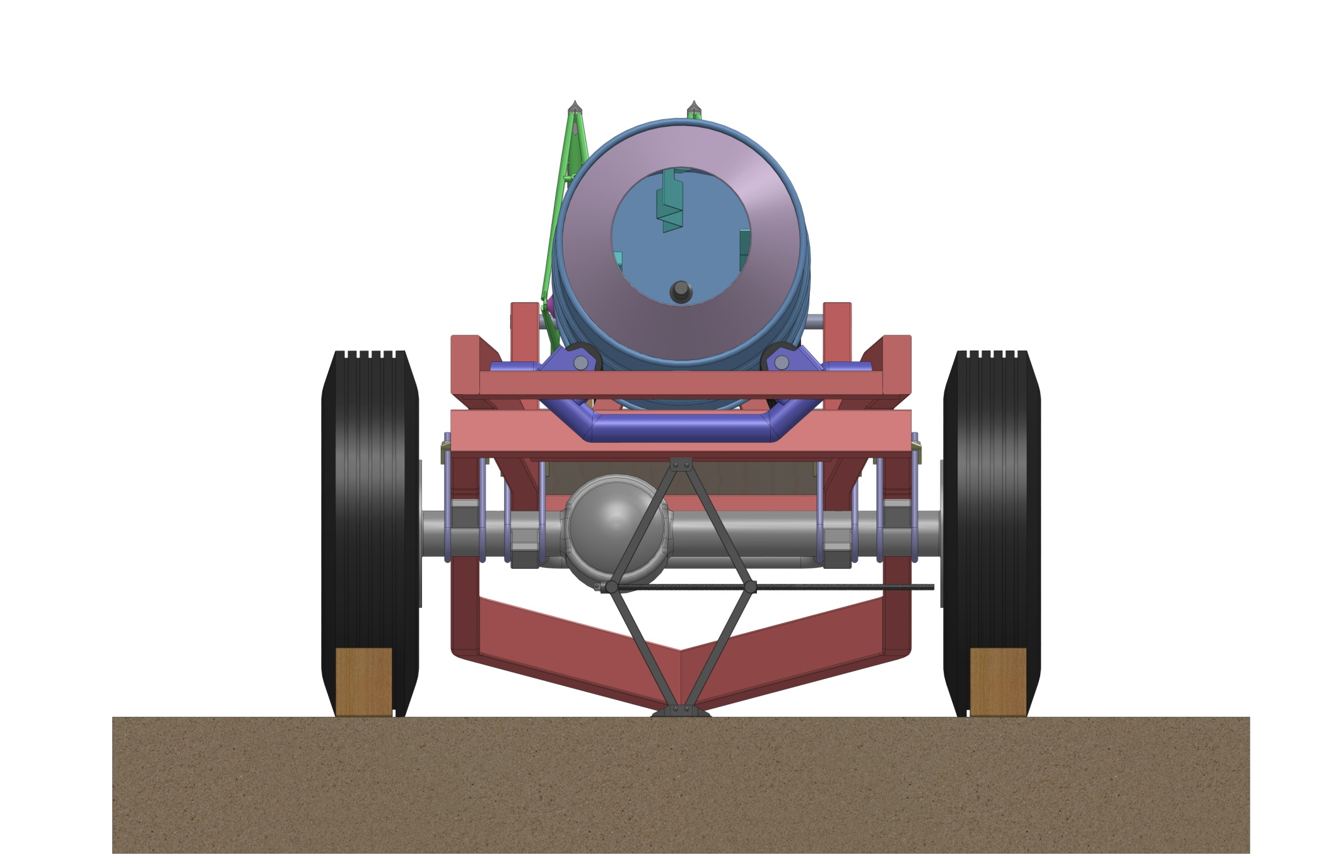

Figure 22: Concrete Mixer in Loading Position Front View.

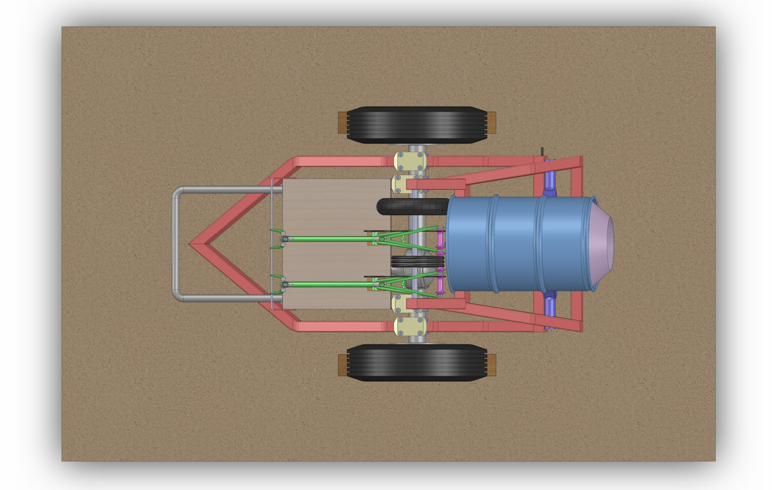

Figure 23: Concrete Mixer in Loading Position Top View.

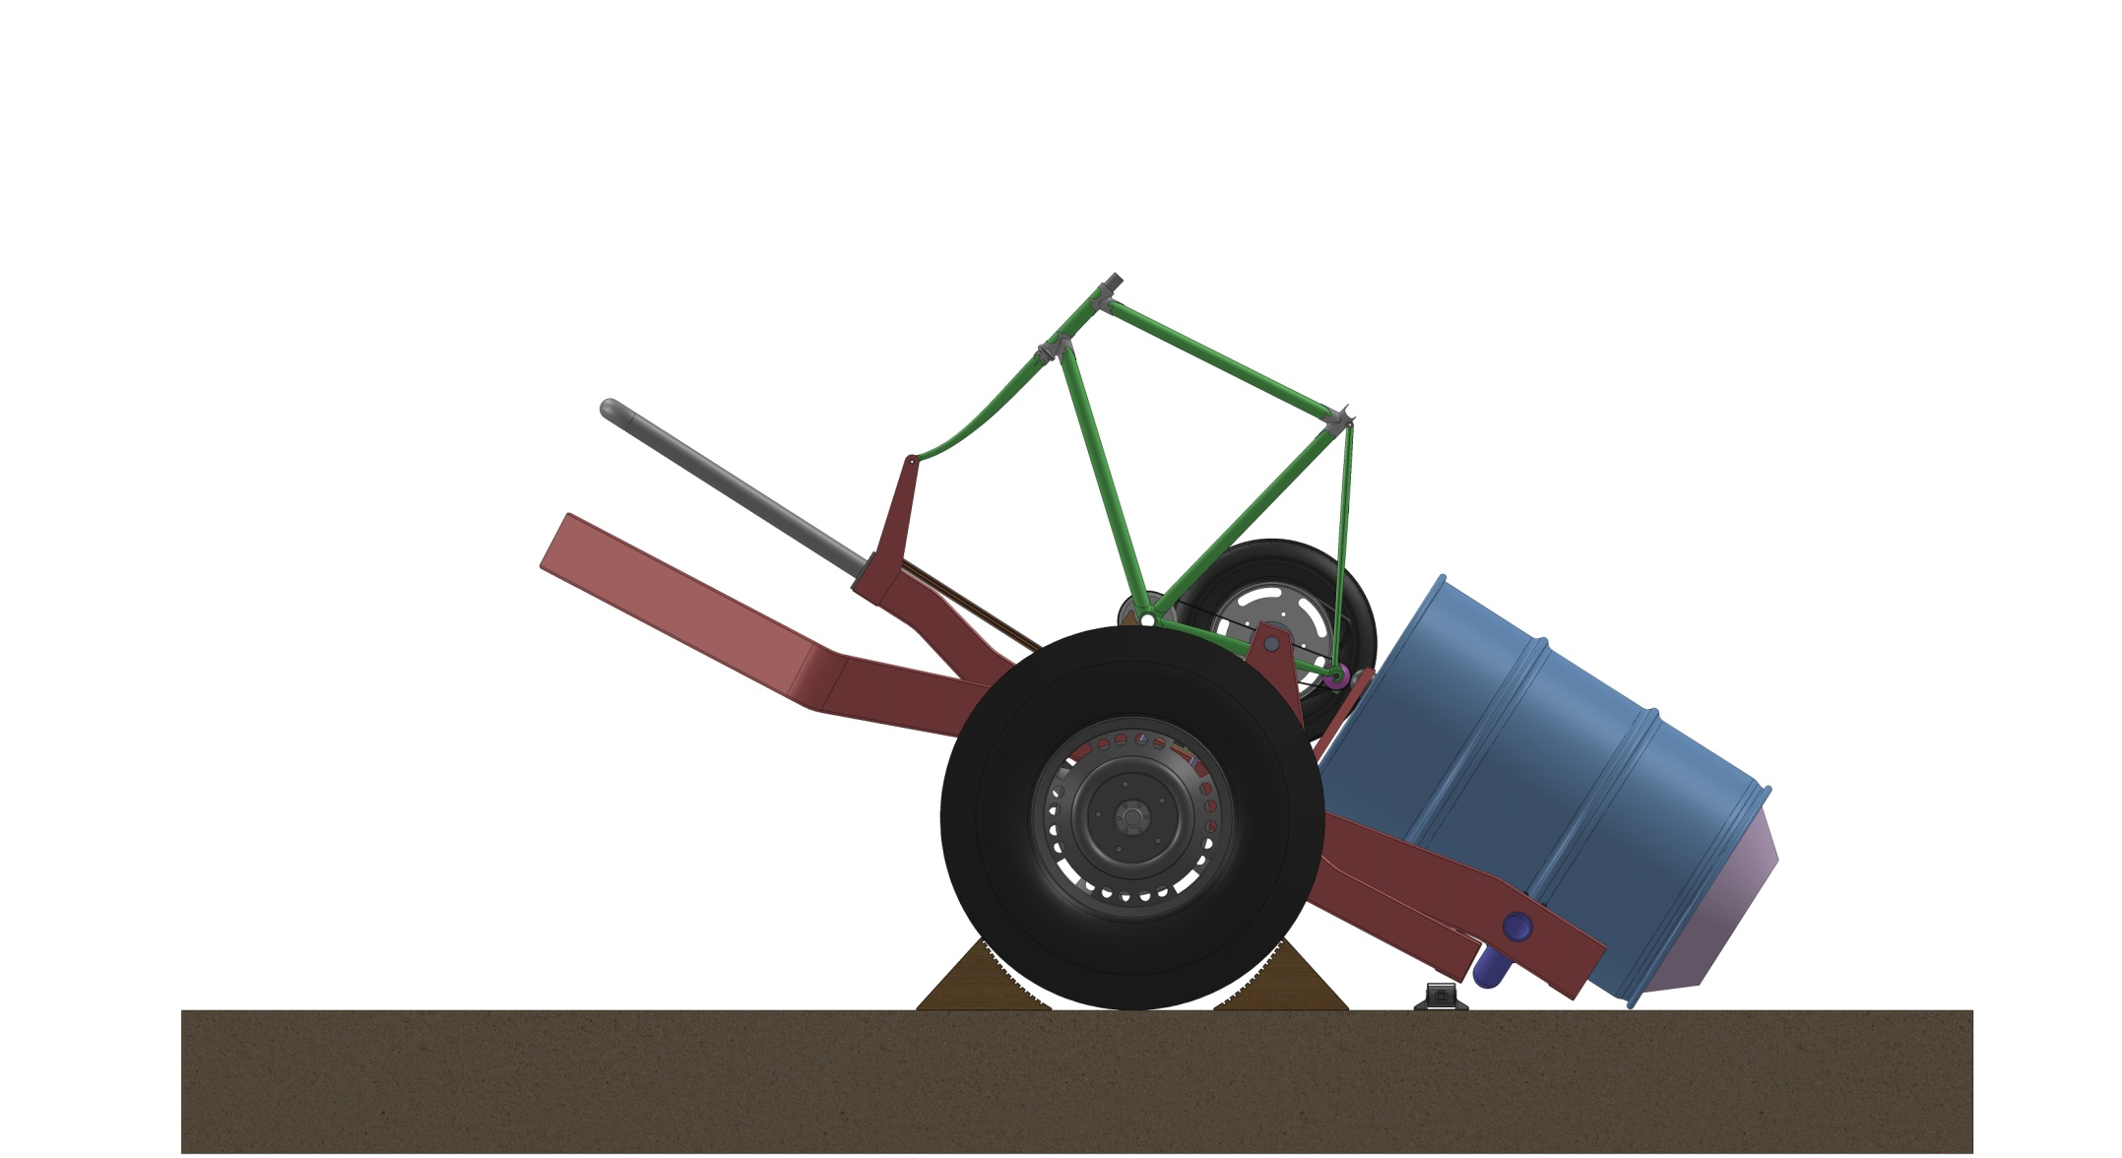

Figure 24: Concrete Mixer in Unloading Position Side View.

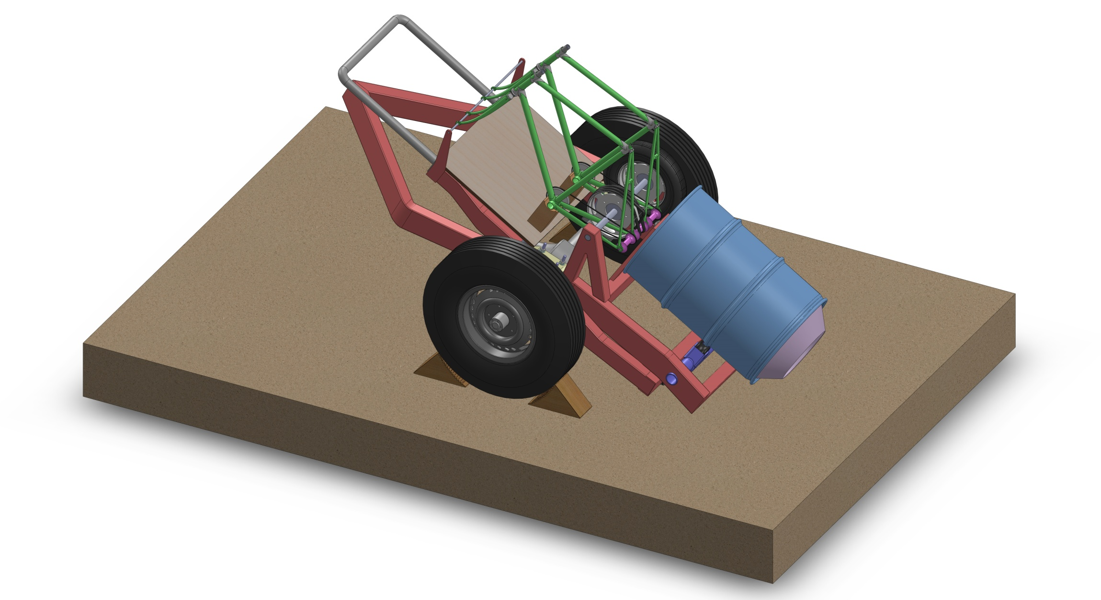

Figure 25: Concrete Mixer in Unloading Position Dimetric View.

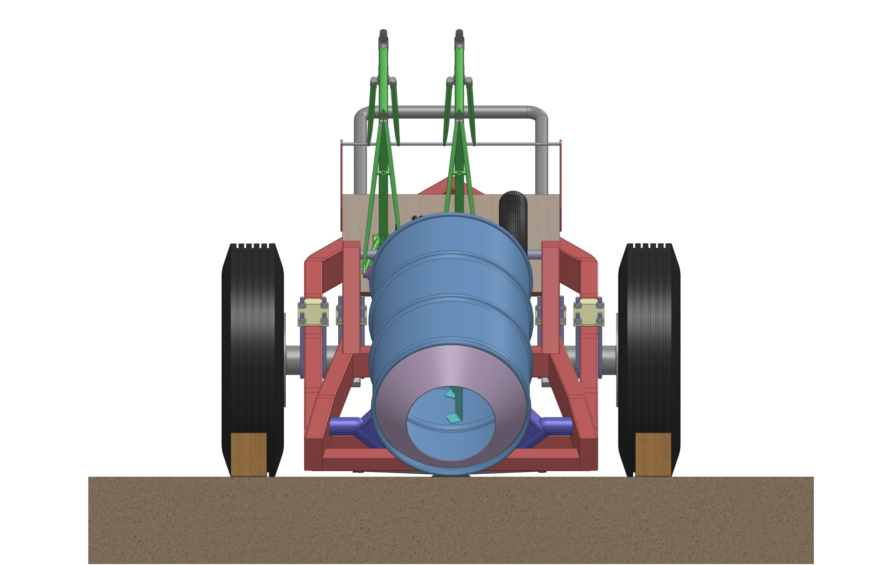

Figure 26: Concrete Mixer in Unloading Position Front View.

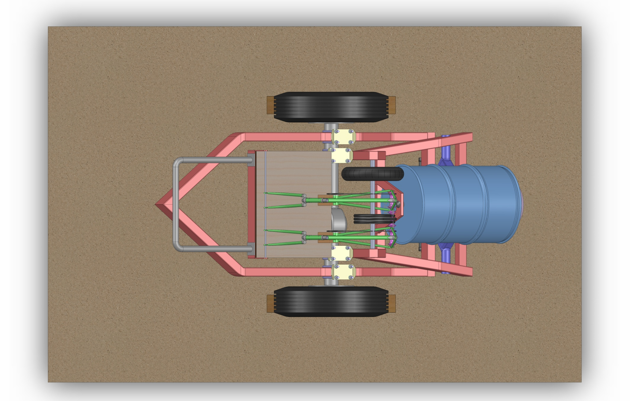

Figure 27: Concrete Mixer in Unloading Position Top View.

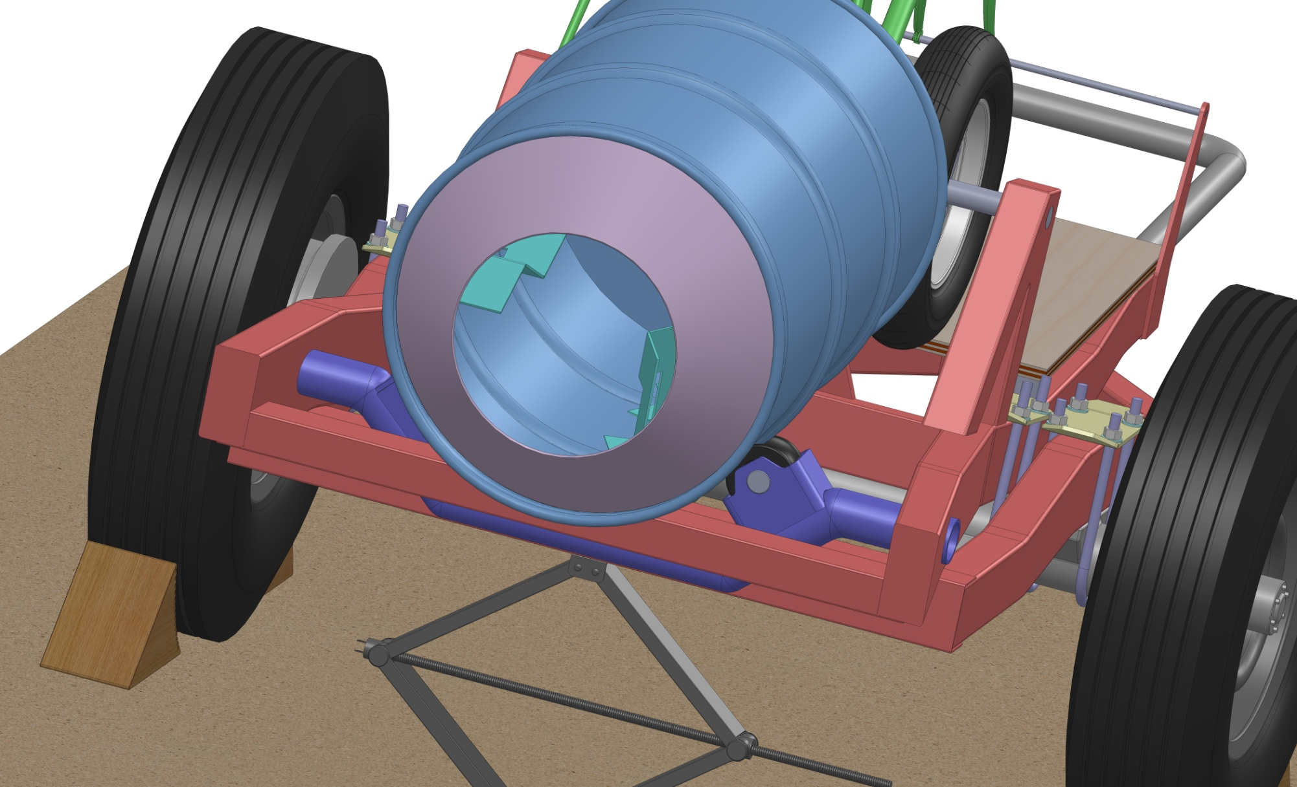

Figure 28: Concrete Mixing Drum Detail.

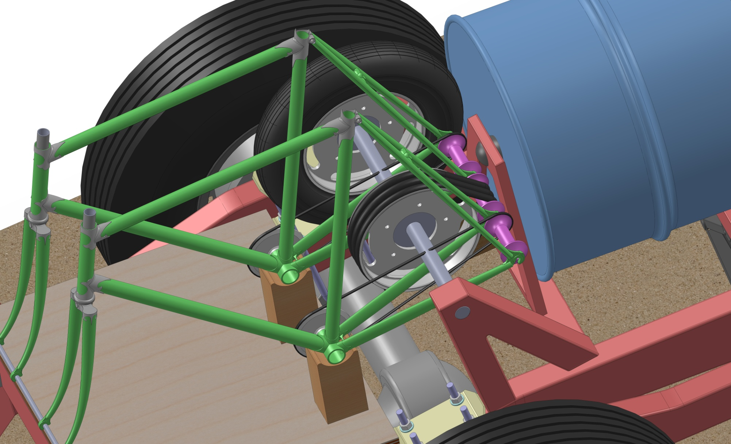

Figure 29: Friction Powertrain Detail.

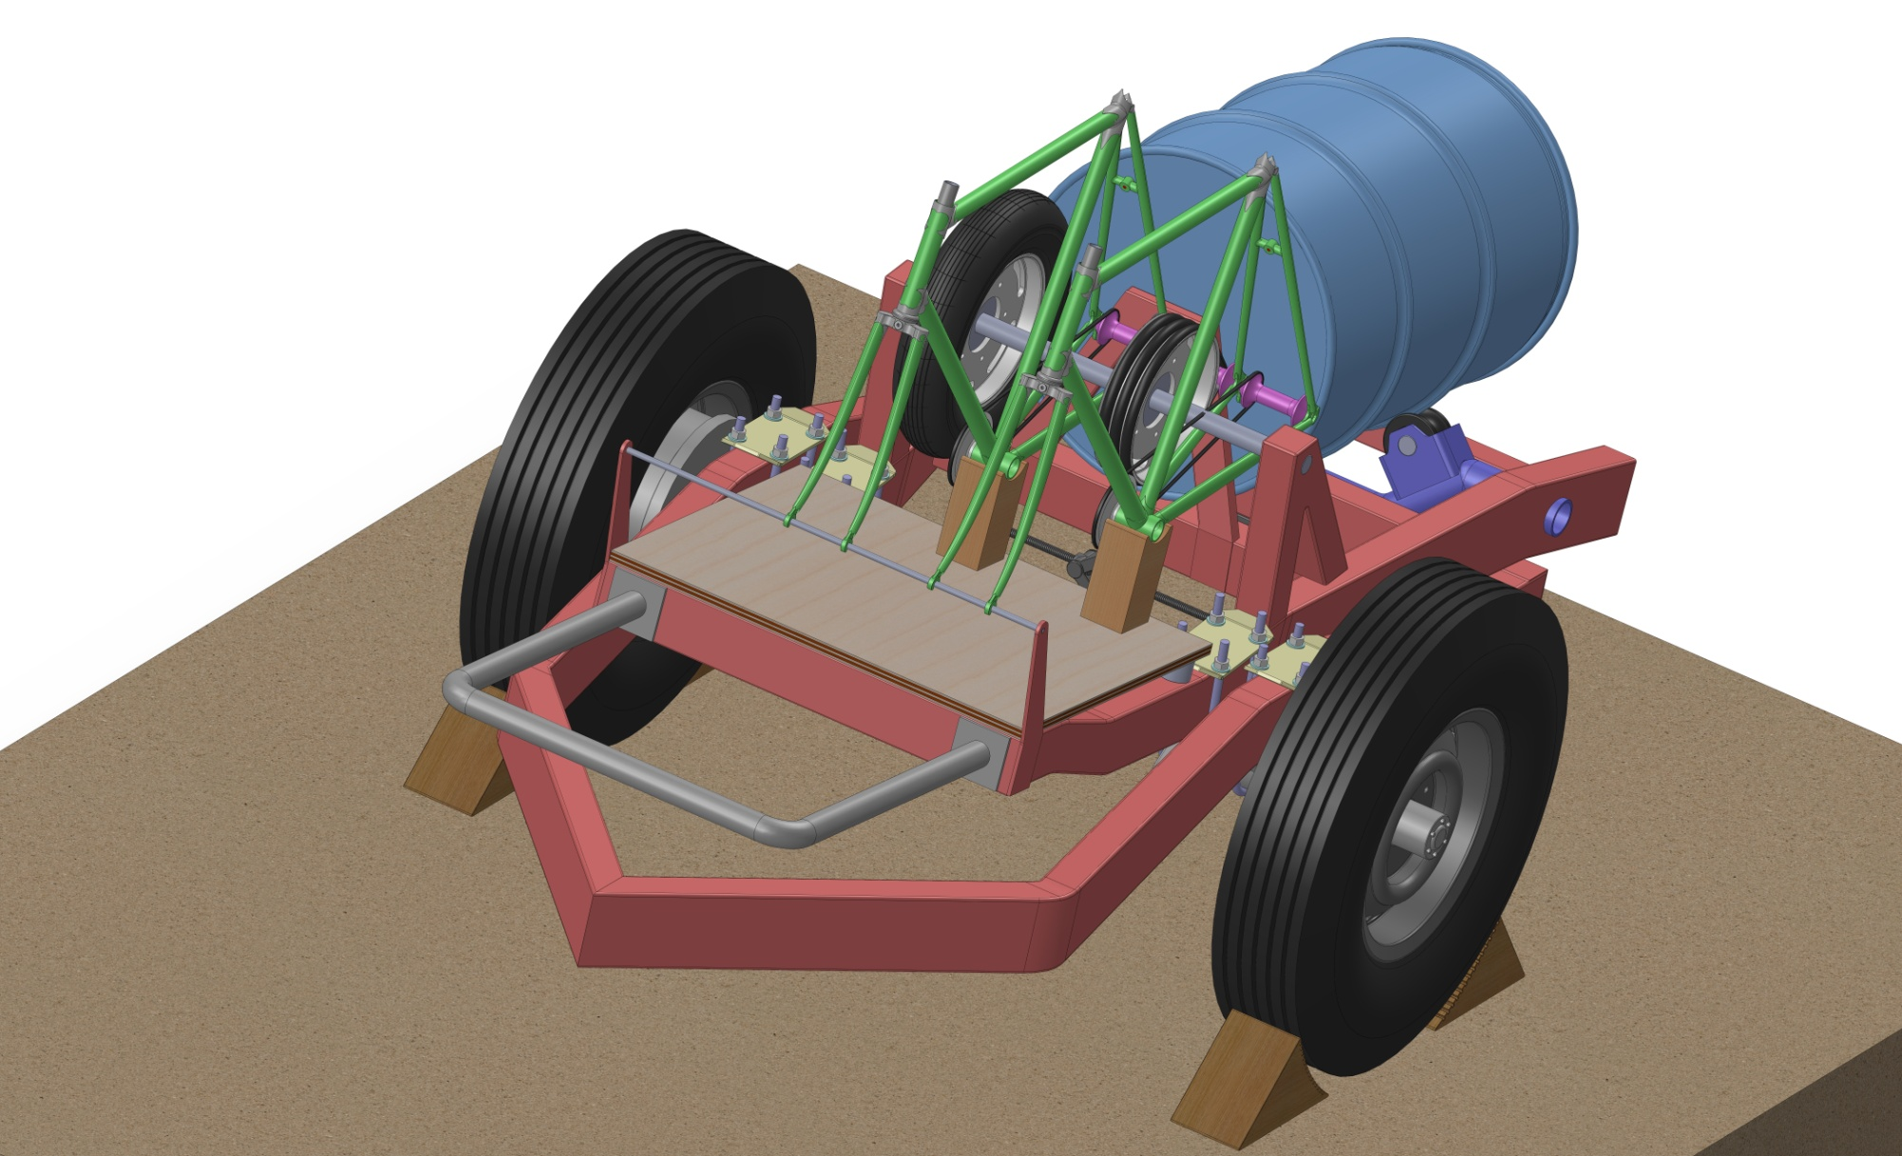

Figure 30: Concrete Mixer Rear Trimetric View.

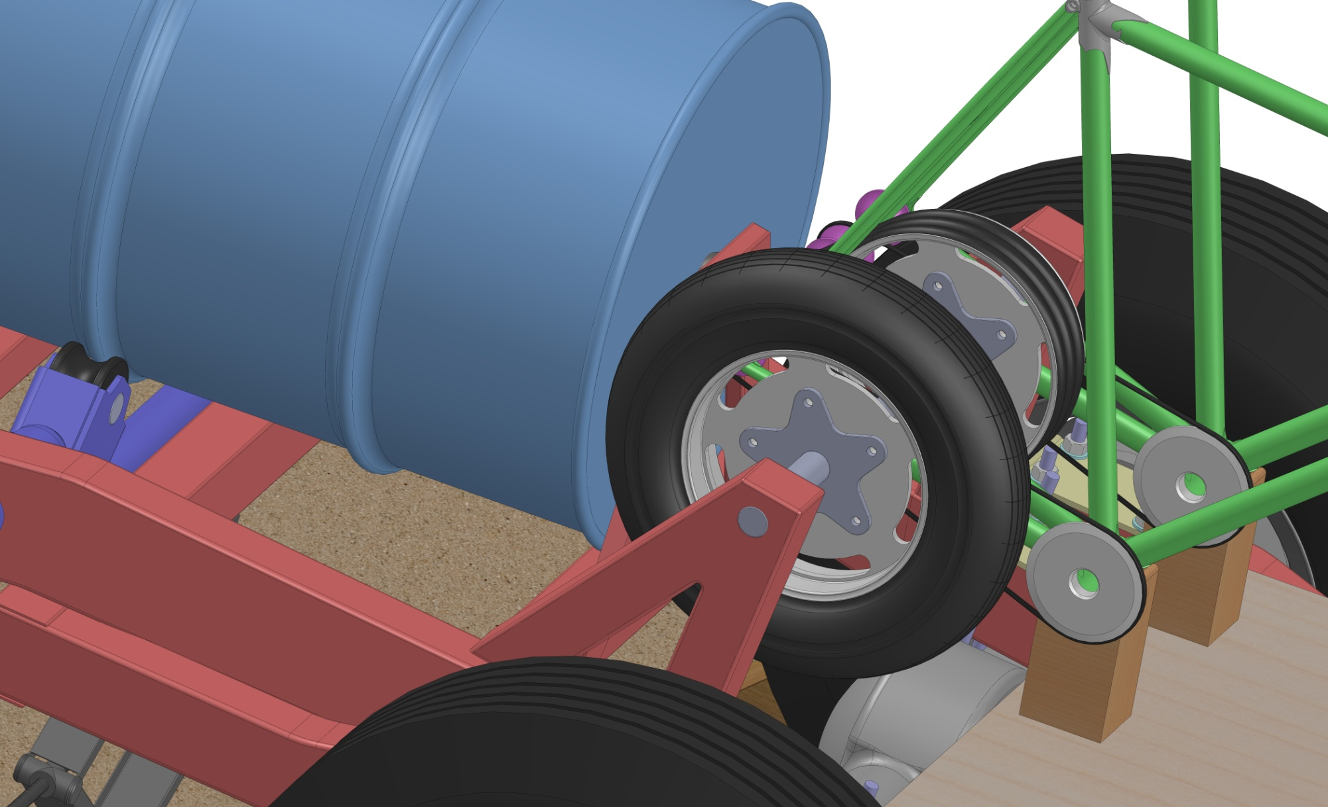

Figure 31: Friction Drive Revealed.

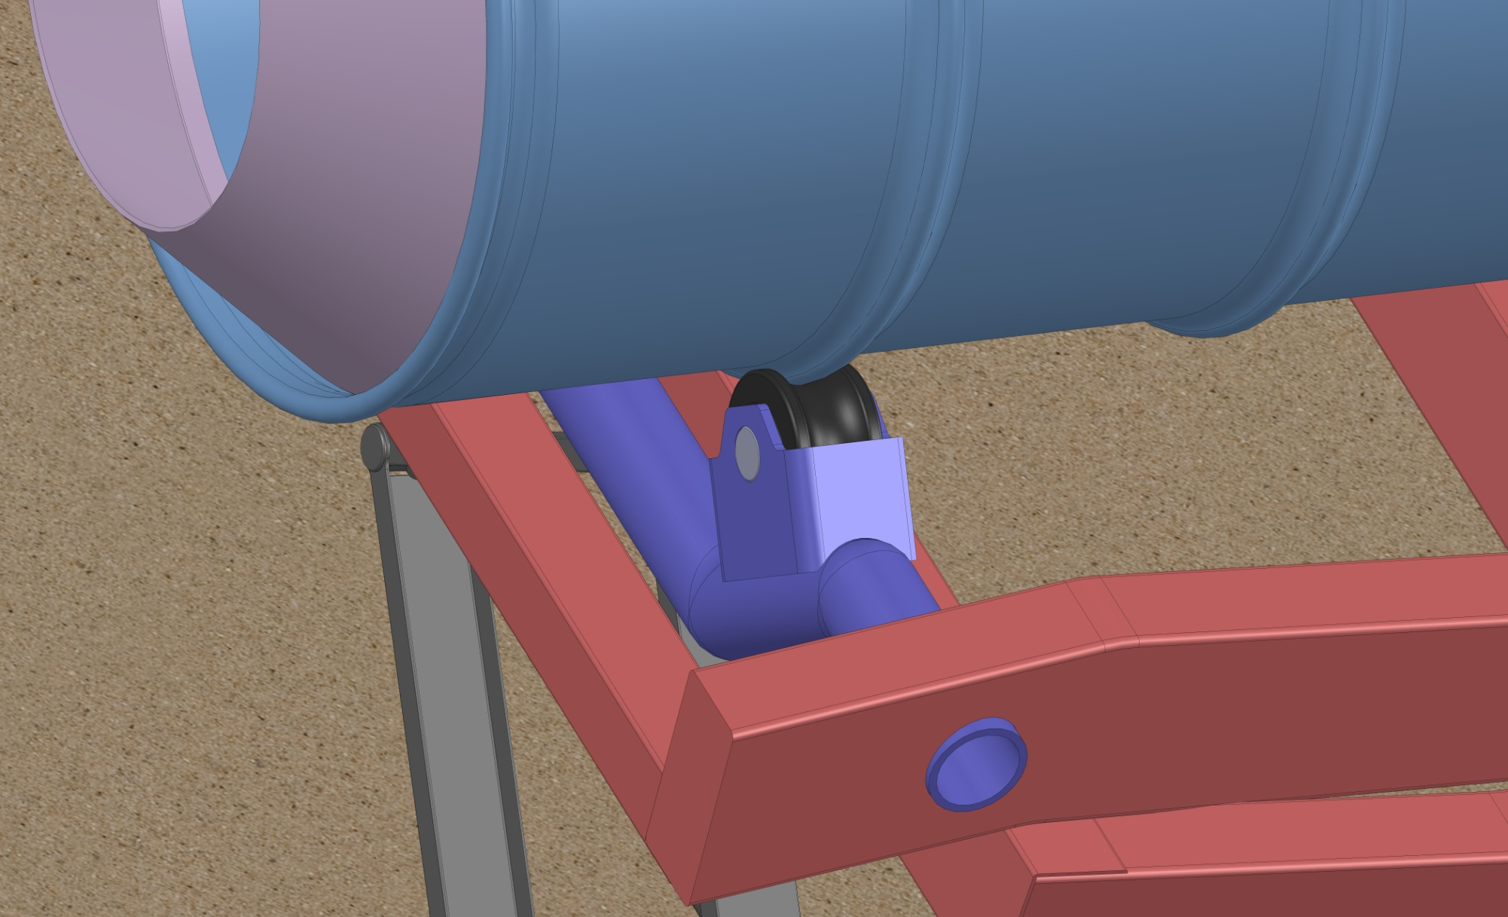

Figure 32: Drum Roller Bearing.

Figure 33: Drum Roller Support.

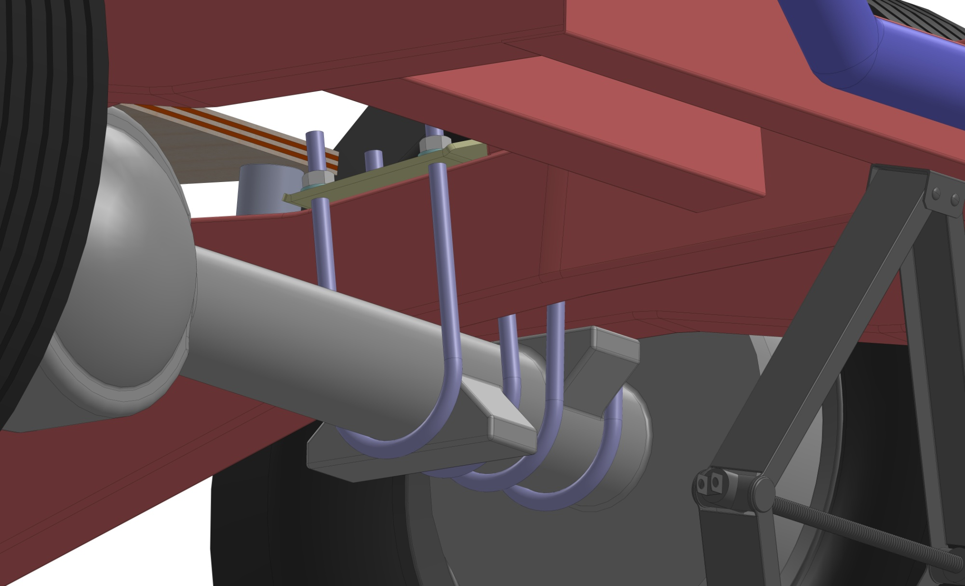

Figure 34: Revamped Axle Mounting Locations.

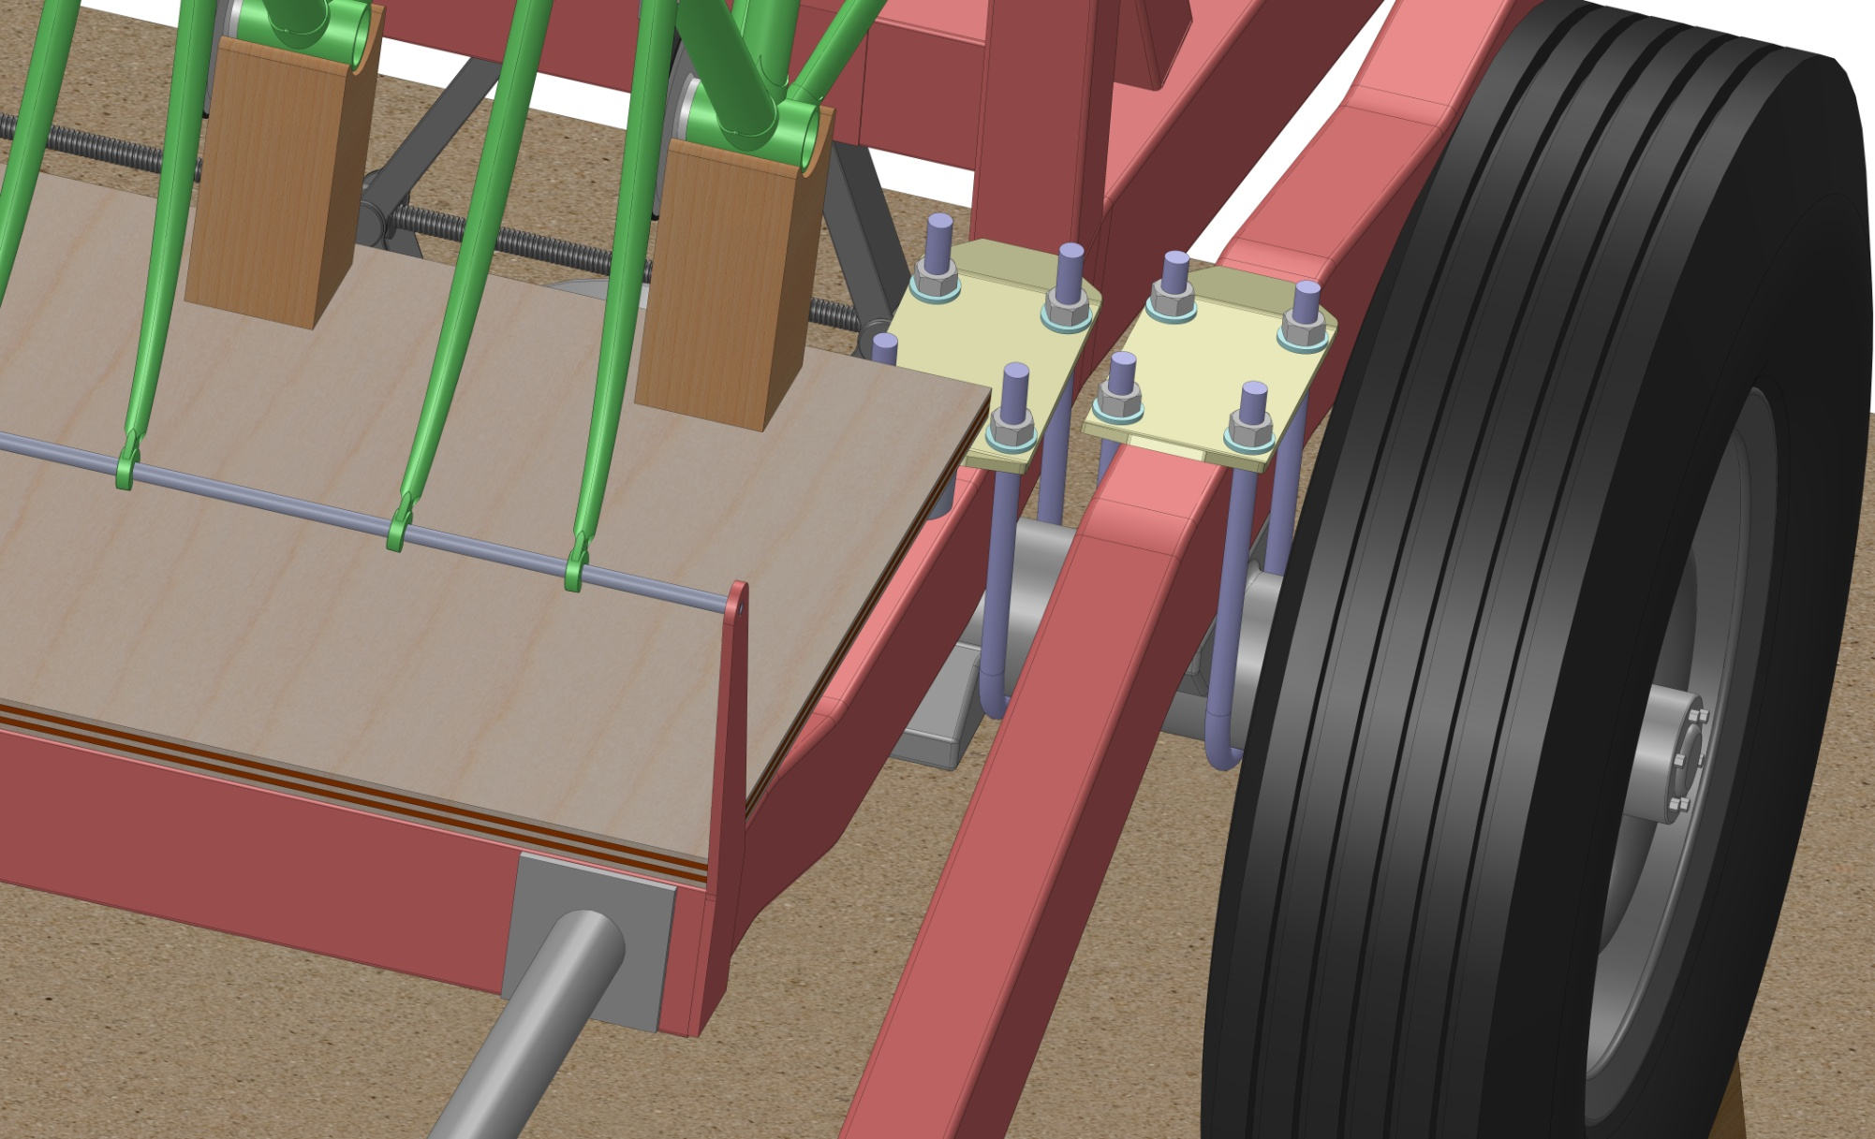

Figure 35:Axle Close-up.

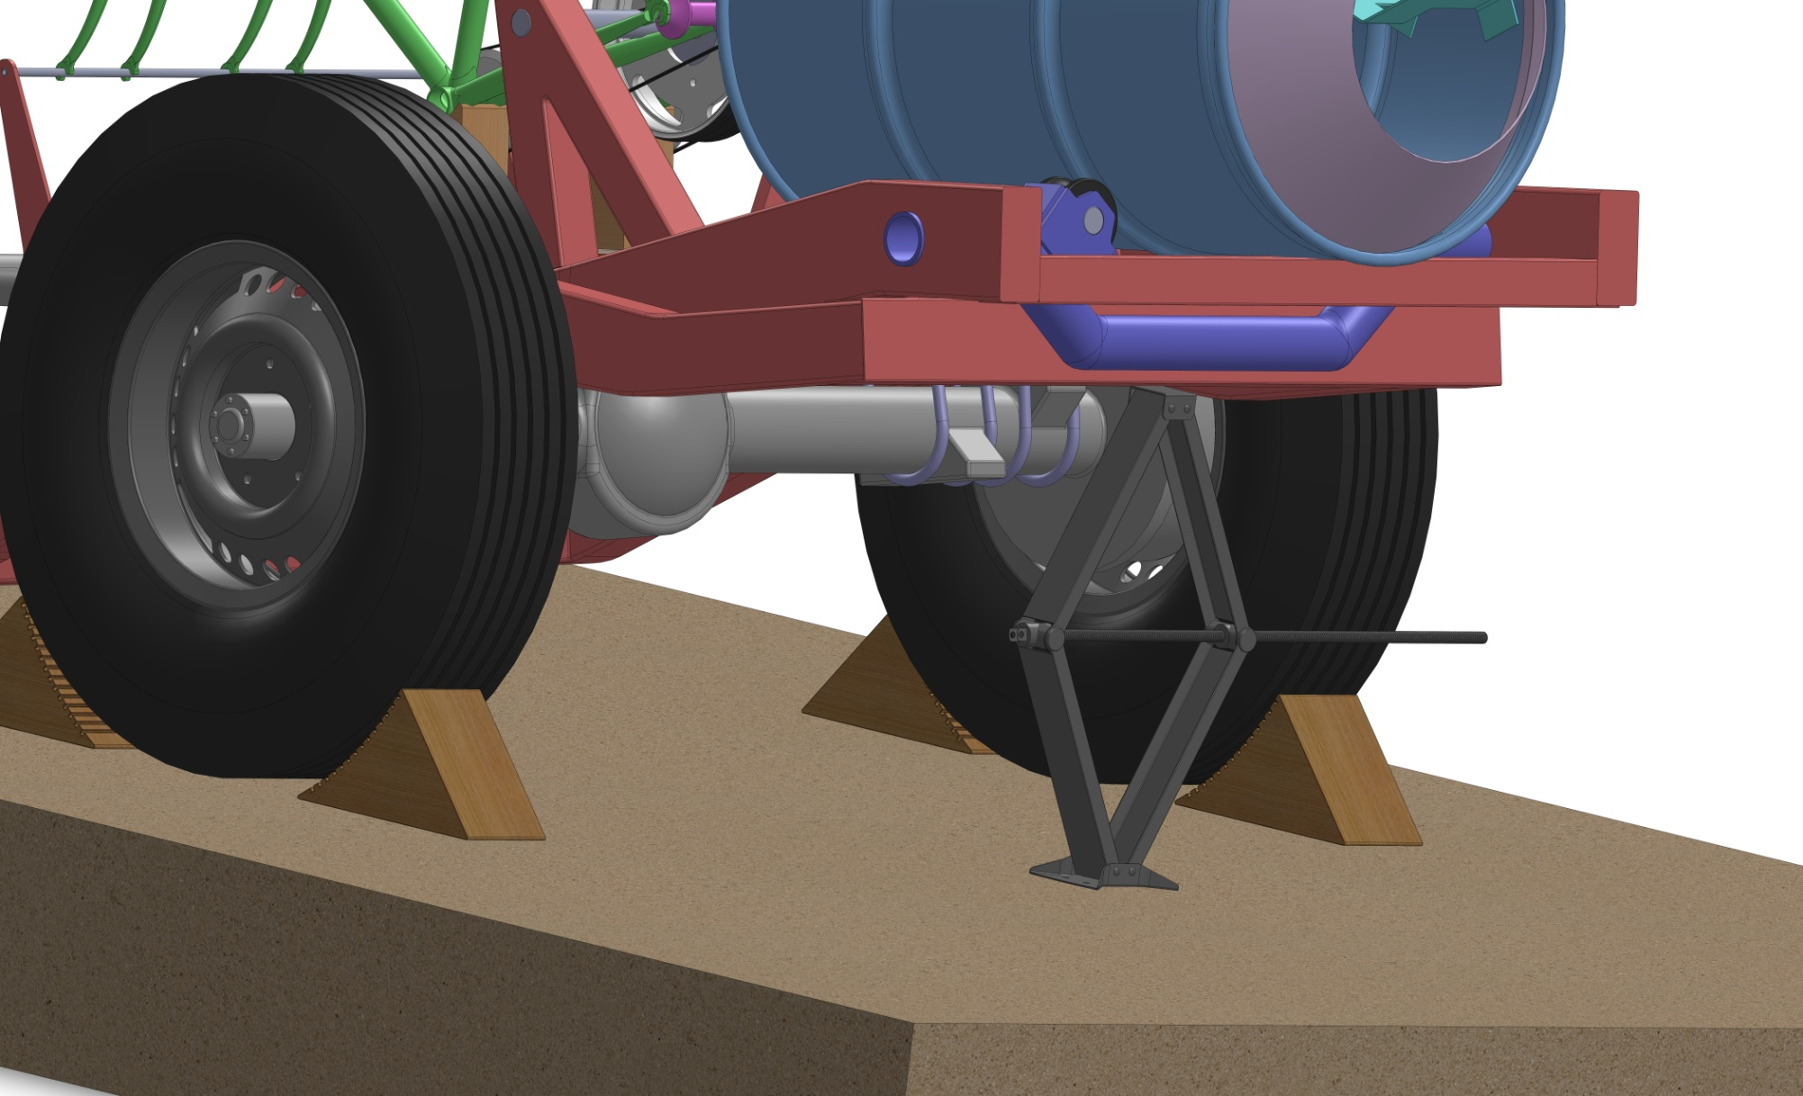

Figure 36: Common Scissor Jack.

# 6.0 Conclusion and Recommendations

The objective of designing a concrete mixer to be used in locales lacking sufficient infrastructure was met by this project. By following the proper design steps, a final design was generated successfully. The PSS defined what the problem was, the PRS specified the requirements and their boundaries bounds, the PAS identified the subsystems that would fulfill these requirements, and finally the PCS brought these subsystems together into a final design which was subsequently designed in detail into a coherent final product.

The most important part of this project was the PSS. It determined the scope of the project and gave us a strategy to follow when designing the project. This was of utmost importance since most confusion regarding the design of the concrete mixer could be resolved by the strategy outlined in the PSS. During the PRS, when determining what the concrete mixer must be and do, questions were frequently raised regarding scope. For example the concrete mixer had to be mobile, however by how much was frequently up for debate. Referencing the PSS, it was decided that it had to have some way of being moved across large distances while hitched up to a car or animal, as well as be relocated across short distances by a person.

The biggest concern that recurred during the project was which materials could be used. The PSS determined that the concrete mixer would be made in a simple machine shop, which greatly simplified the design process by relegating the available manufacturing methods and materials to simple ones, which were all known by the team. Instead of asking the question of “What is the best way to make a concrete mixer?” or “How can a concrete mixer be assembled from scrap in the field?”, the question was “How would we make a concrete mixer right now if we actually had to make one?”.

The product concept ideation and refinement was difficult to do in the specified way since there were few possible system embodiments and many were independent of one another. With the exception of certain contradiction, the embodiments were all compatible with one another, so concept ideation was done with a simple mix and match. For example if a design included the use of a crank to operate, that crank could very easily be replaced with pedals, or a rotating handle. This meant that there were thousands of possible combinations for concepts. The focus of this section fell more upon the individual subsystem embodiments rather than the concepts. The whole was very much equal to the sum of its parts. The final design that was chosen wasn’t selected based on its own merit so much as the merits of its subsystems.

The key attribute of our final design was simplicity. It consisted of few components and systems, none of which had specifications that were absolutely critical for the design to work. This meant that the concrete mixer could be made from a wide range of available materials using simple joining processes like welding and bolting. In addition, the actual mixing process was not compromised by the fact that it was human powered. 2 people pedaling can generate significant power to drive the mixer and provide performance far greater than mixing the concrete with a shovel.

Our design can be improved by making the power transmission involve gears instead of a friction wheel. Gears are readily available and much more reliable and less prone to slippage than a friction wheel. In addition, detailed calculation can be performed on structural components to minimize stress and deflection and optimize the dimensions of the structural components to deal with those two properties.

The relative simplicity of the design enabled all aspects to be well thought out. This is what the group considered to be most satisfying for the final design: it will work and it can be manufactured and built by us.

# REFERENCES

1. Archtoolbox.com,. (2015). *Concrete Composition - archtoolbox.com*. Retrieved 1 October 2015, from http://www.archtoolbox.com/materials-systems/concrete/concretecomposition.html
2. The Family Handyman,. (2015). *How to Properly Mix Concrete*. Retrieved 1 October 2015, from http://www.familyhandyman.com/masonry/pouring-concrete/how-to-properly-mix-concrete
3. Encyclopedia Britannica,. (2015). cement | building material. Retrieved 7 October 2015, from http://www.britannica.com/technology/cement-building-material
4. Newdawnengineering.com,. (2015). *New Dawn Engineering - CONCRETE MIXER*. Retrieved 1 October 2015, from http://www.newdawnengineering.com/website/  
   brickandtile/mixer/
5. Homedepot.ca,. (2015). *Garant | 5 Cu. Ft. Steel Wheelbarrow | Home Depot Canada*. Retrieved 1 October 2015, from http://www.homedepot.ca/product/5-cu-ft-steel-wheelbarrow/949998
6. Lafarge-na.com,. (2015). Calculating Truck Requirements < Concrete < Aggregates & Concrete: Lafarge. Retrieved 1 October 2015, from http://www.lafarge-na.com/wps/portal/na/en/3_A_11_1-Calculating_Truck_Requirements
7. Elert, G. (2015). Density of Concrete. Hypertextbook.com. Retrieved 1 October 2015, from http://hypertextbook.com/facts/1999/KatrinaJones.shtml
8. Hy Harding, Foster L. The great university of life : a soul journey progress report. Golden, Colorado: Park Point Press, 2013. Print.
9. Zcssk0wzim-flywheel.netdna-ssl.com,. (2015). Retrieved 8 October 2015, from http://zcssk0wzim-flywheel.netdna-ssl.com/wp-content/uploads/2015/04/IMG_5644-1024x768.jpg
10. Cementtrust.files.wordpress.com,. (2015). Retrieved 8 October 2015, from https://cementtrust.files.wordpress.com/2010/08/mixing-in-haiti.jpg
11. Elhogar.org,. (2015). Retrieved 8 October 2015, from http://www.elhogar.org/MathWorks/archives/Pax%20fills.JPG
12. YouTube,. (2015). UCSB Human Powered Concrete Mixer. Retrieved 8 October 2015, from https://www.youtube.com/watch?v=Kabb0q38hI4
13. Labour.gov.on.ca,. (2015). Minimum Wage | Ministry of Labour. Retrieved 8 October 2015, from http://www.labour.gov.on.ca/english/es/pubs/guide/minwage.php
14. Ccohs.ca,. (2015). Pushing & Pulling - General : OSH Answers. Retrieved 15 October 2015, from http://www.ccohs.ca/oshanswers/ergonomics/push1.html
15. Salustri, F. (2015). Design Project [DesignWIKI]. Deseng.ryerson.ca. Retrieved 15 October 2015, from http://deseng.ryerson.ca/dokuwiki/mec723:design_project
16. Levi, J., Gardiner, B., & Neville, J. (2015). 65034: Wheelbarrow. Lifetime Products, Inc.. Retrieved 15 October 2015, from http://www.lifetime.com/gallery/storage/gardening/wheelbarrow/65034
17. Engineeringtoolbox.com. (2015). *Concrete Mixtures*. Retrieved 1 October 2015, from http://www.engineeringtoolbox.com/concrete-sand-cement-gravel-mixtures-d_1547.html
18. IIT GUWAHATI Virtual Lab. (2015). *Sitting Antropometry, static heights (Reference datasheet)*. Retrieved 23 November 2015, from http://iitg.vlab.co.in/?sub=72&brch=171  
    &sim=835&cnt=1543
19. Michelin Tires. (2015). *TGS Tyres Guide*. Retrieved 1 December 2015, from http://tgs.online-mediacentre.com/pdf/tgs-tyre-guide.pdf
20. Toyota. (2015). *Toyota 70 Series Repair Manual.* Retrieved 28 November 2015, from http://s267.photobucket.com/user/SimonInAustralia/library/Toyota%2070%20Series%20Repair%20Manual?sort=9&page=1
21. Myers Container. (2015). *55 Gallon Export Overhead Drum.* Retrieved 1 November 2015, from http://www.myerscontainer.com/docs/ISOExportDrum.pdf

# APPENDIX A: Working Drawings

*Note: All dimensions unless otherwise stated are in inches. Off the shelf parts denoted by the ‘RE’ designation in the Bill of Materials are recycled parts and thusly part drawings are not necessary. Proper instructions and rudimentary dimensions will be addressed in the information packet meant to be delivered to the end users which will stipulate modifications and operations required.*

## Concrete Mixer.pngAssembly Drawings

Figure 37: Concrete Mixer Assembly View 1.

## Concrete Mixer1.png

Figure 38: Concrete Mixer Assembly View 2.

## Bill of Materials (BOM)

Table 18: Bill of Materials.

|  |  |  |  |
| --- | --- | --- | --- |
| **ITEM NO.** | **Description** | **QTY.** | **Origin** |
| 1 | Wheel | 2 | RE |
| 2 | Tire | 1 | RE |
| 3 | Wheel | 1 | RE |
| 4 | Axle | 1 | RE |
| 5 | Handle | 1 | FAB |
| 6 | U-Bolt | 8 | RE |
| 7 | 94895A830 | 16 | RE |
| 8 | 98023A034 | 16 | RE |
| 9 | Tie Plate | 4 | RE |
| 10 | Toyo Frame Rail (L) | 1 | RE |
| 11 | Toyo Frame Rail Scrap (R) | 1 | RE |
| 12 | Toyo Frame Rail Scrap (L) | 1 | RE |
| 13 | Drum Support | 1 | FAB |
| 14 | Drum Roller Support | 1 | FAB |
| 15 | Drum Roller Bracket | 2 | FAB |
| 16 | Axle Shaft | 2 | RE |
| 17 | Drum Roller | 2 | FAB |
| 18 | Brace | 1 | RE |
| 19 | Front Brace | 1 | RE |
| 20 | Toyo Frame Rail (R) | 1 | RE |
| 21 | Drive Upright | 2 | RE |
| 22 | Drum Brace | 1 | RE |
| 23 | Jack Brace | 1 | RE |
| 24 | Drum Bearing | 1 | RE |
| 25 | Mount | 2 | RE |
| 26 | Plywood | 1 | RE |
| 27 | Odd Ply | 3 | RE |
| 28 | Even Ply | 2 | RE |
| 29 | Drum | 1 | RE |
| 30 | Scissor Jack | 1 | RE |
| 31 | Bushing | 1 | RE |
| 32 | Foot | 1 | RE |
| 33 | Lower Pin | 2 | RE |
| 34 | Lower Spar | 2 | RE |
| 35 | Nut | 1 | RE |
| 36 | Pivot | 2 | RE |
| 37 | Screw | 1 | RE |
| 38 | Upper Spar | 2 | RE |
| 39 | Upper Pin | 2 | RE |
| 40 | Upper Bracket | 1 | RE |
| 41 | Ball | 1 | RE |
| 42 | Floor | 1 | RE |
| 43 | Chock | 4 | FAB |
| 44 | Drum Corral | 1 | FAB |
| 45 | Drum Agitator | 4 | FAB |
| 46 | kirk3 | 2 | RE |
| 47 | Mitsugi BB-61.1x61.9 | 1 | RE |
| 48 | Component22; | 1 | RE |
| 49 | K3Fork | 1 | RE |
| 50 | Component6; | 1 | RE |
| 51 | Component2; | 1 | RE |
| 52 | Component3; | 1 | RE |
| 53 | Component5; | 1 | RE |
| 54 | SPEED METTLE 27x17 ROAD CHAINSTAY; | 1 | RE |
| 55 | TT-28.6; | 1 | RE |
| 56 | TT-28.6;-1 | 1 | RE |
| 57 | ARTISAN_TOP LUG-73; | 1 | RE |
| 58 | DT; | 1 | RE |
| 59 | DT;-1 | 1 | RE |
| 60 | ARTISAN_DOWN LUG-606; | 1 | RE |
| 61 | ARTISAN_SEAT LUG-72.5; | 1 | RE |
| 62 | HT; | 1 | RE |
| 63 | ST; | 1 | RE |
| 64 | kirk3; | 1 | RE |
| 65 | kirk3;-1 | 1 | RE |
| 66 | kirk3;-2 | 1 | RE |
| 67 | kirk3;-3 | 1 | RE |
| 68 | Bicycle Hub | 3 | RE |
| 69 | Front Fork Mount | 1 | FAB |
| 70 | Front Fork Rest | 1 | FAB |
| 71 | Front Fork Rest Bracket | 2 | FAB |
| 72 | Crank Support | 2 | RE |
| 73 | Friction Wheel Halfshaft | 1 | RE |
| 74 | Friction Wheel Flange | 2 | FAB |
| 75 | Driving Shaft | 1 | RE |
| 76 | Friction Wheel | 1 | RE |
| 77 | Friction Tire | 1 | RE |
| 78 | Friction Rim | 1 | RE |
| 79 | Friction Rim | 1 | RE |
| 80 | Rope | 3 | FAB |
| 81 | Gear | 2 | RE |
| 82 | Chain | 2 | FAB |

## Part Drawings

Figure 39: Axle Shaft Part Drawing.

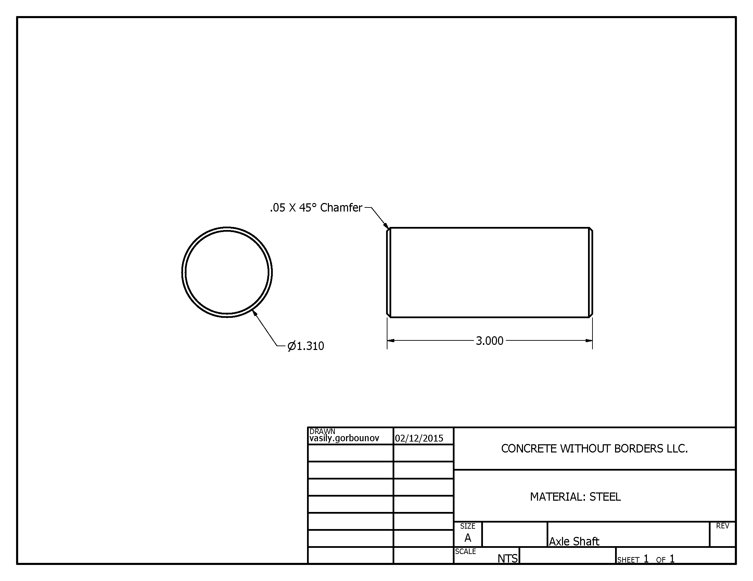

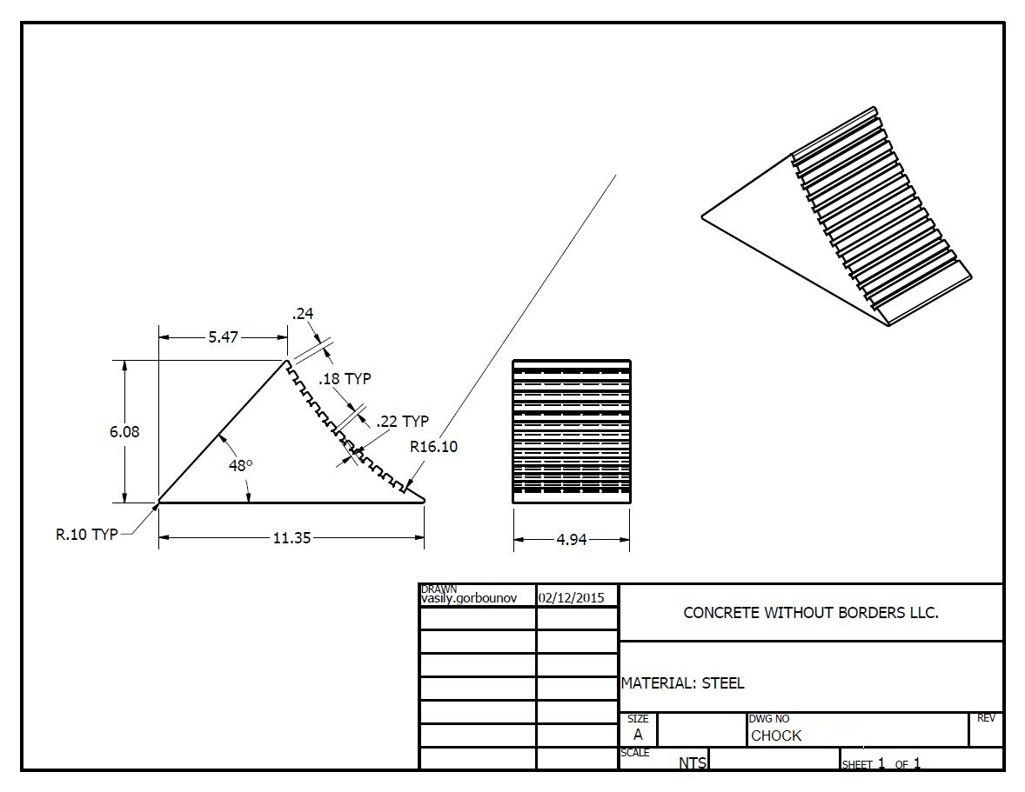

Figure 40: Chock Part Drawing.

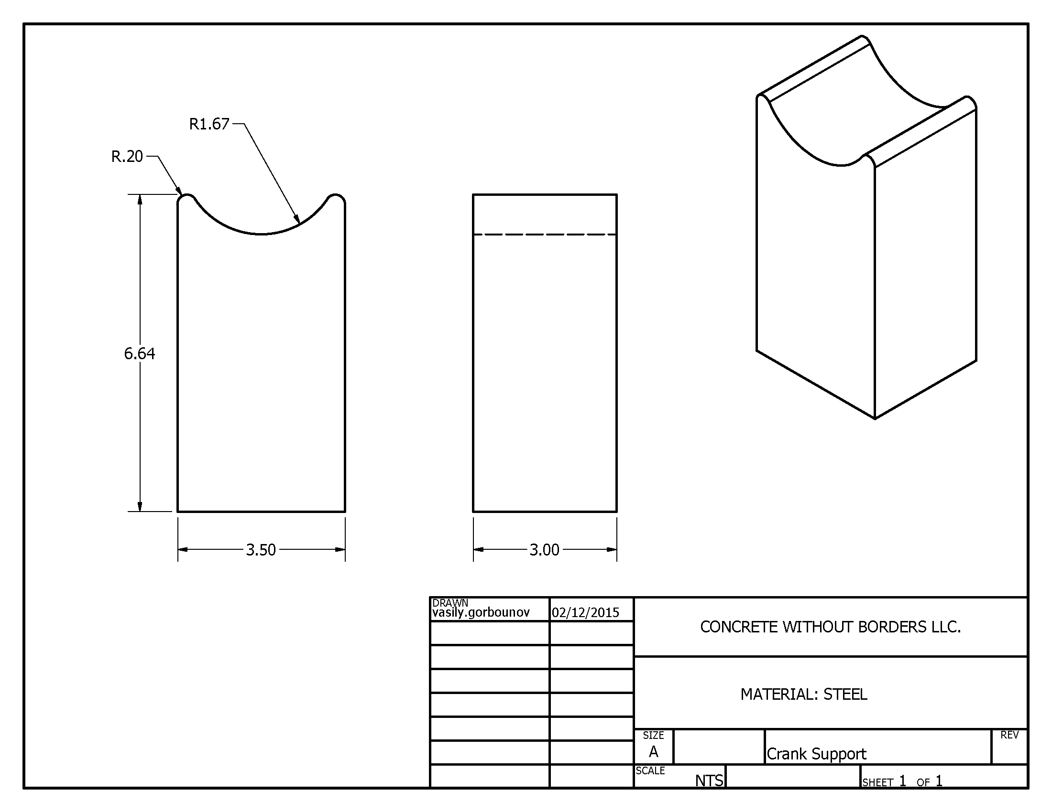

Figure 41: Bicycle Crank Support Part Drawing.

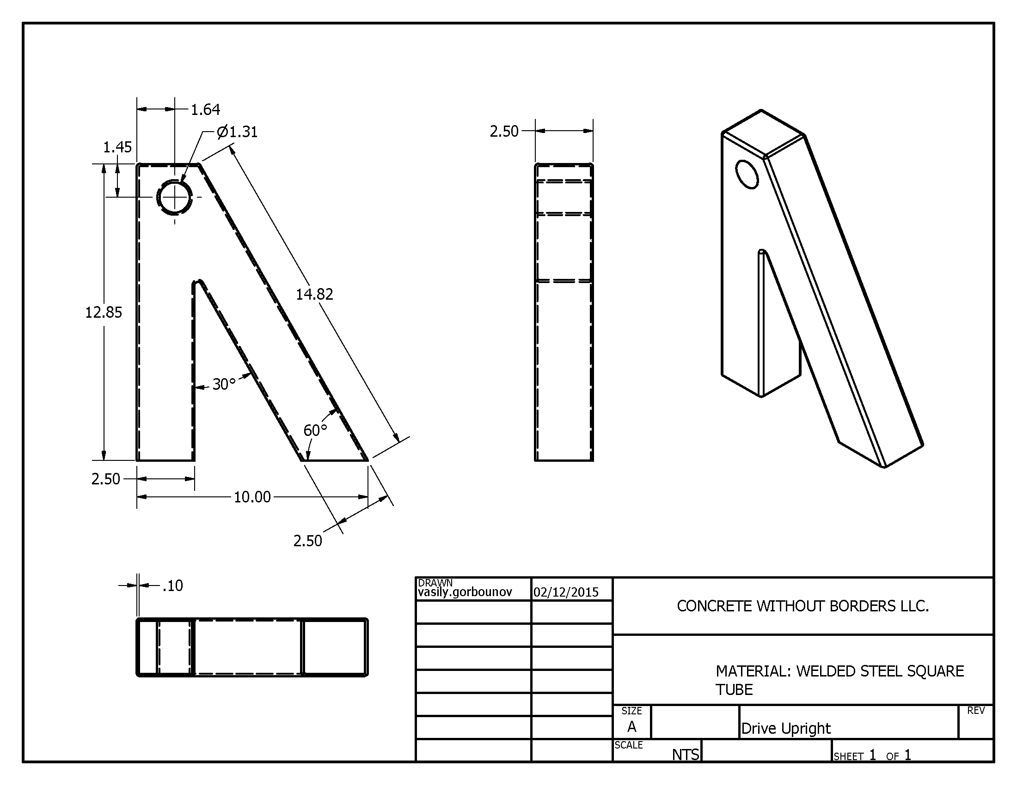

Figure 42: Friction Drive Upright Support Part Drawing.

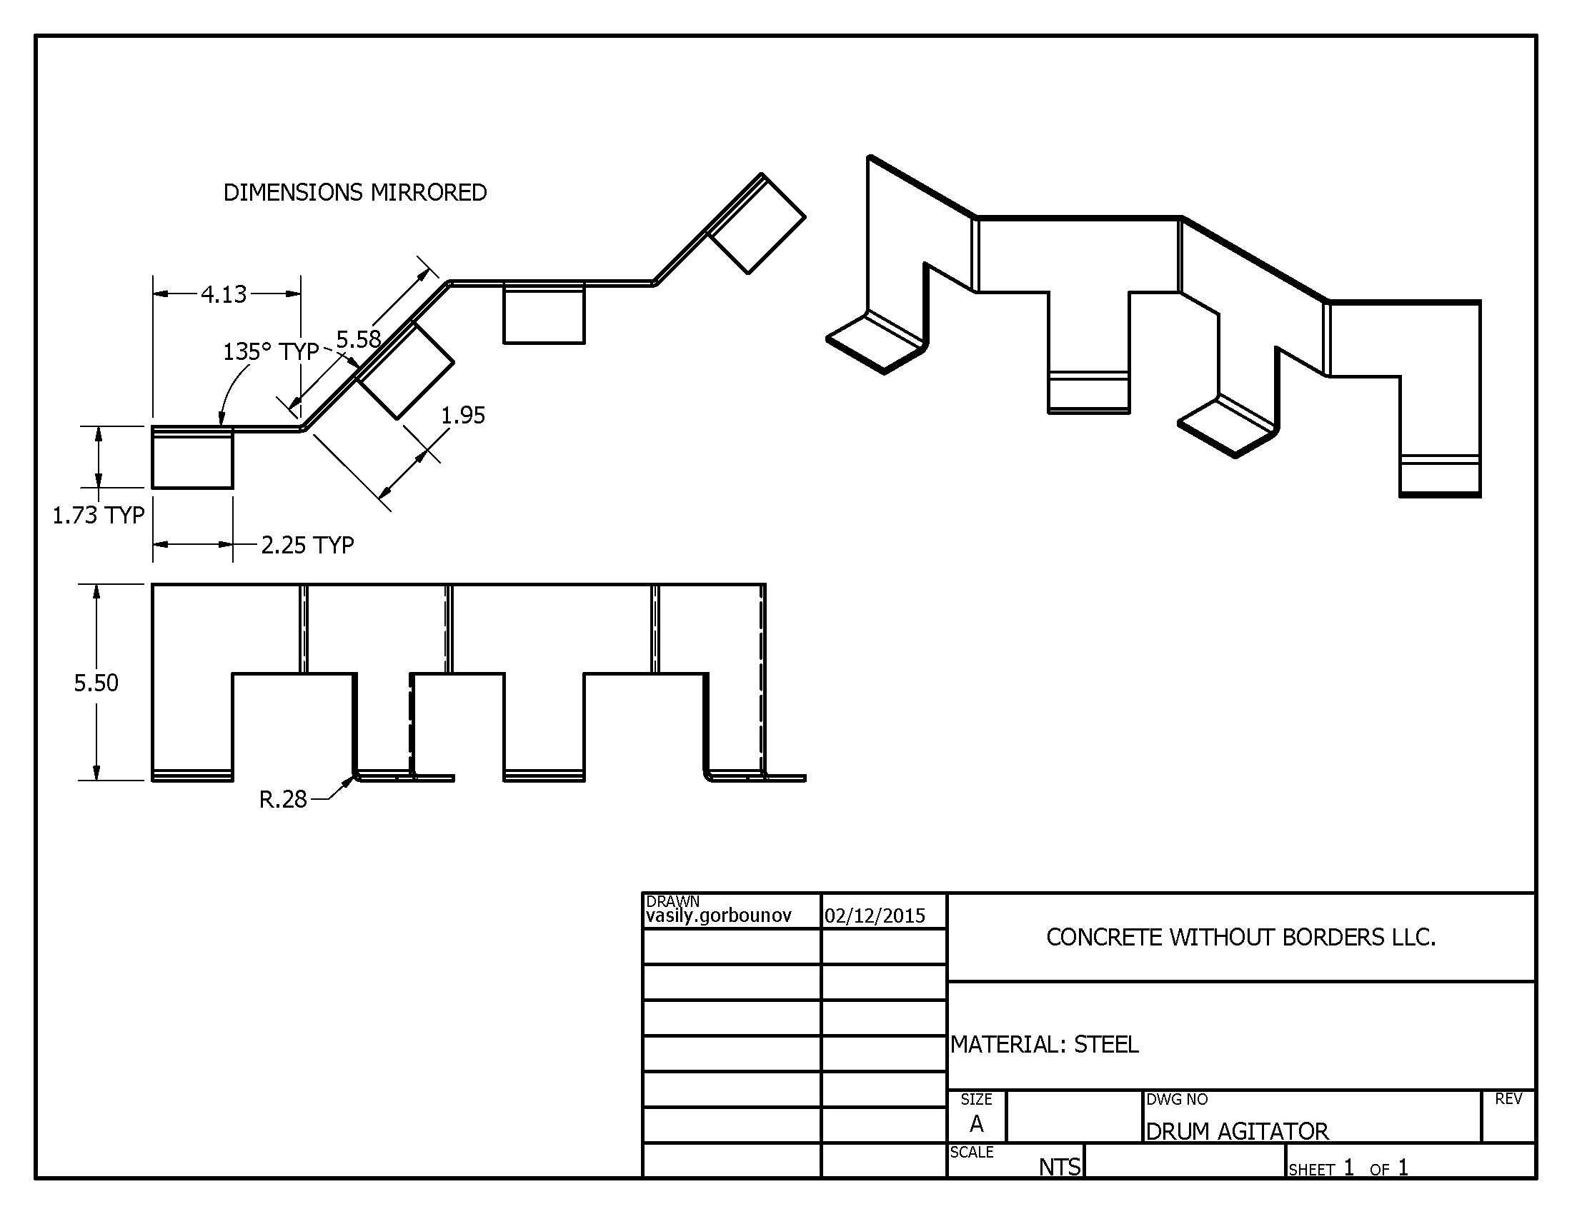

Figure 43: Drum Agitator Part Drawing.

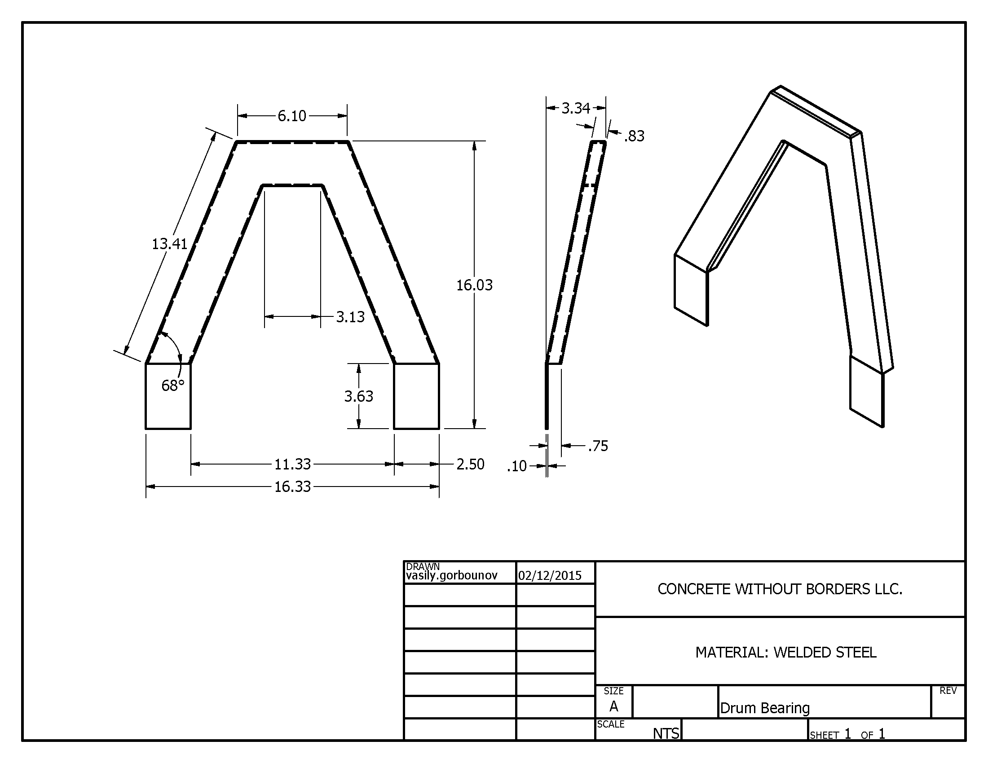

Figure 44: Drum Bearing Support Part Drawing.

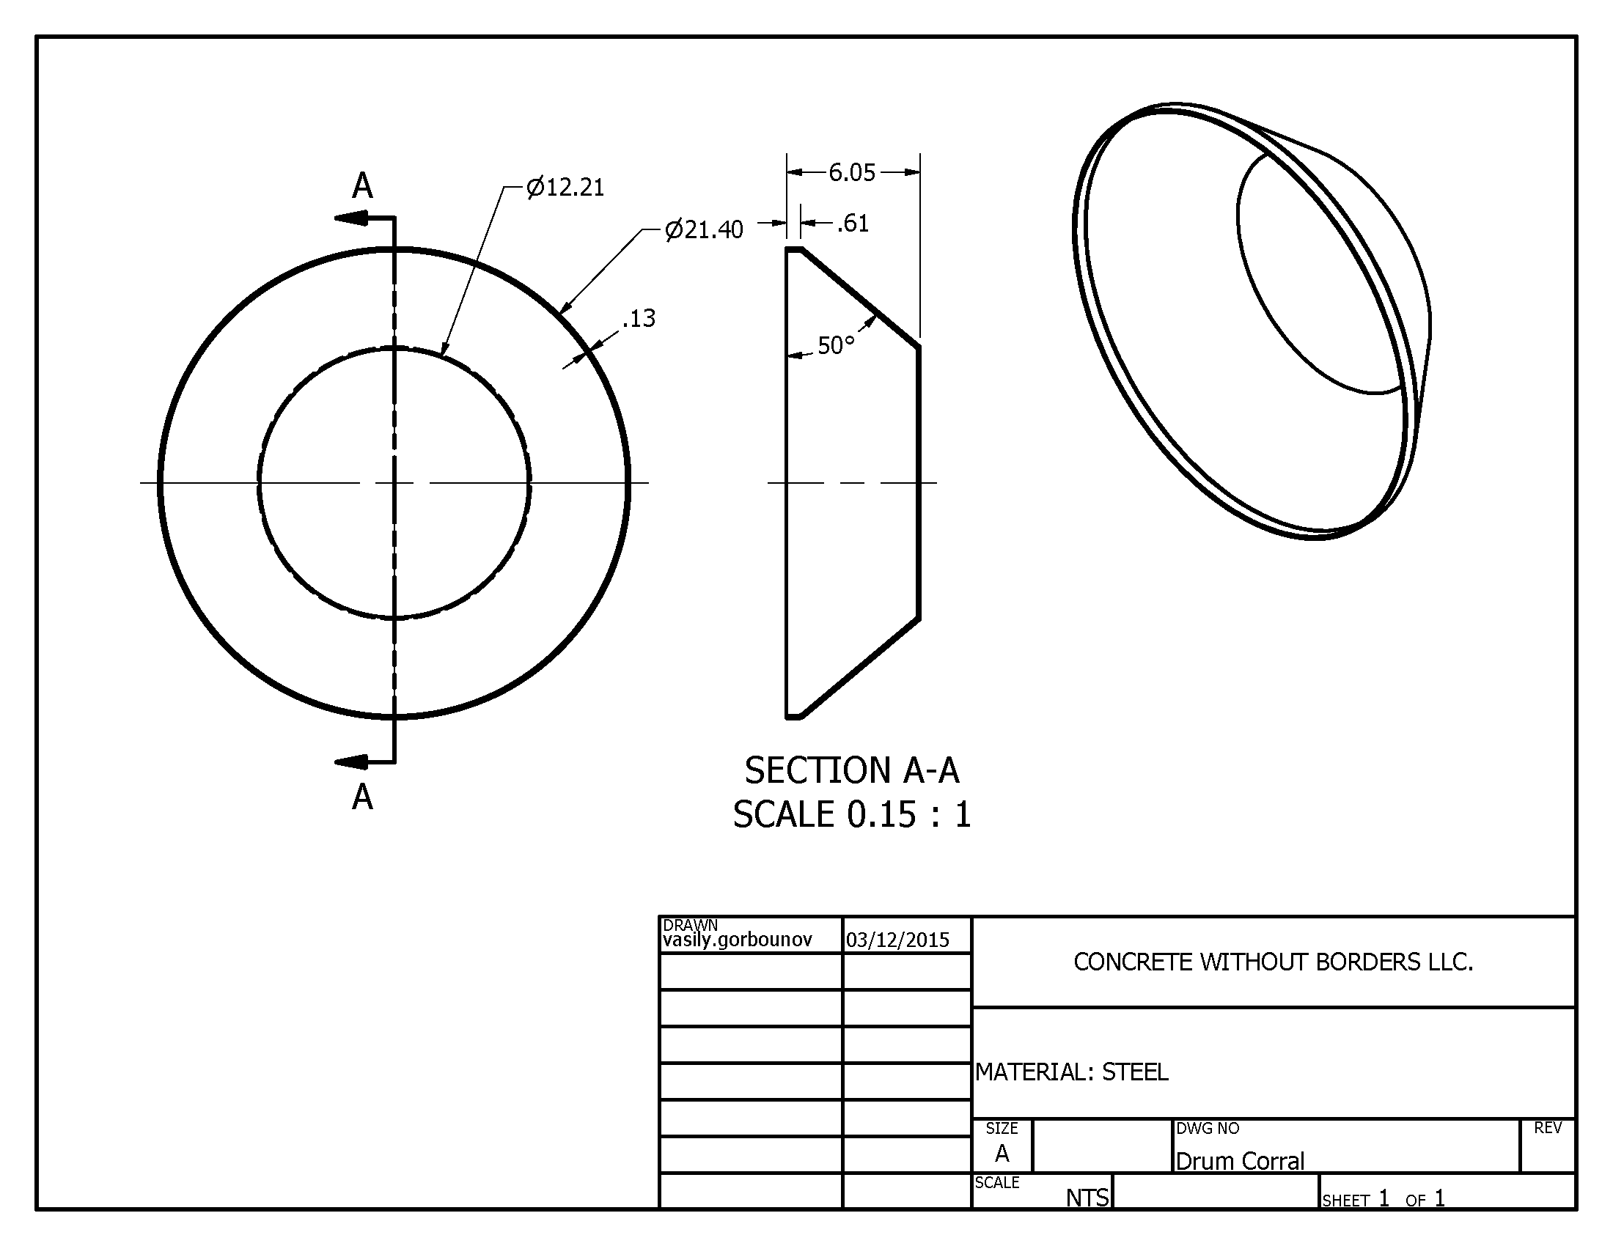

Figure 45: Drum Concrete Corral Part Drawing.

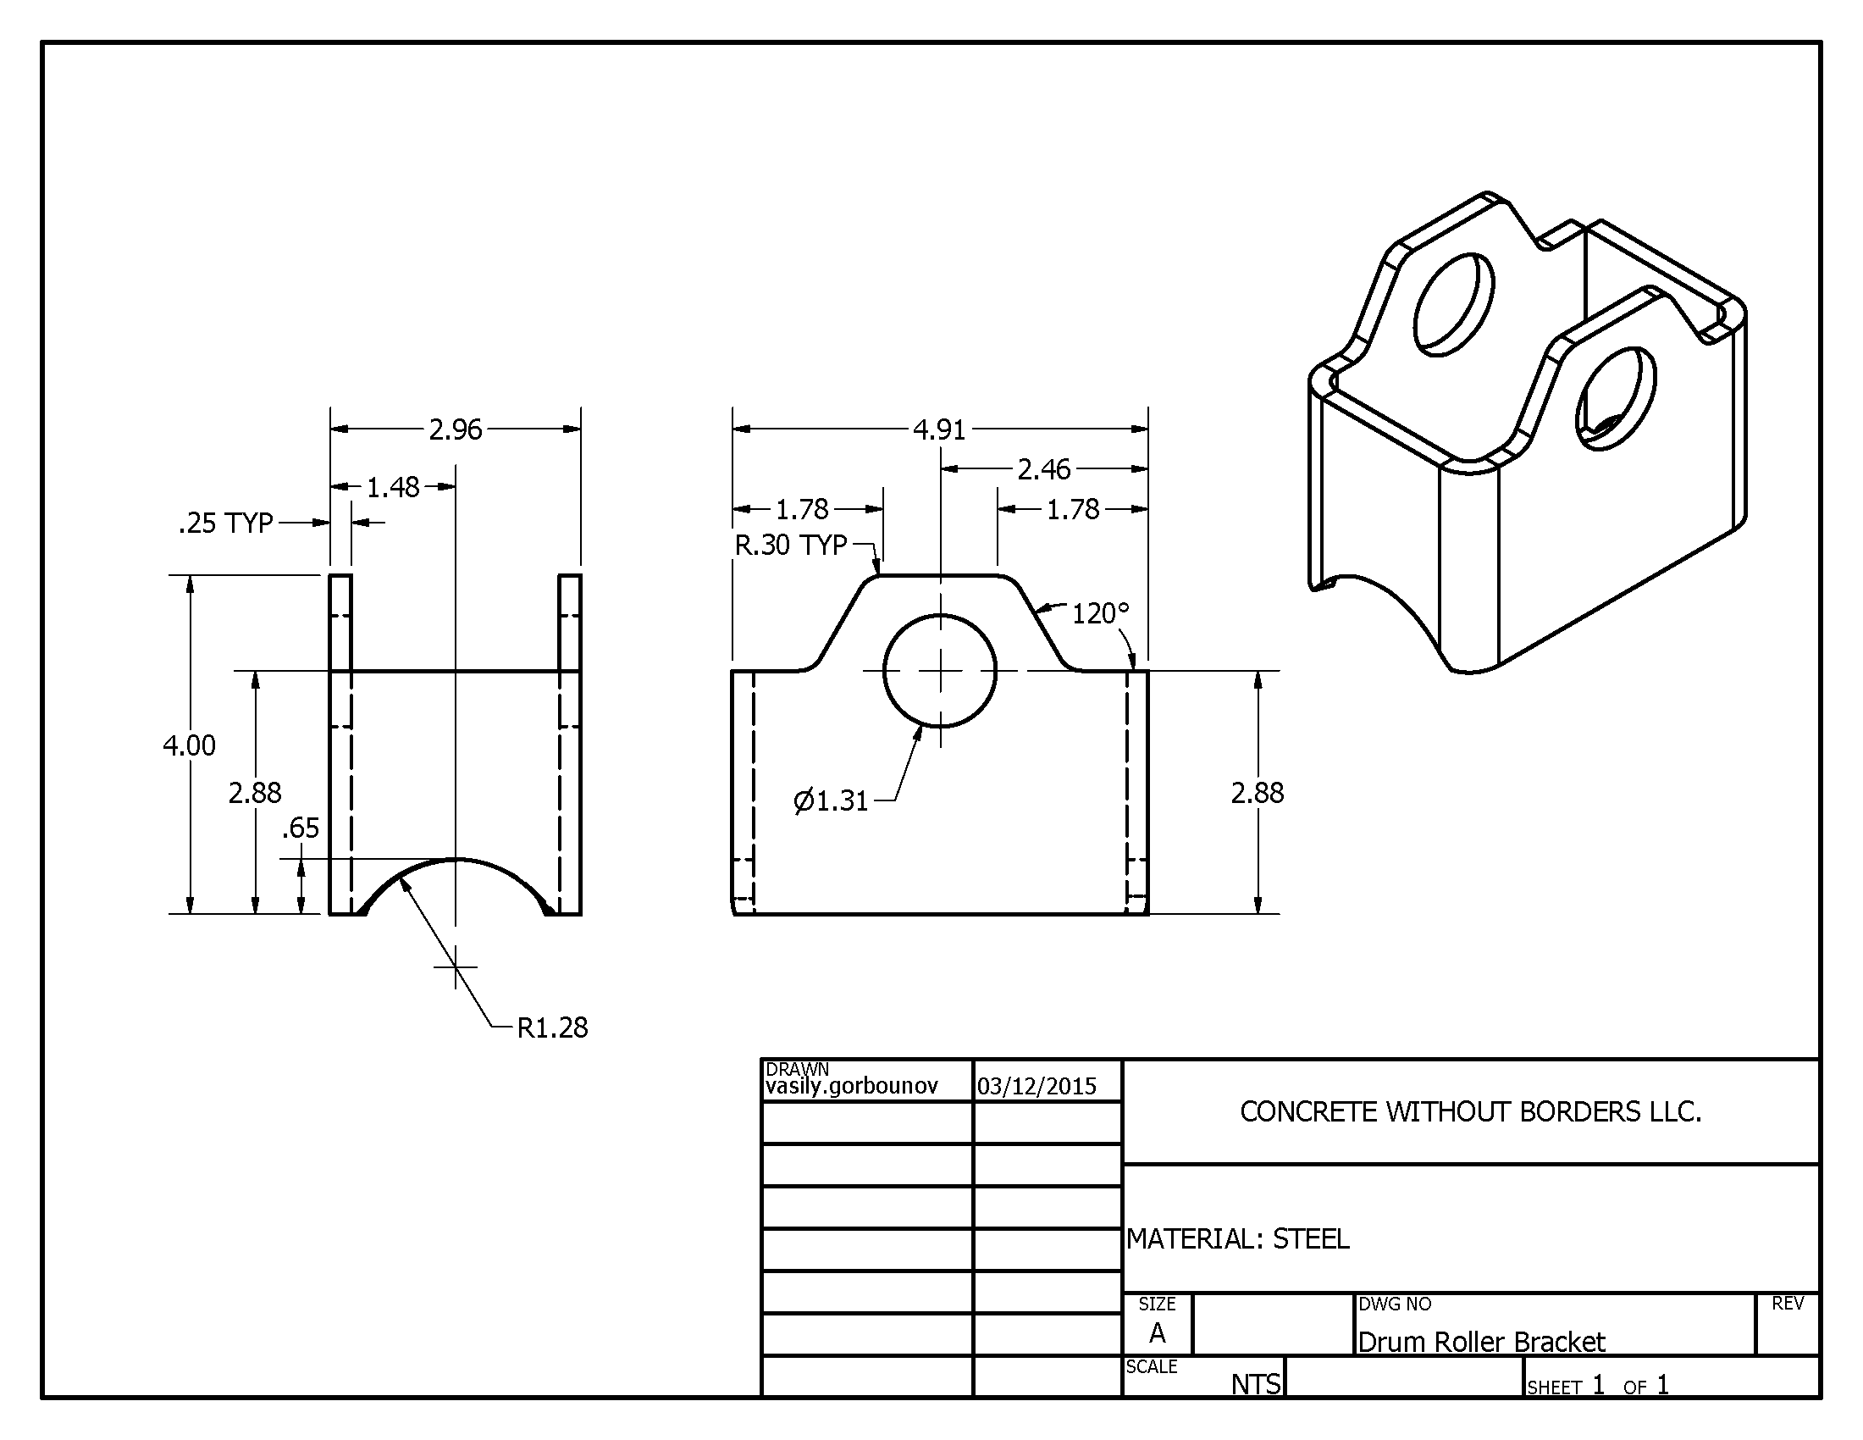

Figure 46: Drum Roller Bracket Part Drawing.

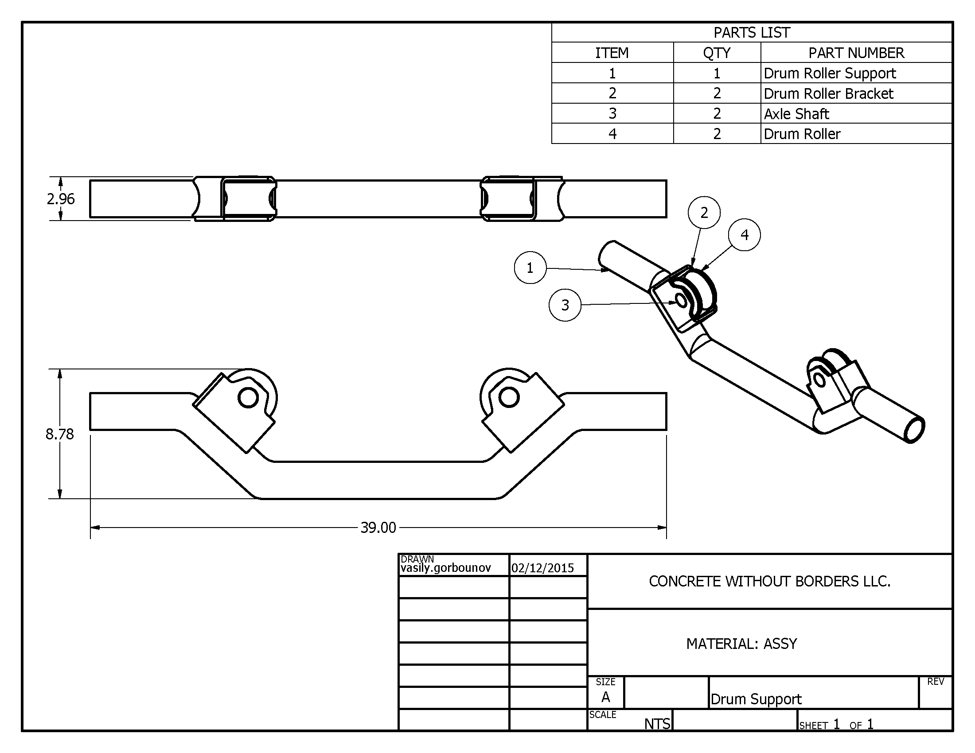

Figure 47: Drum Support System Part Drawing.

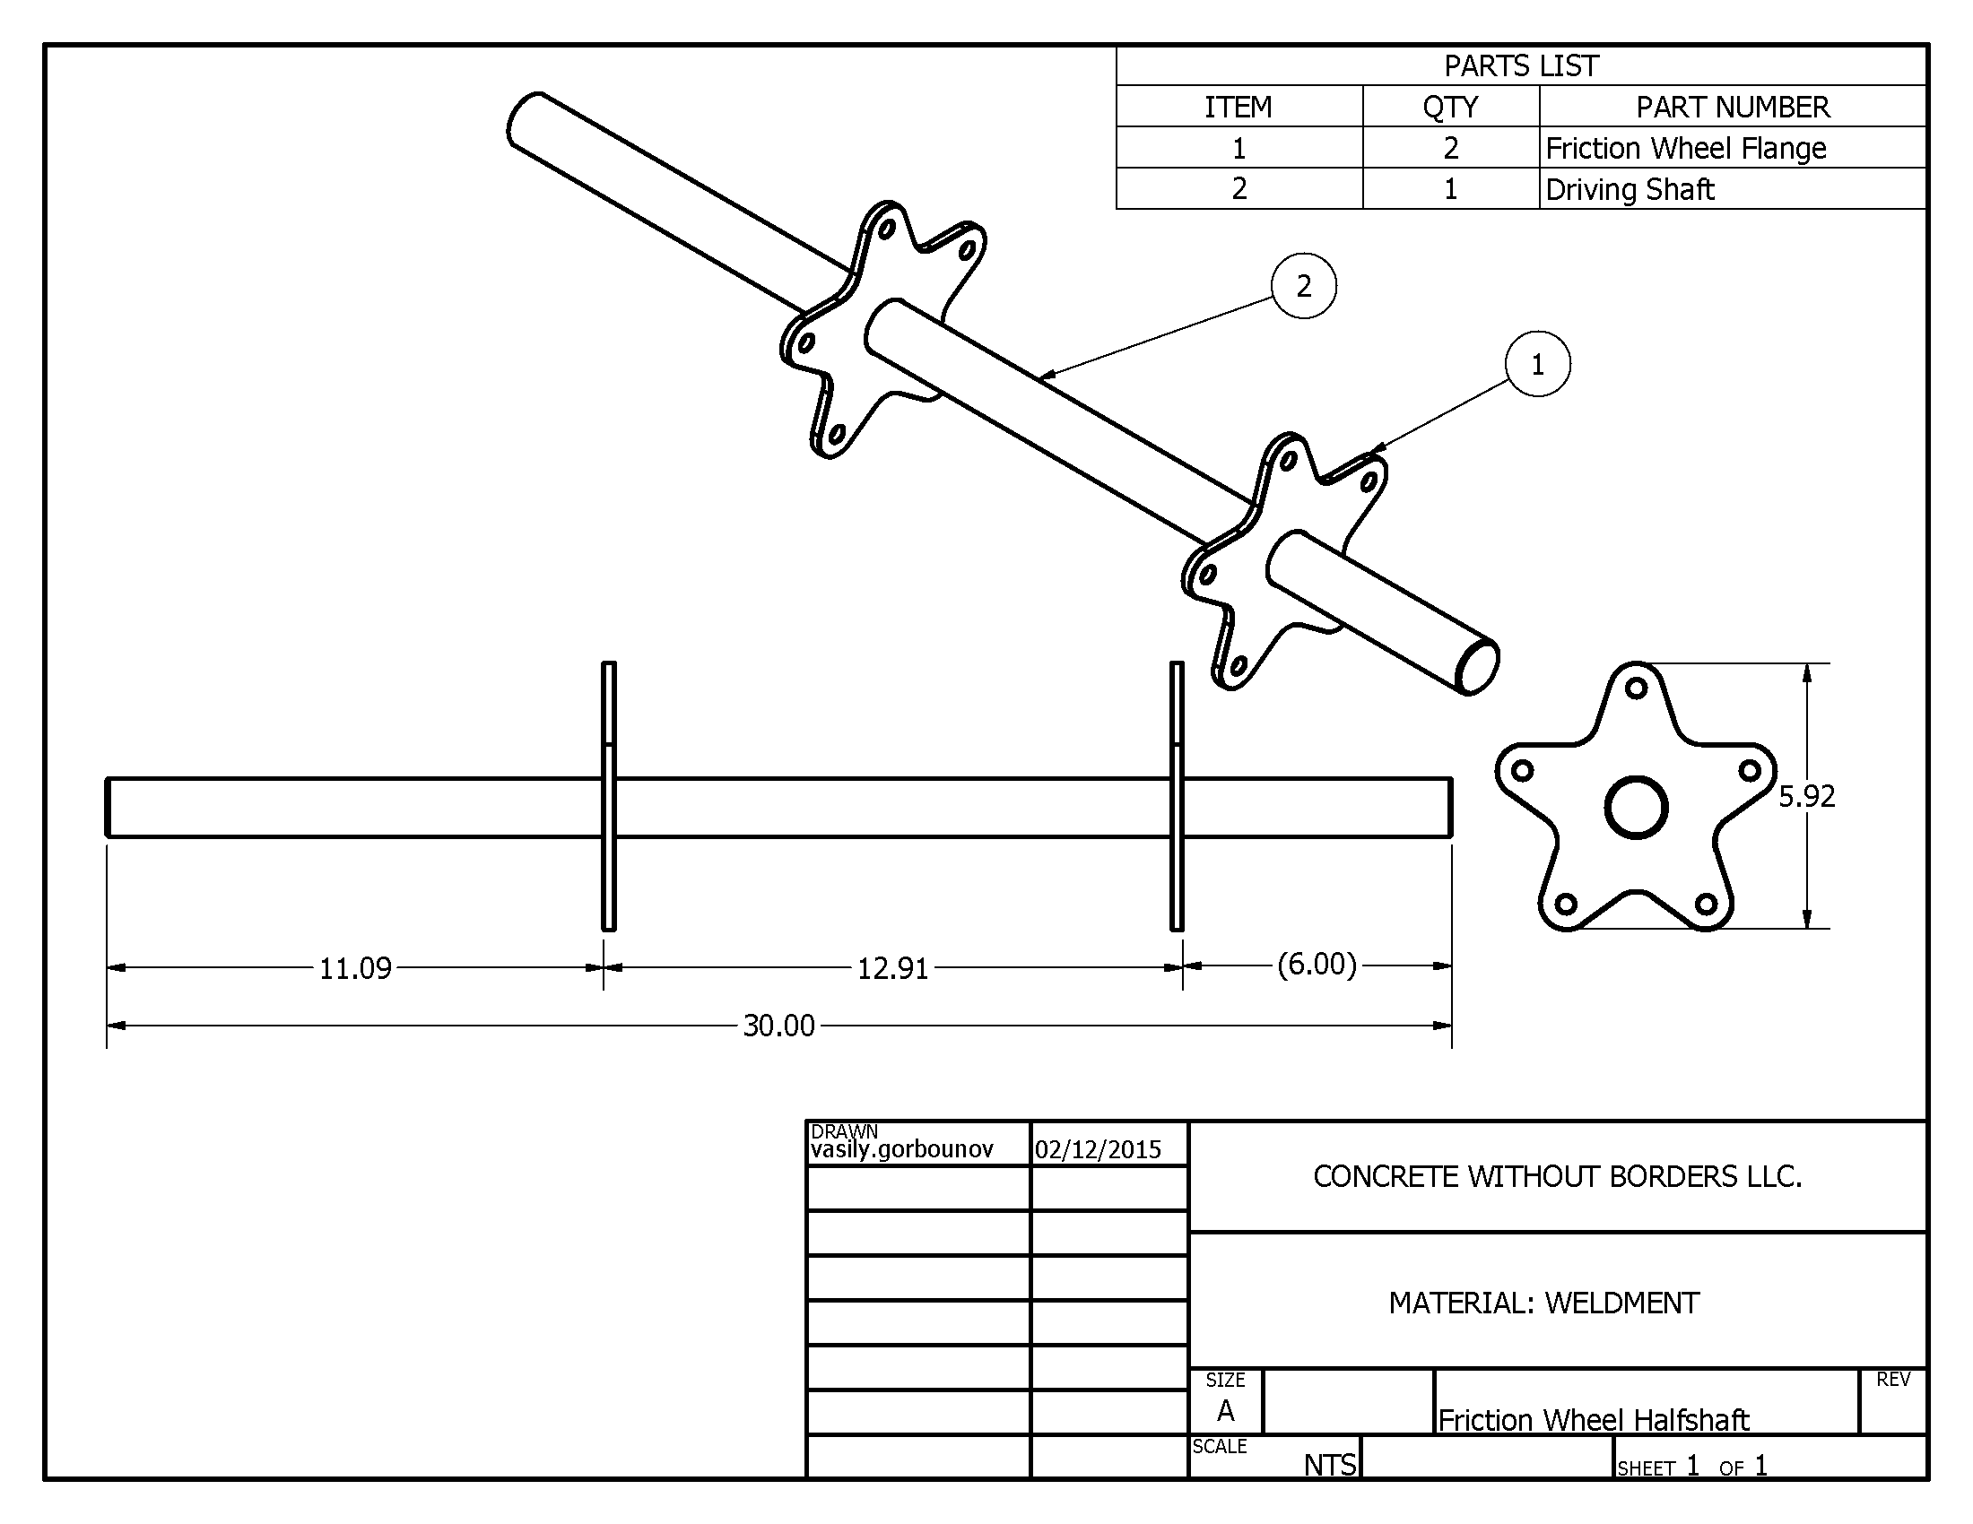

Figure 48: Friction Drive Half-shaft Part Drawing.

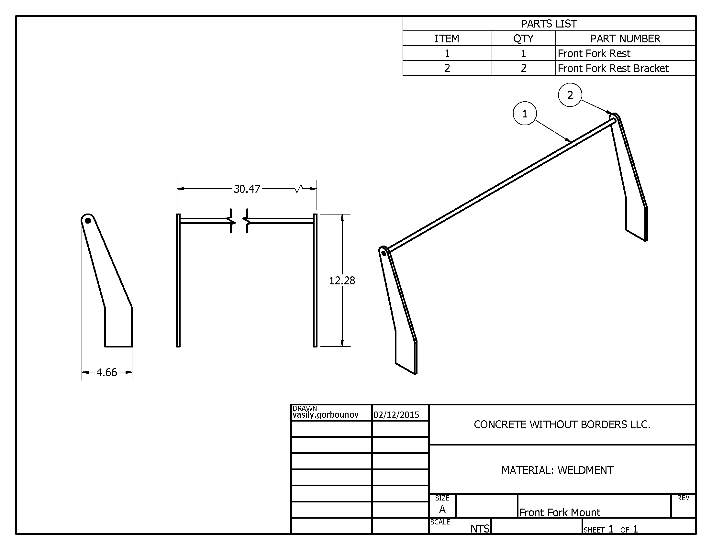

Figure 49: Front Fork Support Part Drawing.

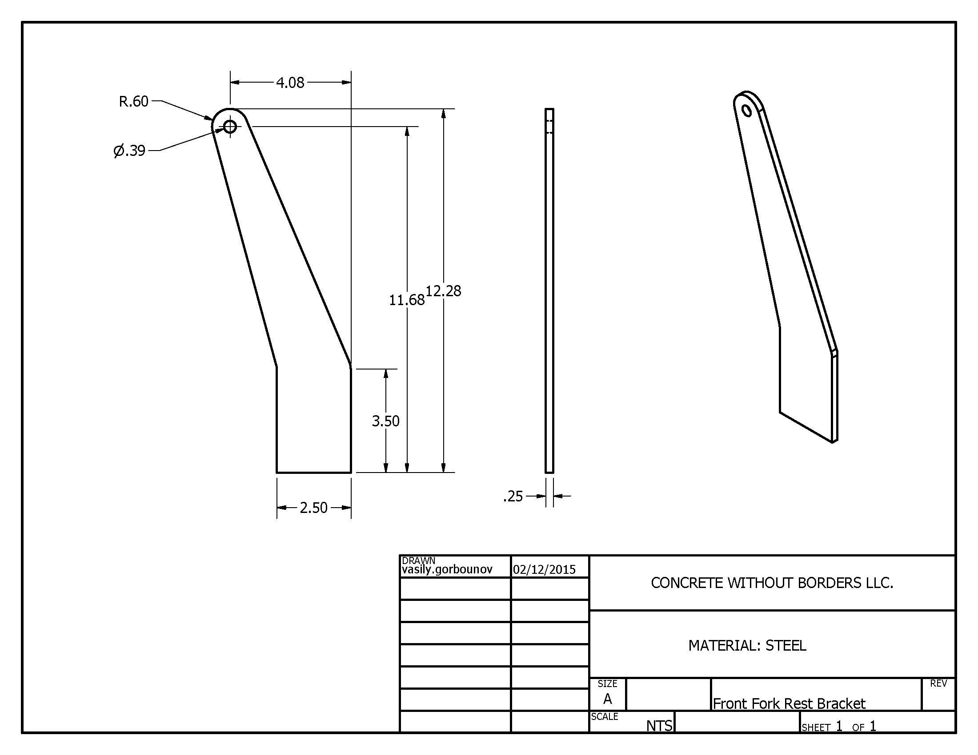

Figure 50: Front Fork Support Bracket Part Drawing.

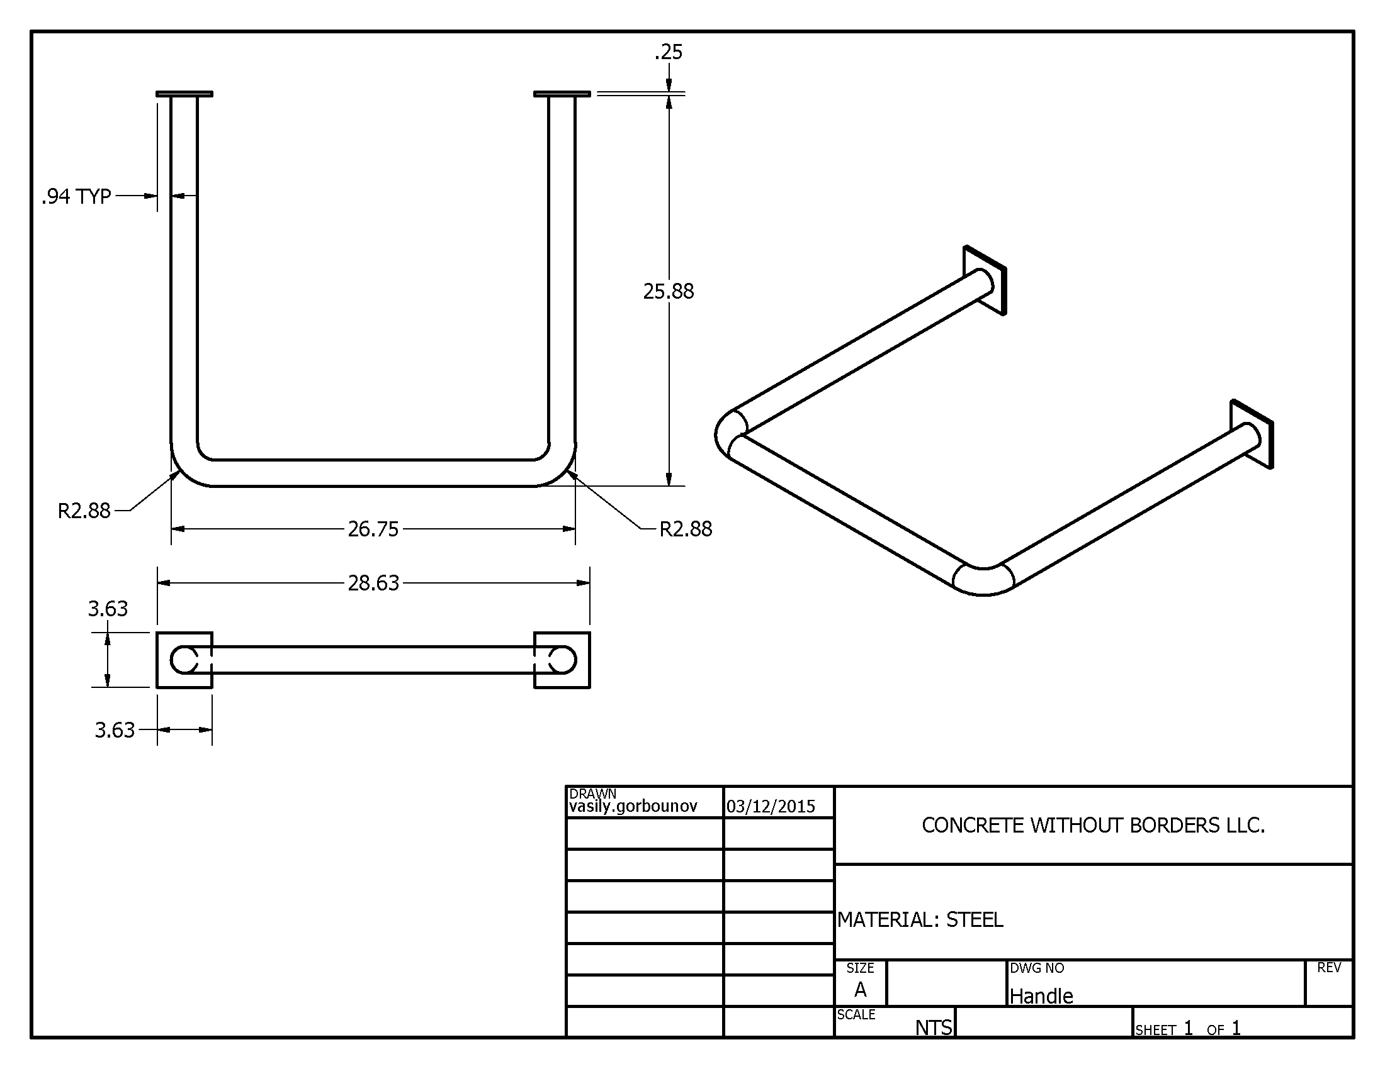

Figure 51: Handle Part Drawing.

# Mount.png

Figure 52: Plywood Platform Mount Part Drawing.

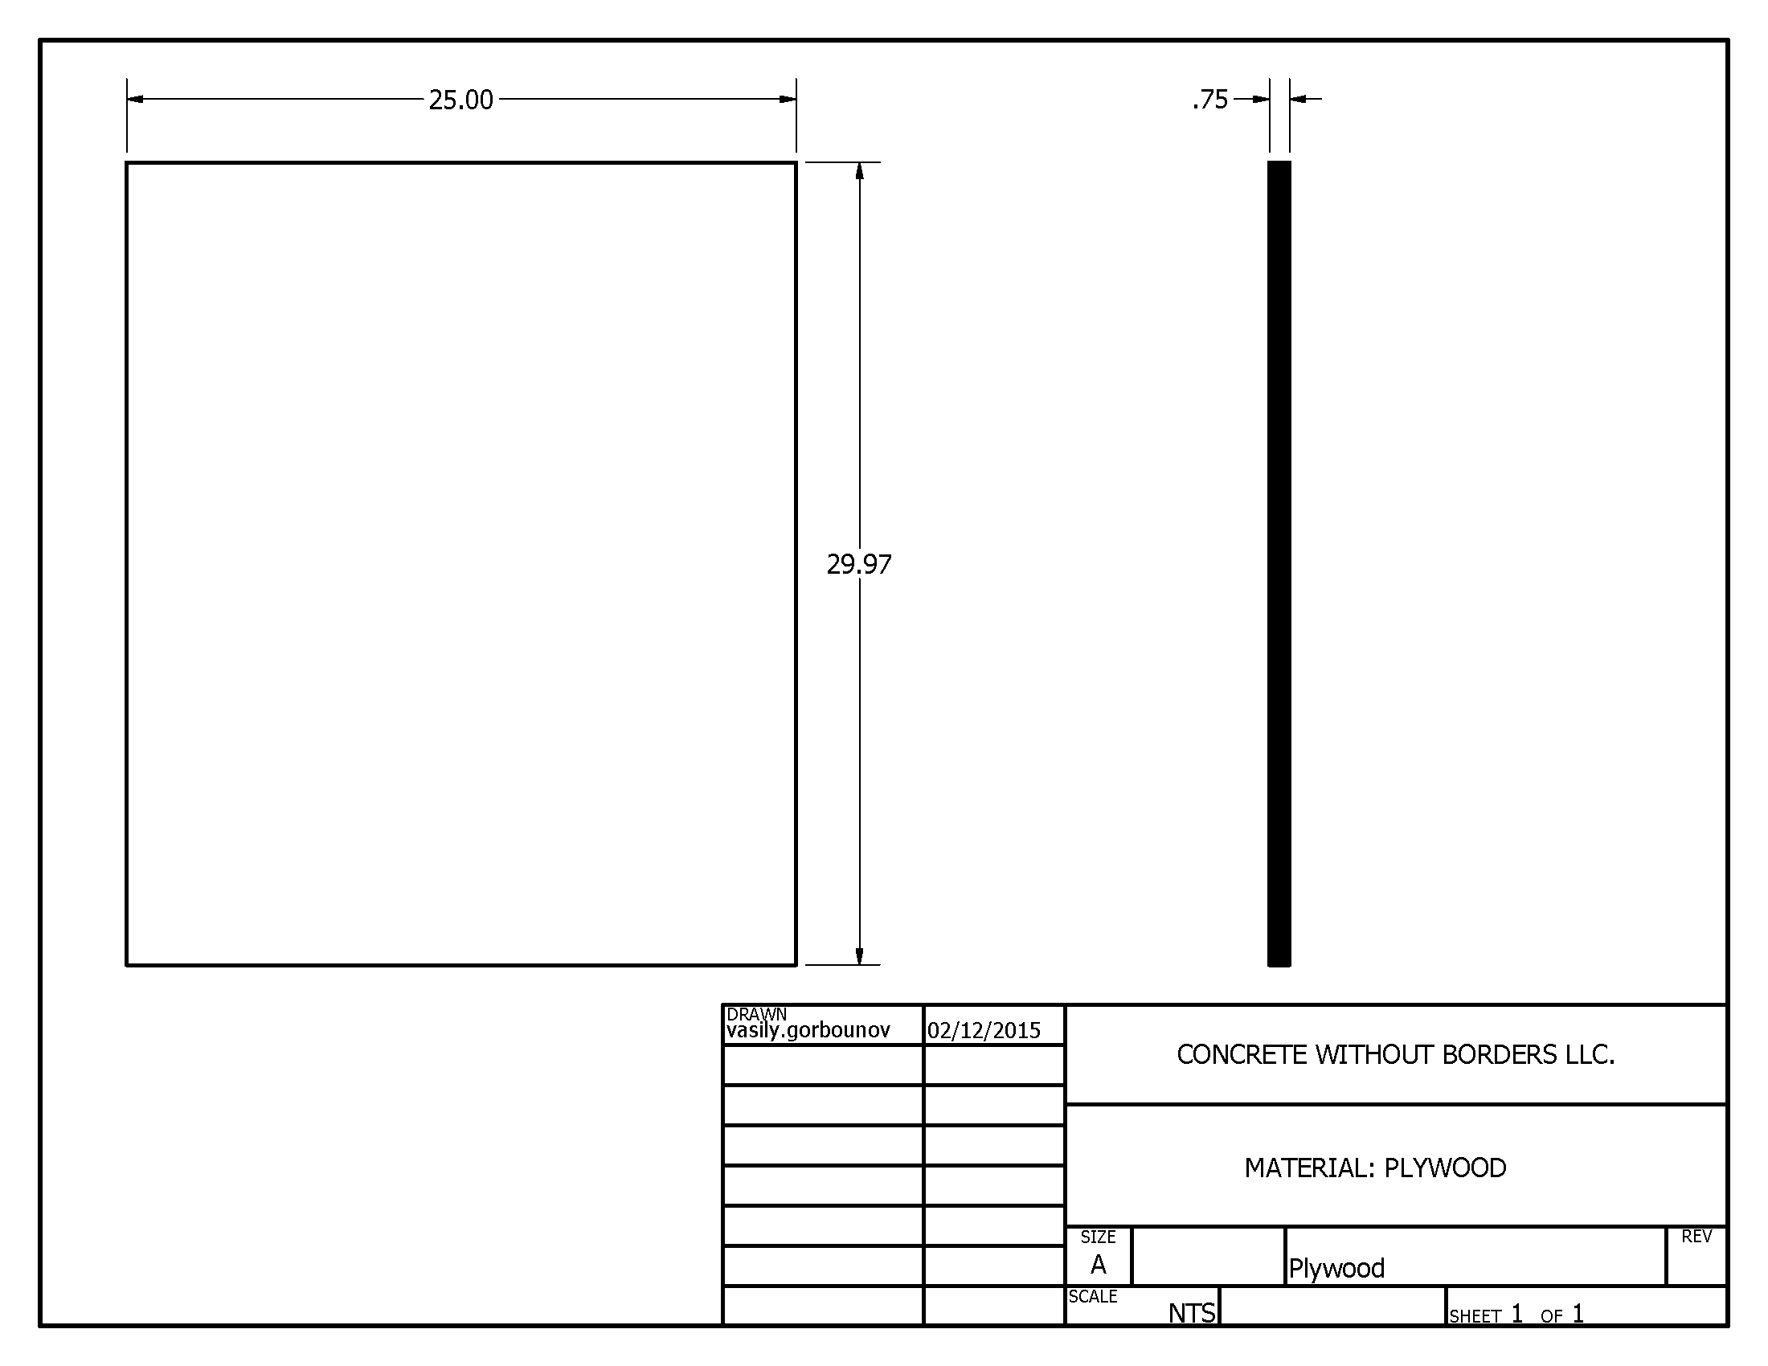

Figure 53: Plywood Platform Part Drawing.

# APPENDIX B: Mathematical Analysis

## Determining Mechanical Advantage

This uses the principle of torque amplification through axles where the tension in the linking body, the chain in this case, has a constant tension. This means that the torque in a pair of axles that have two different diameter sprockets attached to them will have different torques.

Torque is calculated as a function of perpendicular distance R times the tension force FT.

|  |  |  |
| --- | --- | --- |
|  | $$T=R*Ft$$ | Eq. 1.0 |

With two different sized sprockets, with D1 and D2 for respective diameters, the tension force is as follows:

|  |  |  |
| --- | --- | --- |
|  | $$Ft=\frac{T1}{{D1}/2}=\frac{T2}{{D2}/2}$$ | Eq. 1.1 |
|  | $$Ft=\frac{T1}{D1}=\frac{T2}{D2}$$ |  |
|  | $$T2=T1\frac{D2}{D1}$$ | Eq. 1.2 |

This can be coupled for multiple gears and sprockets for the use in this mixer to obtain multiple factors. With Tout and Dout representing the output torque and drum ring gear diameter respectively. Dout was determined to be 572 mm. D3 represents the diameter of the hub, 1.09” (27.686 mm) and D4 represents that of the wheel attached to the hub via a belt, with a 10” (254 mm) diameter. D5 represents the diameter of the friction wheel, which was found to be 17.6” (447.04 mm). T1 is the input torque applied at the axle that D1, the pedal sprocket is affixed to. D2 represents the diameter of the gear that is attached to the same axle as the bicycle’s drive wheel.

The mechanical advantage, or the ration of input to output torque is as follows:

|  |  |  |
| --- | --- | --- |
|  | $$\frac{Tout}{T1}=\frac{D2}{D1}\frac{D4}{D3}\frac{Dout}{D5}$$ | Eq. 1.3 |
|  | $$\frac{Tout}{T1}=\frac{D2}{D1}\left(\frac{254 mm}{27.686 mm}\right)\left(\frac{572 mm}{447.04 mm}\right)$$ |  |

The mechanical advantage is provided by the most positive gear ratios that exist between D2 and D1.

Table 19: Gear Diameters.

|  |  |
| --- | --- |
| **D1 Diameter (inches)** | **D2 Diameter (inches)** |
| 4 | 1.75 |
| 5.5 | 2.75 |
| 7 | 3.25 |
| - | 3.75 |

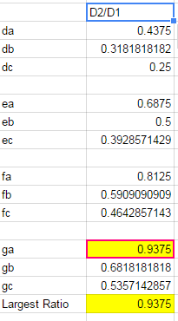Software was used to tabulate and determine the size combination between D2 and D1 that produced the largest mechanical advantage. The results of this are shown in the table below:

Table 20: Excel Calculations (Sprocket Ratio).

The result was that the combination of D1 = 4” (101.6 mm) and D2 = 3.75” (95.25 mm) gave the largest mechanical advantage with respect to torque out of the available gear combinations. Substituting in the values into the mechanical advantage equation (Eq. 1.3):

|  |  |  |
| --- | --- | --- |
|  | $$\frac{Tout}{T1}=\left(\frac{0.09525 m}{0.1016 m}\right)\left(\frac{254 mm}{27.686 mm}\right)\left(\frac{572 mm}{447.04 mm}\right)$$ |  |
|  | $$\frac{Tout}{T1}=11.01$$ |  |

This yielded a mechanical advantage of 11.01.

## Determining Necessary Force to Spin Drum

Modeling the drum with cement as a solid cylinder of density 2400 kilograms per cubic meter lying horizontally and spinning along its longitudinal axis. The governing equation for this is the relationship between the mass moment of inertia, angular acceleration, and net torque. This relationship is shown below:

|  |  |  |
| --- | --- | --- |
|  | $$\sum{T=αI}$$ | Eq. 1.2 |

The mass moment of inertia, I, for a cylinder rotating about its longitudinal axis is as follows:

|  |  |  |
| --- | --- | --- |
|  | $$I=\frac{1}{2}mr^{2}$$ | Eq. 1.3 |

With the mass being a function of density and volume and assuming a full cylinder, the mass moment of inertia is as follows:

|  |  |  |
| --- | --- | --- |
|  | $$I=\frac{1}{2}mr^{2}$$ |  |
|  | $$I=\frac{1}{2}\left[ρπd^{2}L\frac{1}{4}\right]d^{2}\frac{1}{4}$$ |  |
|  | $$I=\frac{1}{32}ρd^{4}πL$$ | Eq. 1.4 |

Subbing in values:

$$I=\frac{1}{32}(2400\frac{kg}{m^{3}}){\left(0.572 m\right)}^{4}π(0.889 m)$$

$$I=22.42 kg*m^{2}$$

The next step is to determine the angular acceleration, which is based off the assumption that 10 seconds are allowed for the drum to transition from rest to a rotational speed of 60 rpm. The calculation of angular acceleration is as follows:

|  |  |  |
| --- | --- | --- |
|  | $$α=\frac{ω2-ω1}{T2-T1}$$ | Eq. 1.5 |
|  | $$α=\frac{\frac{60 Rev.}{min}\frac{2π rad}{Rev.}\frac{min}{60 sec}-0}{10 sec}$$ |  |
|  | $$α=\frac{2π}{10}\frac{rad}{s^{2}}$$ |  |

The torque calculation is as follows:

|  |  |  |
| --- | --- | --- |
|  | $$\sum{T=αI}$$ | Eq. 1.6 |
|  | $$\sum{T=\frac{2π}{10}\frac{rad}{s^{2}}}22.42 kg*m^{2}$$ |  |
|  | $$\sum{T=14.09 N*m}$$ |  |

This is the torque required to spin the drum and concrete at the drum, therefore the applied torque required is determined through the torque mechanical advantage previously determined. This is determined as follows:

|  |  |  |
| --- | --- | --- |
|  | $$\frac{Tdrum}{Tin}=11.01$$ | Eq. 1.7 |
|  | $$Tin=\frac{Tdrum}{11.01}$$ |  |
|  | $$Tin=\frac{14.09 N*m}{11.01}=1.28 N*m$$ |  |

The required force is a function of torque and pedal crank length. The required force is therefore the input torque divided by the crank length, 0.170m. This is determined as follows:

|  |  |  |
| --- | --- | --- |
|  | $$Tin=L\left(crank\right)*Fin$$ | Eq. 1.8 |
|  | $$Fin=\frac{Tin}{L\left(crank\right)}$$ |  |
|  | $$Fin=\frac{1.28 N*m}{0.170 m}=7.53 N$$ |  |

This leads to the conclusion that the required force at the pedals to move a full drum of concrete from stationary to 60 rpm in 10 seconds is 7.53 N, which is manageable across our breadth of user profiles.

# MEC 723 Project Schedule2.pngAPPENDIX C: Scheduling (Gantt Chart)

Figure 54: Gantt Chart.

# Pages from michelin-catalogue.pngAPPENDIX D: Data Sheets

Figure 55: Michelin Ad for the S83 Scooter Tire [19].

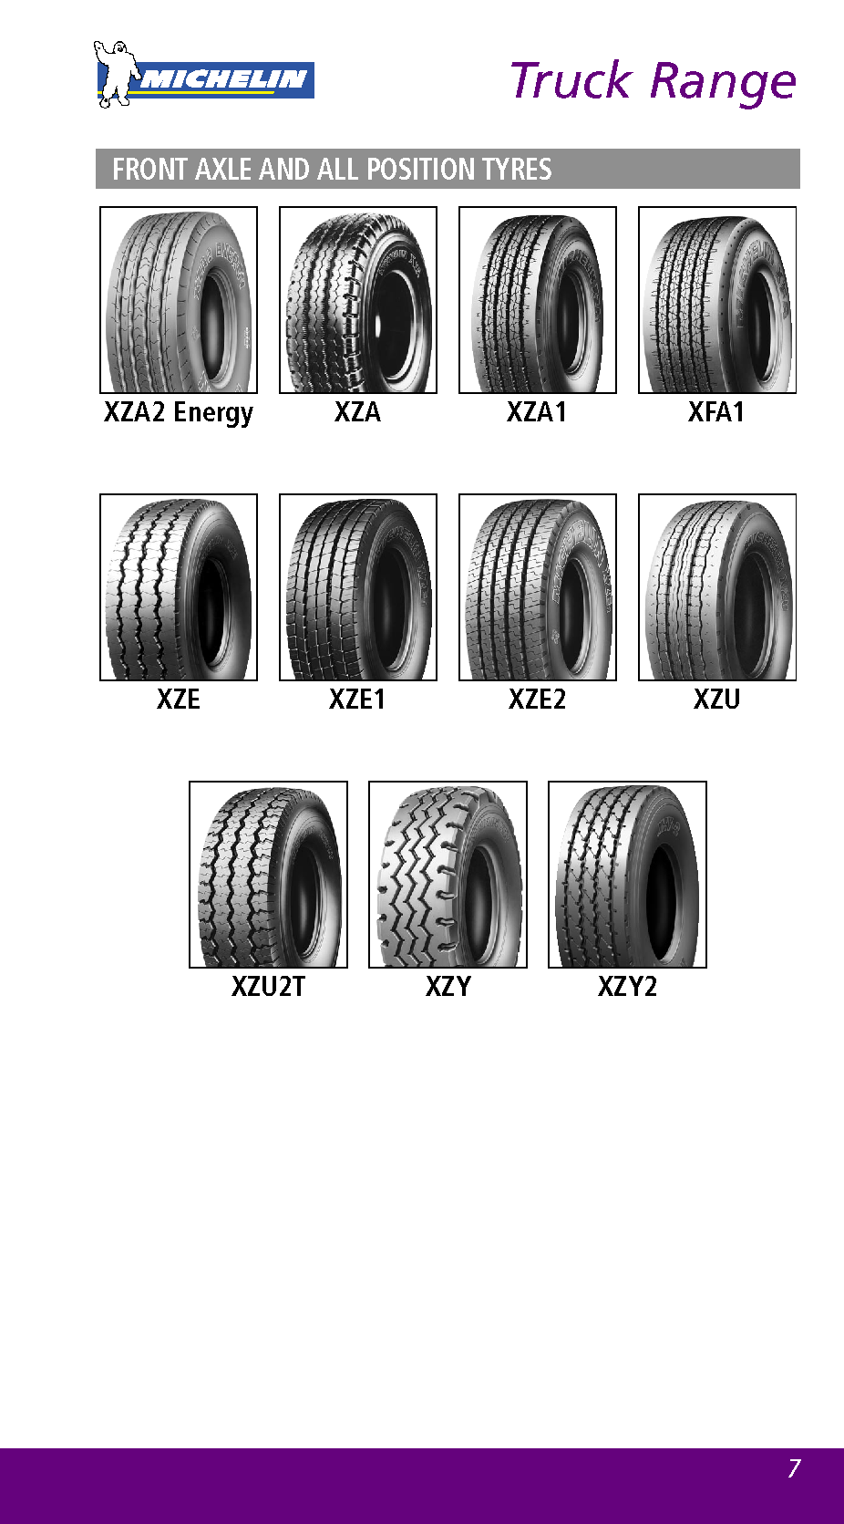

Figure 56: Michelin Ad for the XZL Tire [19]

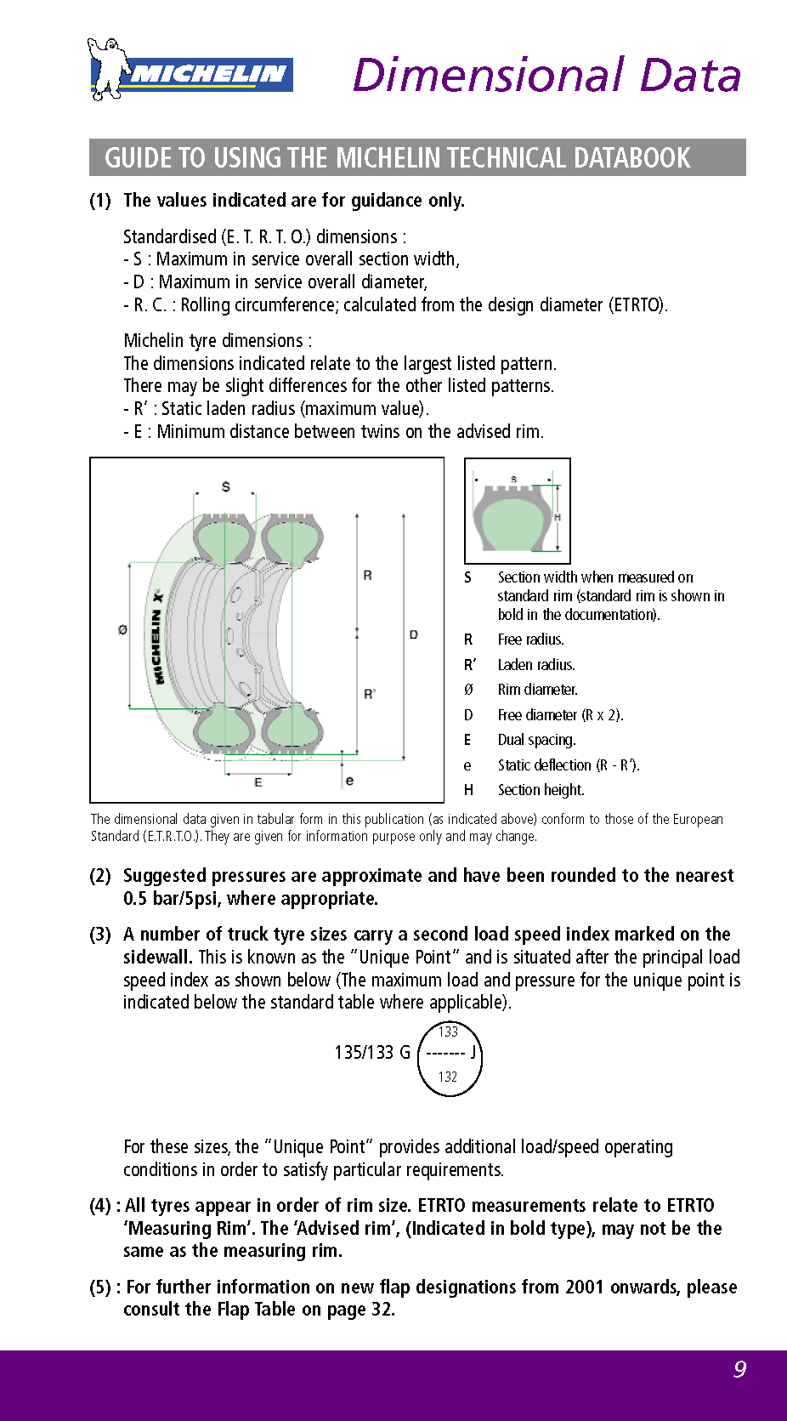

Figure 57: Michelin Tire Marking Definitions [19].

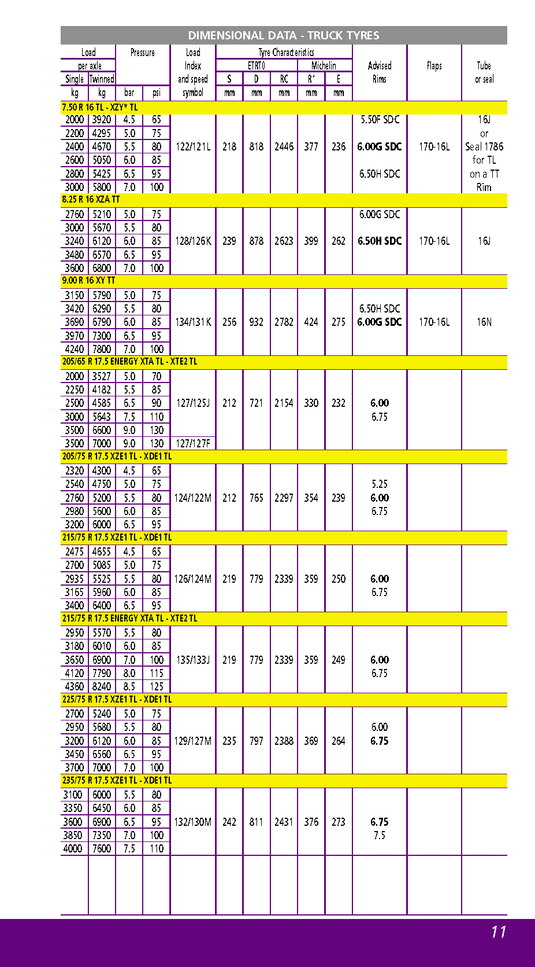

Figure 58: Michelin XZY Tire Specifications [19].

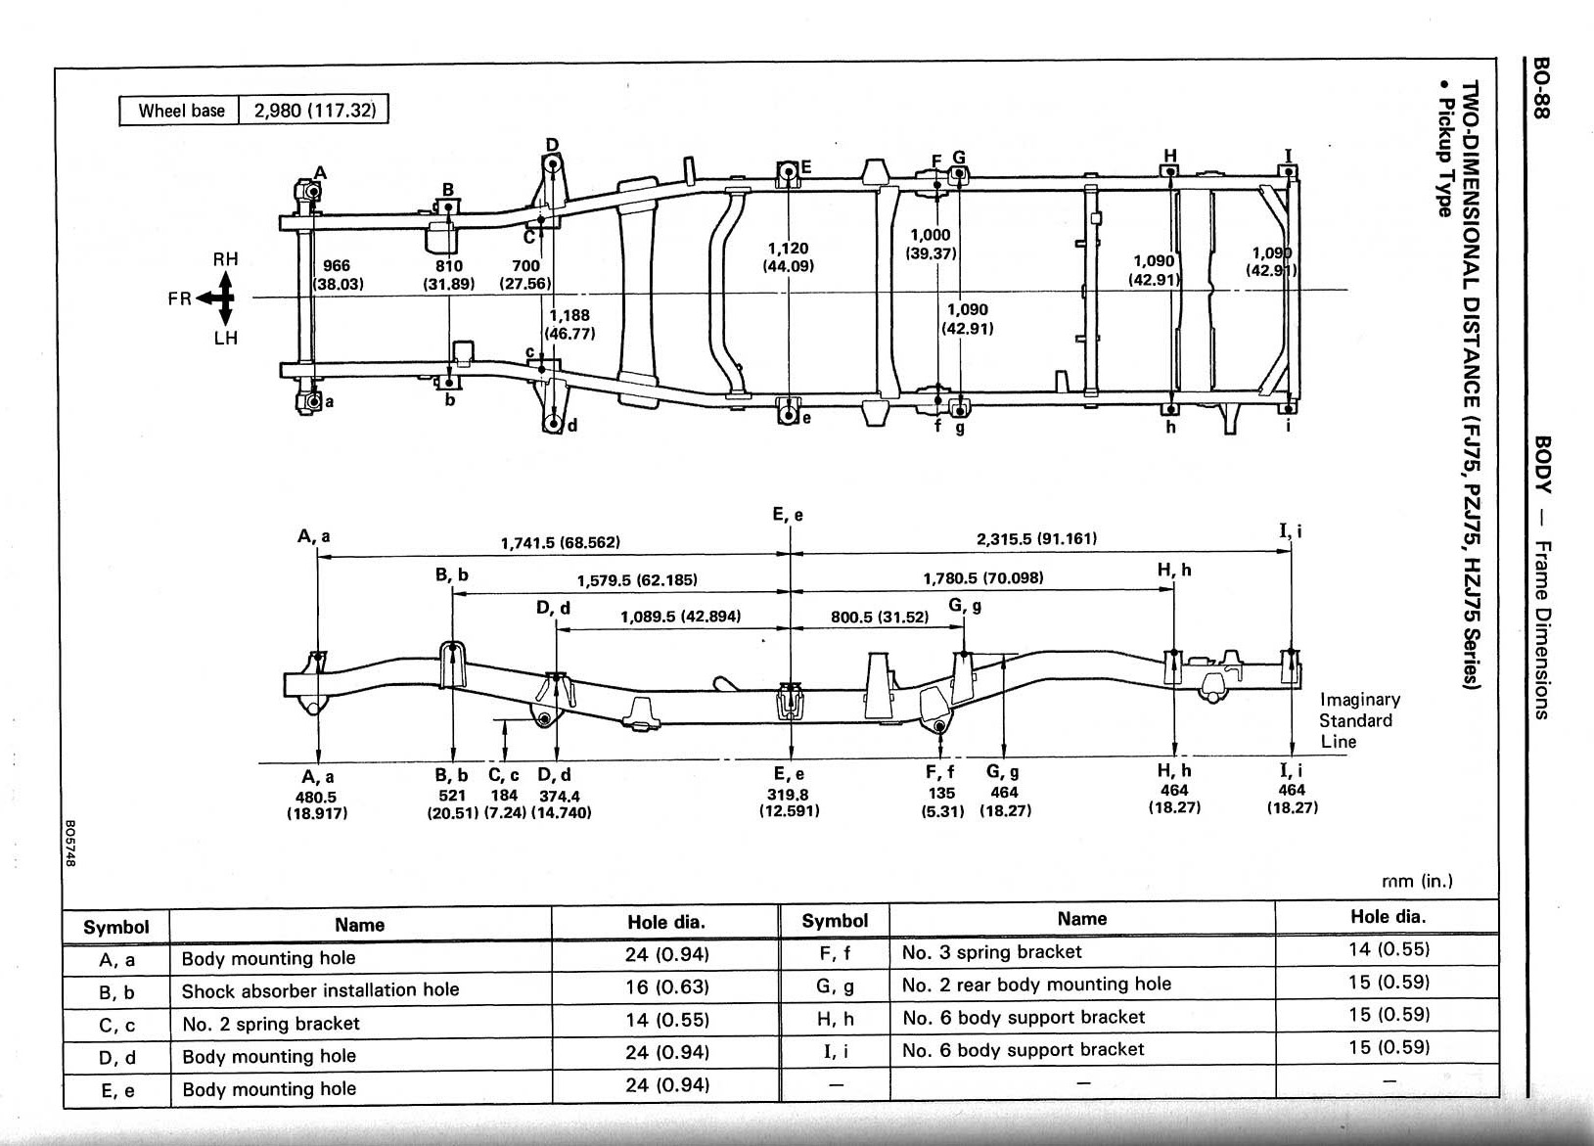

Figure 59: Toyota Land Cruiser 70-Series Repair Manual Frame Dimension Page [20].

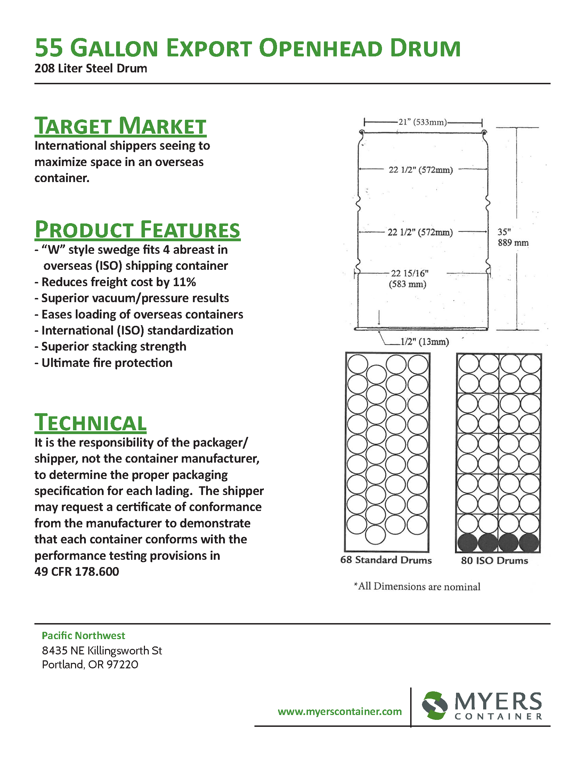

Figure 60: Myers ISO Export Drum [21].